PROTON e.MAS — CRM Feature Guide
Operator Handbook — Edition 4, August 2026

Table of Contents
Introduction
What is Proton e.MAS CRM
Logging in
Screen layout
Roles: agent vs administrator
Language (English / Indonesian)
Conversations
Conversation inbox & views
Assignment & teams
Labels
AI-suggested escalation department
Escalation replies
Inbound alerts
SLA breach alerts
Priorities
Private notes
Canned responses
Macros
Mentions
Ask Copilot panel
Translate
FAQ suggestion strip
Suggest-a-reply
Summarize conversation
AI auto-draft and suggest-vs-auto mode
Contact side panel
Resolving, snoozing & transcripts
Contacts
Contacts list & search
Contact profile & history
Notes & segments
Customer 360
Knowledge
FAQs
Documents
Assistants
Scenarios
Playground
Tools
Inboxes (assignment)
Settings (persona, language, lifecycle messages, guardrails)
Cases
Case list
Case categorisation (five fields)
Case lifecycle & status
How cases relate to conversations
Escalation status on a case
RSA Incident Log
Logging an RSA incident
Incident statuses & updates
RSA in Customer 360 & reports
Reports
Standard reports (Overview, Conversation, CSAT, Agent, Label, Inbox, Bot)
Anomaly report
Departments & PIC report
Case Lifecycle report
Weekly Report
SLA reports
Dealer escalation turnaround
Campaigns & Help Center
Campaigns
Help Center portal
Administration (Settings)
Agents
Teams
Inboxes (incl. inactivity timing)
Labels
Custom Attributes
Automation
Macros
Canned Responses
Integrations (incl. DMS / TSP connection)
SLA Policies
Audit Log
Roles & Permissions
Escalation Routing
Agent Availability & Workforce Dashboard
AI Conversational Quality
Account settings
AI Assistant Behaviour
When the AI replies vs. hands off to a human
Suggest mode vs. Auto mode
Escalation labels & the escalation email
Lifecycle messages
Voice bot behaviour (the AI-answered part of a call)
Phone handoff behaviour (the human side)
End-to-End Scenarios
Scenario 1: WhatsApp inquiry to resolution
Scenario 2: Complaint escalation, the dealer's reply, and the turnaround report
Scenario 3: RSA call to Customer 360 follow-up
Scenario 4: FAQ batch import to live bot answer
Scenario 5: Weekly reporting routine
Scenario 6: New agent onboarding
Scenario 7: A customer replies to their own acknowledgement email
Scenario 8: Maintaining a dealer group
Scenario 9: An SLA breach reaches the PIC group and the case
Scenario 10: Adjusting SLA thresholds ahead of a launch event
Scenario 11: Editing a customer-facing email template
Scenario 12: A WhatsApp case looks escalated, but nothing was sent
Scenario 13: The same limitation on a web chat case
Scenario 14: An after-hours breakdown call, and an unanswered transfer
Scenario 15: Categorising a case through all five taxonomy dropdowns
Scenario 16: An AI-suggested escalation department — accepted, and ignored
Scenario 17: Checking escalation routing before you rely on it
Channel Playbooks
How the channels map to the CRM
The toolkit that is identical on every channel
WhatsApp
Web chatbot
Voice bot — the AI-answered part of a call
Phone — the human side of the same call
Email
One customer, four touchpoints
Quick reference
Known limitations, and what to tell the customer
Integration Overview
WhatsApp
Web chatbot
Voice bot
Phone
Email (incl. escalation emails)
Gemini AI
DMS / TSP
Knowledge base (Vertex corpus)
BI / reporting exports
Glossary
Terms

Introduction

What is Proton e.MAS CRM

What it is
Proton e.MAS CRM is Proton's unified customer support platform for the e.MAS electric-vehicle business. It brings every customer conversation — WhatsApp, email, and phone/IVR calls — into a single inbox, adds an AI assistant that can draft or send replies, and layers on automotive support tools such as roadside-assistance (RSA) incident logging, a vehicle/service lookup (Customer 360), case tracking, and reporting built around dealer and PIC (person-in-charge) escalation.
Every agent and administrator uses the same platform through a web browser; there is nothing to install.

Where to find it
The platform is reached at your organization's CRM web address, provided by your administrator. Bookmark it — you'll come back to it every shift.

How to use it
1. Open a web browser and go to your organization's CRM address.
2. Sign in with the account your administrator created for you (see Logging in below).
3. After signing in you land on the Conversations view — the default screen showing every conversation across the inboxes you have access to.
4. Use the sidebar on the left to move between Conversations, Contacts, Knowledge, Cases, RSA, Reports, and (for administrators) Administration.
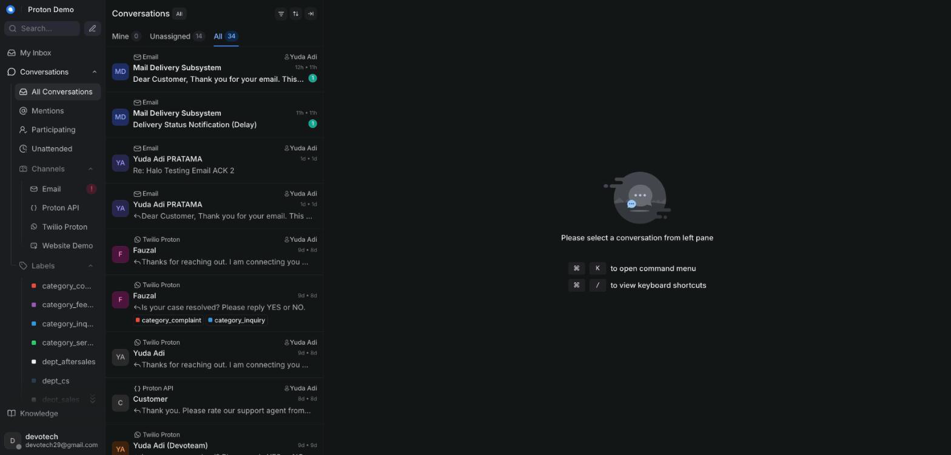
Landing view after logging in to Proton e.MAS CRM

Example scenario
At the start of a shift, an agent at a Proton e.MAS dealership opens the CRM in their browser and lands directly on the Conversations view, where overnight WhatsApp inquiries about test drives and service bookings are already waiting.

Integrations & automation
The CRM is the single front door for WhatsApp, email, and phone/IVR conversations, the Gemini-powered AI assistant, the vehicle/service data lookup (DMS/TSP), and Proton's reporting — every chapter in this guide covers one part of that single platform.

Logging in

What it is
The sign-in screen that authenticates you as an agent or administrator before you can see any conversations or customer data.

Where to find it
Your CRM web address opens directly to the login screen if you are not already signed in.

How to use it
1. Go to your organization's CRM address.
2. Enter the email address and password your administrator set up for you.
3. Click the sign-in button.
4. If you forget your password, use the "Forgot password?" link to request a reset email.
5. Once signed in, you stay logged in on that browser until you sign out or your session expires.

Example scenario
A newly hired agent receives a welcome email with their login details, opens the CRM address on their laptop, signs in for the first time, and is prompted to set a new password before reaching the dashboard.

Integrations & automation
Signing in does not touch any other system by itself — it simply opens the session you use for every other feature in this guide.

Screen layout

What it is
The main working screen you see after logging in: a navigation sidebar on the left, the conversation list in the middle-left column, the open conversation with its reply box in the center, and a contact side panel on the right.

Where to find it
This layout is what you see any time you are inside the Conversations area of the CRM.

How to use it
1. Use the sidebar on the far left to switch between Conversations, Contacts, Knowledge, Cases, RSA, Reports, Campaigns/Help Center, and (for administrators) Administration and other admin-only pages.
2. Use the conversation list to browse and filter the conversations in your inboxes — see the Conversations chapter for the filters available.
3. Click a conversation to open it in the main conversation pane, where the message thread and reply box live.
4. Check the contact side panel on the right for the customer's details and history alongside the conversation you're reading.
5. Look for AI-assist buttons (Ask Copilot, Suggest a reply, Summarize) above the reply box when you need help drafting a response.
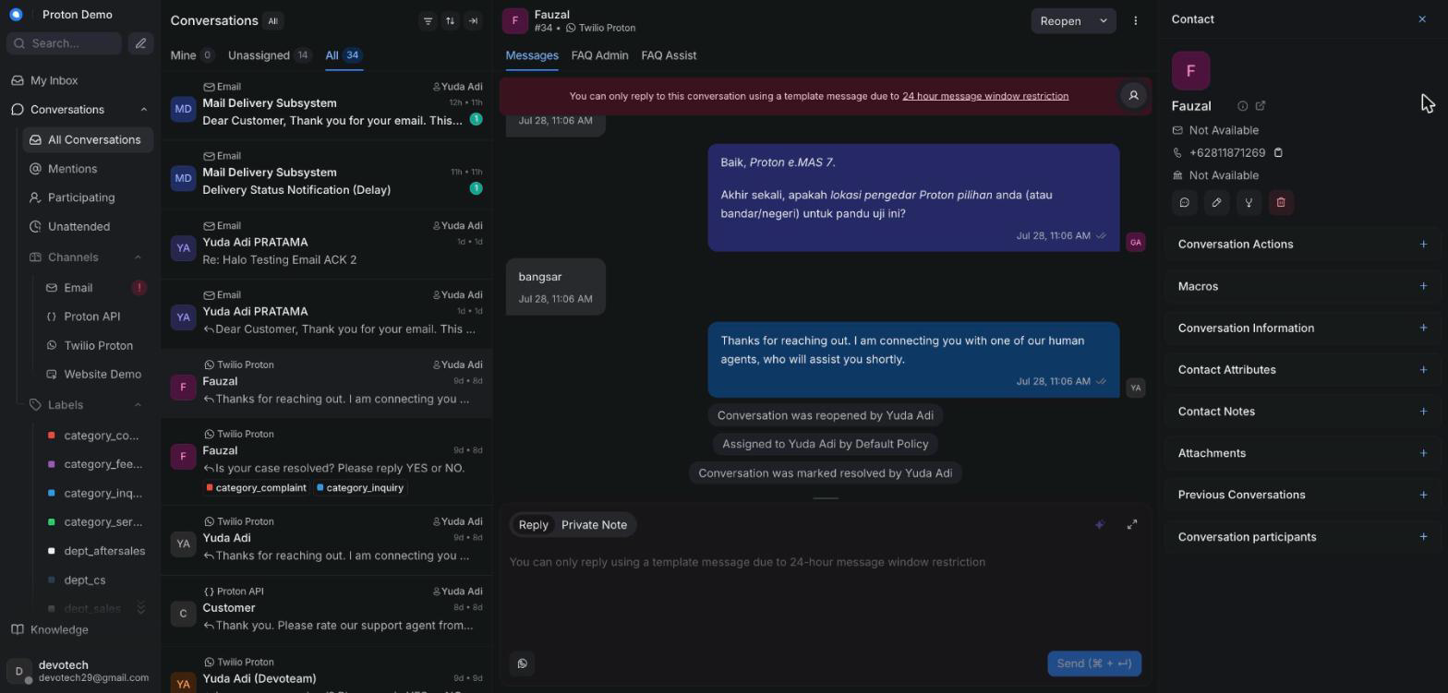
Main dashboard layout: sidebar, conversation list, reply box, contact panel

Example scenario
An agent handling a service-booking question keeps the contact panel open to check the customer's vehicle model while typing a reply in the main conversation pane, without leaving the conversation.

Integrations & automation
The sidebar is where Proton's added modules — Knowledge, Cases, RSA, the extra Reports pages, and (for administrators) Integrations, Escalation Routing, SLA Policies, Audit Log, and Roles & Permissions — sit alongside the standard Conversations and Contacts views, so everything is reachable from one place.

Roles: agent vs administrator

What it is
Every account has a base role — Agent or Administrator — that controls what you can see and do. Administrators can additionally be granted specific permissions (for example, managing escalation routing, SLA policies, integrations, or viewing the audit log), so two administrators may not see exactly the same admin pages unless they've been granted the same permissions.

Where to find it
Your role is set by an administrator when your account is created, under Administration → Agents. Fine-grained permissions are managed under Administration → Roles & Permissions.

How to use it
1. As an agent, you see Conversations, Contacts, and Knowledge — the day-to-day support tools. Knowledge isn't read-only for agents: the same page and its editing controls are available to both roles.
2. As an administrator, you additionally see Cases, the RSA Incident Log, Customer 360, Reports, and Administration together with any admin-only pages your permissions grant, such as Integrations, Escalation Routing, SLA Policies, Audit Log, and Roles & Permissions.
3. If you believe you're missing access you should have, ask an administrator to check your role and permissions under Administration → Roles & Permissions.
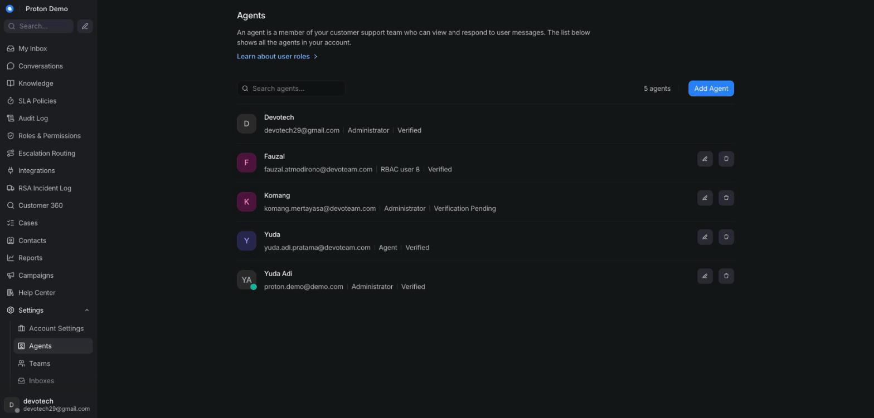
Sidebar differences between an agent and an administrator account

Example scenario
A support supervisor is given the Administrator role plus the escalation-routing permission, so they can update which dealer receives escalation emails without also being handed full account-wide administrator access to every setting.

Integrations & automation
Roles and permissions gate every admin-only page covered in the Administration chapter — what you see there depends directly on what's set up here.

Language (English / Indonesian)

What it is
A setting that switches the CRM's interface text between English and Indonesian. It changes labels and menus, not the language customers write to you in.

Where to find it
Your profile settings menu, usually reached from your avatar/name in the top corner of the screen.

How to use it
1. Open your profile settings from your avatar or name.
2. Find the interface language option.
3. Choose English or Indonesian (Bahasa Indonesia).
4. The interface labels update immediately (or after a page refresh).
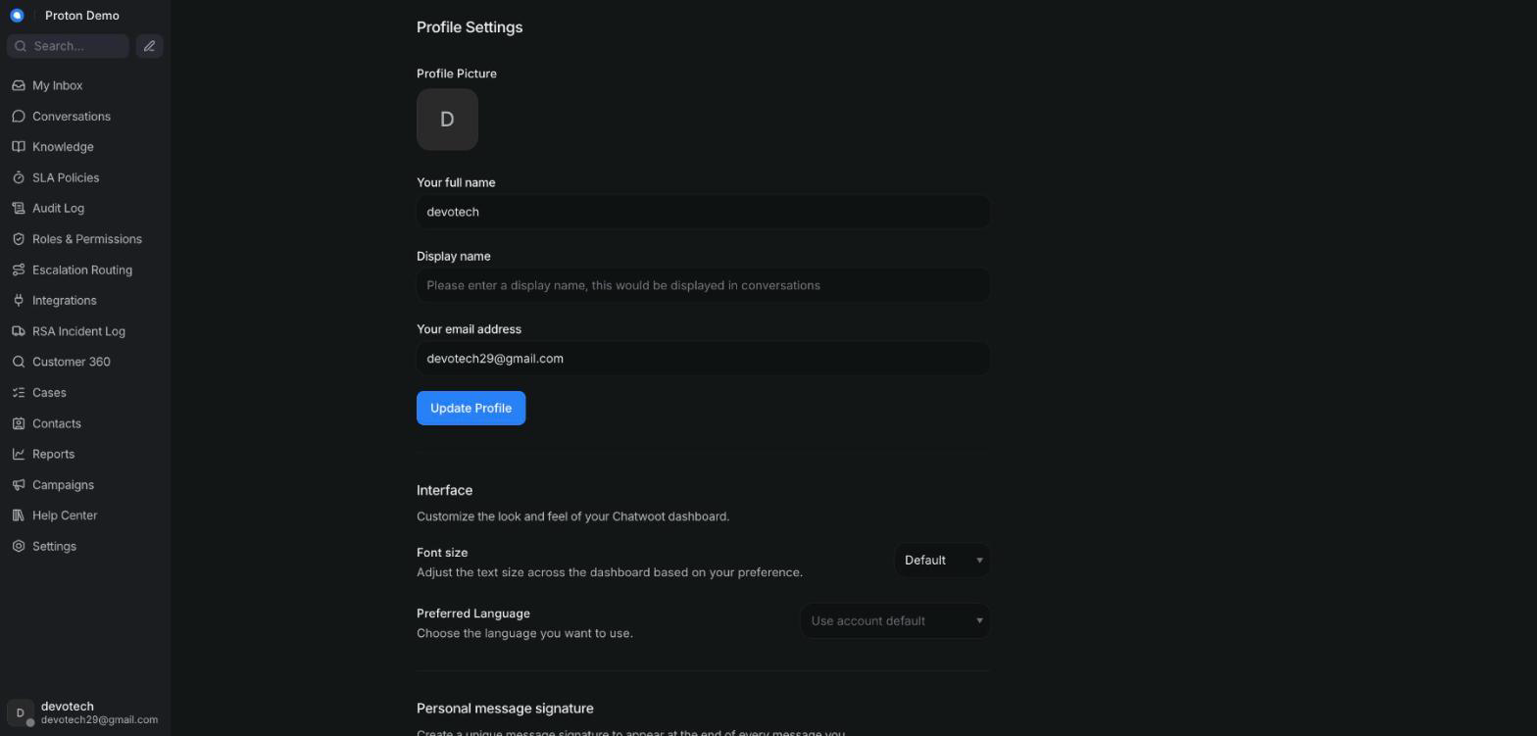
Switching the interface language between English and Indonesian

Example scenario
An agent who is more comfortable working in Bahasa Indonesia switches their interface language, while the AI assistant continues to reply to each customer in whatever language that customer writes in.

Integrations & automation
The interface language is a personal preference only — it doesn't change which language the AI assistant uses when replying to a customer.

Conversations

Conversation inbox & views

What it is
The conversation list is where every incoming conversation lands — WhatsApp, the website chatbot, email, and phone/IVR alike — filterable by who it's assigned to and by its status. By default the CRM shows every conversation across all statuses, so nothing is hidden behind a narrower filter unless you choose one.

Where to find it
The left-hand column of the Conversations view, always visible once you're signed in.

How to use it
1. Use the assignee tabs to switch between Mine, Unassigned, and All conversations.
2. Use the status filter to narrow the list to Open, Pending, Snoozed, or Resolved conversations, or leave it on All to see everything regardless of status.
3. Click an inbox name in the sidebar to scope the list to a single channel (for example, just WhatsApp).
4. Click any conversation in the list to open its full thread.
5. Use the sort option to reorder the list, for example by most recent activity.
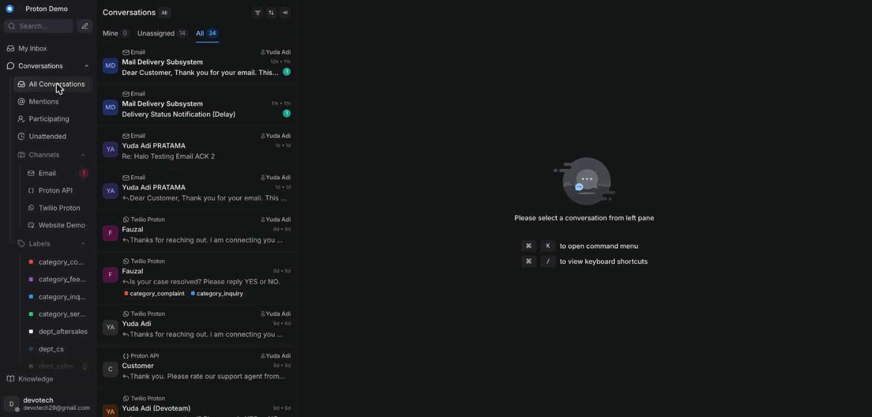
Conversation list showing the default "All" tab and "All" status filter

Example scenario
At the start of a shift, an agent opens the Conversations view and — since it defaults to "All" agents and "All" statuses — immediately sees a pending WhatsApp inquiry about a test drive that came in overnight, without having to change any filter first.

Integrations & automation
New conversations can arrive automatically from the AI assistant handling WhatsApp, web chatbot, or phone/IVR contact before a human ever sees them (see the AI assistant behaviour chapter); this list is also where assignment, labels, and priorities (below) become visible at a glance.

Assignment & teams

What it is
Assignment determines which agent — or which team — owns a conversation. An unassigned conversation is visible to the whole team until someone picks it up or it's assigned.

Where to find it
The assignee and team controls in the conversation's action panel, next to an open conversation.

How to use it
1. Open the conversation you want to assign.
2. Click the assignee control and choose an agent, or click the team control and choose a team.
3. To reassign, repeat the same steps and pick a different agent or team.
4. To unassign, clear the assignee field.
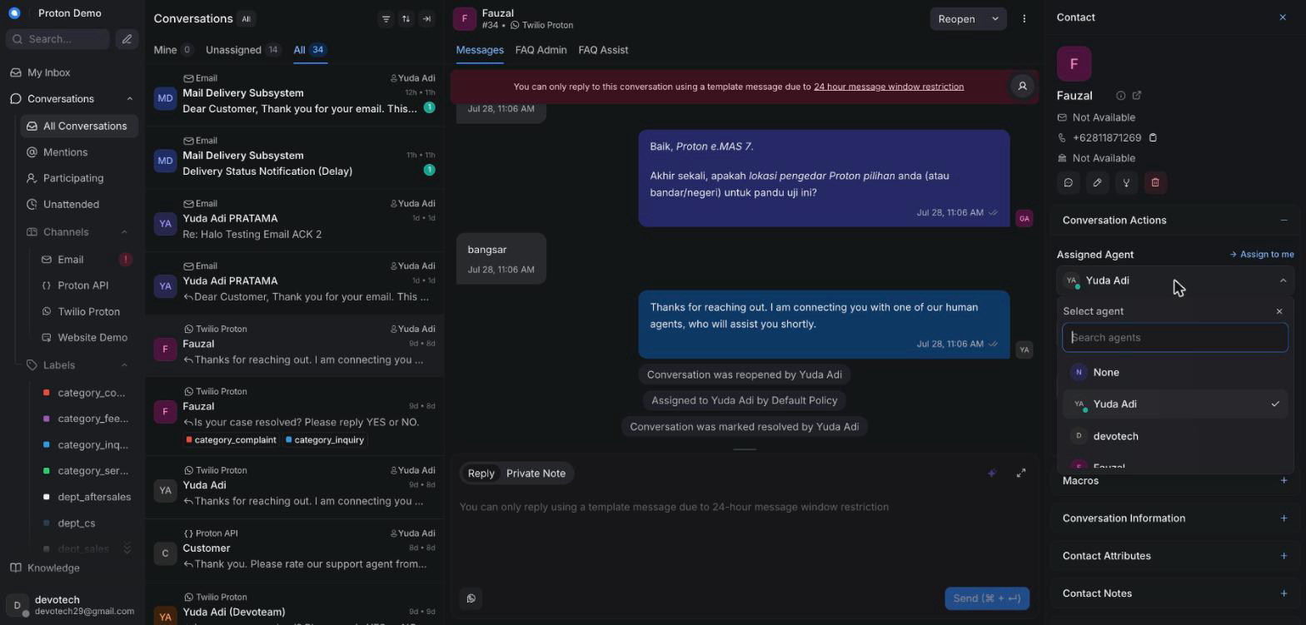
Assigning a conversation to an agent or team

Example scenario
A WhatsApp inquiry about booking a test drive for the Proton e.MAS 7 comes in; the on-duty agent assigns it to the "Sales — Jakarta" team so any available team member can respond, rather than keeping it for themselves.

Integrations & automation
When the AI assistant hands a conversation off to a human, it can trigger an automatic agent assignment as part of that handoff (see the AI assistant behaviour chapter). Administrators can also set which channels each agent handles first, to steer that automatic assignment — see the Administration chapter's Inboxes section.

Labels

What it is
Labels are tags you attach to a conversation to categorize it. Alongside general-purpose labels, Proton uses two special families: an escalate label that flags a conversation for the escalation email workflow, and dept_<slug>/dealer-specific labels used to route that escalation and, for dealer labels, to feed turnaround-time reporting. Applying a department label routes the escalation to whichever contact is configured for that department under Escalation Routing (see the Administration chapter) — and a department with no contact configured there sends the escalation email to nobody, with no error anywhere to warn you. Check the Escalation Routing page rather than assume every department is covered. A dealer label works the same way but can route to a whole dealer group instead of a single contact — every member of that group is forwarded the case, again only for a dealer that's actually been configured there.

Where to find it
The label control on an open conversation, and a Labels view in the sidebar listing conversations by label.

How to use it
1. Open the conversation you want to label.
2. Click the label control and pick one or more existing labels.
3. Apply the department label first — one of dept_sales, dept_engineer, dept_pre_sales, dept_aftersales, dept_cs, or dept_technical — then the dealer label if one is involved, and apply escalate last. The escalation handler reads whichever labels are already on the conversation at the moment escalate is applied — applying it first means the department/dealer leg doesn't fire for that trigger. On an Email-channel conversation with no department label yet, you may see a private note suggesting one before you get here — see AI-suggested escalation department, below.
4. Apply the relevant dealer label so the conversation counts toward that dealer's turnaround reporting, even outside an email escalation.
5. Remove a label the same way, by deselecting it.
6. A limitation worth knowing before you rely on this: the automated escalation email only fires on an Email-channel conversation. Applying escalate on a WhatsApp, web chatbot, or phone conversation changes the label and nothing else — no one is notified. The dealer label still records the case for turnaround reporting on any channel; that part isn't affected. See the Integration Overview chapter's WhatsApp, Web chatbot, and Phone sections for what to actually do on those channels instead.
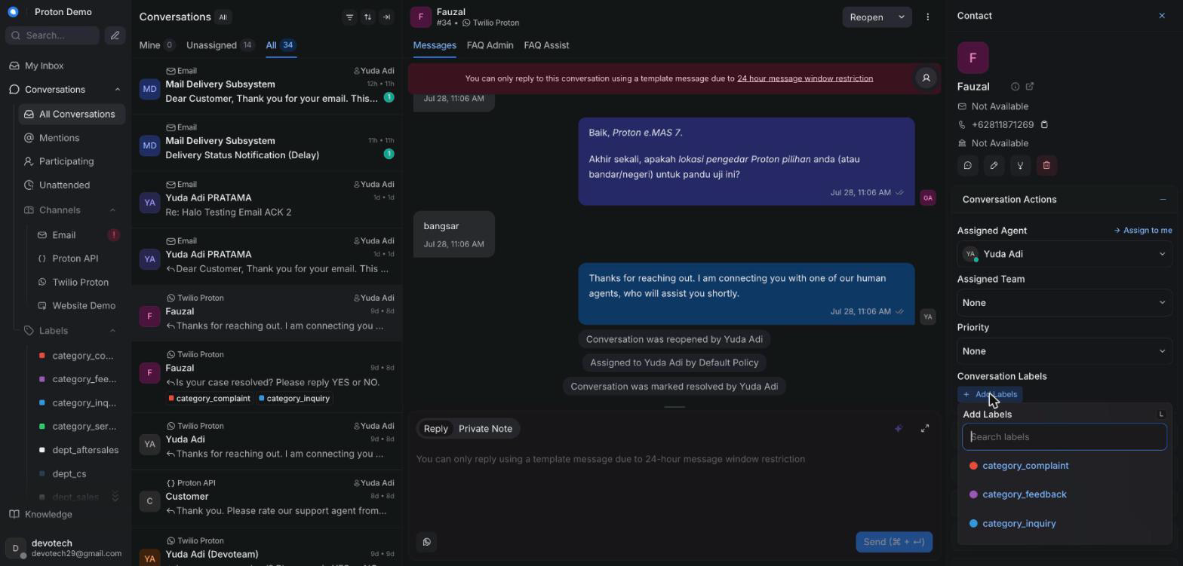
Applying a label to a conversation

Example scenario
A customer's warranty complaint escalates over email; the agent adds the department label, then the dealer's label, then escalate — in that order — which together kick off the automated escalation email to everyone on that dealer group and start the clock for turnaround reporting. See Escalation replies, below, for what happens once the dealer answers.

Integrations & automation
The escalate label triggers the two-thread escalation email described in the AI assistant behaviour chapter; dealer labels feed the dealer turnaround figures shown in the Reports chapter. The email this sends now carries a hidden reference back to this conversation, which is what makes Escalation replies (below) possible.

AI-suggested escalation department

What it is
New since the last edition of this guide. On an Email-channel conversation with no dept_<slug> label yet, an incoming customer message can trigger a private note naming the department the AI thinks is the best fit — for example:
AI-suggested escalation department: pre_sales. This is a suggestion only — no label has been applied. If you agree, add the dept_pre_sales label yourself, BEFORE the escalate label…
It never applies the label itself. This is a nudge for a human, not an automatic escalation — the note only ever proposes; you decide. It only ever proposes a department that actually has a PIC configured, so it can't suggest a dead end. It posts once per conversation (a second incoming message won't post a second suggestion), and only on Email inboxes.

Where to find it
As a private note on the conversation, the same place any other private note appears (see Private notes, below). Not something an agent turns on — it's an administrator/tenant-level setting, off by default, and live today on this tenant.

How to use it
1. Watch for a private note starting AI-suggested escalation department: on an Email conversation you haven't yet labelled with a department.
2. To act on it: add the exact dept_<slug> label the note names — for example dept_pre_sales — yourself, from the label control, then continue the normal escalation order (dealer label if needed, then escalate last; see Labels, above). The note doesn't do this for you.
3. To ignore it: simply don't add the suggested label. Nothing happens automatically either way — you can pick a different department, or none at all, and the conversation carries on exactly as if the note weren't there. There's no "reject" button to click; not acting on it is the reject.
4. If you disagree with the suggestion, trust your own read of the case over the note — it's a best-effort classification from a single Gemini call over the recent transcript, not a guarantee.

Example scenario
A customer emails asking about financing options and a trade-in value before committing to an order — no department label yet. The AI posts a private note suggesting pre_sales. The agent agrees, adds dept_pre_sales, then escalate, and the case routes to the Pre-Sales PIC as normal. On a different case, a customer's email is a straightforward delivery-status question the agent already knows is Sales' — they see the suggestion, judge it doesn't fit, and label it dept_sales themselves without ever adding the suggested label.

Integrations & automation
Candidates always come from the same Escalation Routing directory used to actually send the mail (see the Administration chapter's Escalation Routing section) — a department with no PIC configured can never be suggested. This is a separate, best-effort layer on top of the escalation mechanics in Labels (above) and the AI Assistant Behaviour chapter's Escalation labels & the escalation email section; it changes nothing about how the escalation email itself fires.

Escalation replies

What it is
When a dealer or PIC replies to an escalation email, their reply doesn't start a fresh conversation you have to go hunting for — it's linked back onto the original conversation automatically, as a private note starting Reply from <name> <email>:. If a customer instead replies to their own acknowledgement email, that reply rejoins their case too and the conversation reopens — but correction from the previous edition of this guide: it does not arrive as an ordinary incoming message. Chatwoot only accepts a synthetic incoming message on an Api-channel inbox; every Email-channel conversation (which is the only channel this loop ever runs on) rejects it with {"error":"Incoming messages are only allowed in Api inboxes"}. The CRM tries the inline post first, and it always fails on this tenant's Email inbox today, so what you actually see is a private note, prefixed Customer's own reply (from <email>, could not be posted inline -- see conversation <id>):, followed by the customer's own words. The reopen still happens either way — that part behaves exactly as before.

Where to find it
The reply lands as a new message on the original escalated conversation — not on any new conversation that may briefly appear elsewhere in the inbox. A throwaway conversation is created behind the scenes to receive the raw email, but it's automatically labelled and resolved, so it shouldn't show up in your queue as something to work.

How to use it
1. Watch a conversation you've already escalated for a new private note starting Reply from . That's the dealer or PIC's reply, with any quoted trail and signature stripped out.
2. Directly beneath it, look for a second private note titled exactly Suggested customer reply (draft — review before sending):. This is an AI-drafted reply based on what the dealer said — read it, edit it to sound right, and send it as your own reply. It never goes to the customer on its own.
3. The conversation also picks up an escalation_replied label, so you can spot which escalated cases already have an answer waiting for review just by scanning labels in the conversation list.
4. If the reply instead comes from the customer replying to their own acknowledgement email, watch instead for a private note prefixed Customer's own reply (from <email>, could not be posted inline -- see conversation <id>):, followed by their own words — not a normal incoming message, on this tenant's Email inbox. The conversation still reopens by itself either way. What to actually do: read the note as if it were the customer's message (it is, word for word, just delivered as a note instead of an inline bubble), then reply publicly the same way you would to any other reopened case — don't wait for a "real" incoming message that this loop is never going to post here.
5. A second reply from the same dealer/PIC address after the first one's already linked in doesn't post another note — check the dealer's own mailbox directly if they say they've replied twice. A customer can reply more than once without limit; each reply lands as its own private note the same way.

Example scenario
An agent escalates a charging-fault complaint to a dealer on Monday. On Wednesday the dealer emails back confirming the part has been ordered. Within a couple of minutes the agent sees a Reply from private note on the original conversation with the dealer's update, and a second note with a drafted customer-facing reply already summarizing it — the agent tidies the wording and sends it straight to the customer without re-typing anything.

Integrations & automation
This is the other half of the escalate label workflow described in Labels, above, and in the AI Assistant Behaviour chapter's Escalation labels & the escalation email section. Only senders in the Escalation Routing directory (Administration chapter) — or the conversation's own customer — are trusted to link a reply back onto a case this way.

Inbound alerts

What it is
A toast notification that pops up right inside the CRM the moment a new customer message arrives on one of your inboxes — so you don't have to keep staring at the conversation list to notice new work.

Where to find it
It appears on its own, anywhere in the CRM, whenever a new customer message lands in your inbox. No particular page needs to be open for it to fire.

How to use it
1. Keep working anywhere in the CRM — the alert appears on its own when a new customer message comes in.
2. Click the toast to jump straight to that conversation.
3. Today this fires on the platform's built-in default for a new message: a toast notification, nothing more. A fuller, self-service preferences page — where each agent could add a sound or a desktop notification, or tune alerts for other events — exists in the product but is not switched on for this tenant, so there's nothing to configure yet. What you see is the same for every agent, and it can't currently be changed.

Example scenario
An agent is deep in a different conversation when a new WhatsApp inquiry lands on their inbox; a toast notification in the corner of the screen catches their attention immediately, instead of the message sitting unnoticed until they next glance at the conversation list.

Integrations & automation
This is separate from SLA breach alerts (below), which are email-driven and scoped to a missed response/resolution target rather than to every new message.

SLA breach alerts

What it is
If a conversation on the Email inbox goes past its response or resolution target without action, the CRM posts a private note on that conversation flagging the breach, and separately emails the department's PIC group (resolved from the conversation's own department label) so the breach doesn't rely on someone happening to notice the note.

Where to find it
The private note appears directly in the conversation's timeline, marked private the same way any other internal note is. The matching email goes to whichever PIC group is configured for that conversation's department under Escalation Routing (see the Administration chapter).

How to use it
1. Watch for a private note starting ⚠️ SLA breach on a conversation — it names which target was missed (first response or resolution) and the case number.
2. Treat it as a prompt to act on the conversation now, not just a record — the department's PIC group has already been emailed the same breach, so a customer-facing follow-up may already be expected.
3. Respond to or resolve the conversation as normal; a second scan doesn't re-alert for the same breach once it's been recorded, so you won't see the note repeat on its own.
4. If a breach note appears but you believe the response/resolution target is wrong for this inbox, check — or ask an administrator to check — the thresholds under SLA Policies (see the Administration chapter).

Example scenario
An email case sits unassigned past its response window overnight. The next morning, the agent opens the conversation and finds a private note flagging the breach, already an hour old — the department's PIC group also got an email at the same moment, so the agent replies immediately rather than treating it as a routine pickup.

Integrations & automation
SLA breach alerts read the same response/resolution targets set on the SLA Policies admin page (see the Administration chapter), including the Tier-2 re-alert and warning thresholds described there. Today this only scans the Email inbox.

Priorities

What it is
A priority flag (for example Urgent, High, Medium, Low, or none) you can set on a conversation to indicate how urgently it needs attention. It shows as a badge in the conversation list so high-priority conversations stand out.

Where to find it
The priority control in the conversation's action panel.

How to use it
1. Open the conversation you want to flag.
2. Click the priority control.
3. Choose the priority level that matches how urgently it needs handling.
4. Change it at any point as the situation develops.
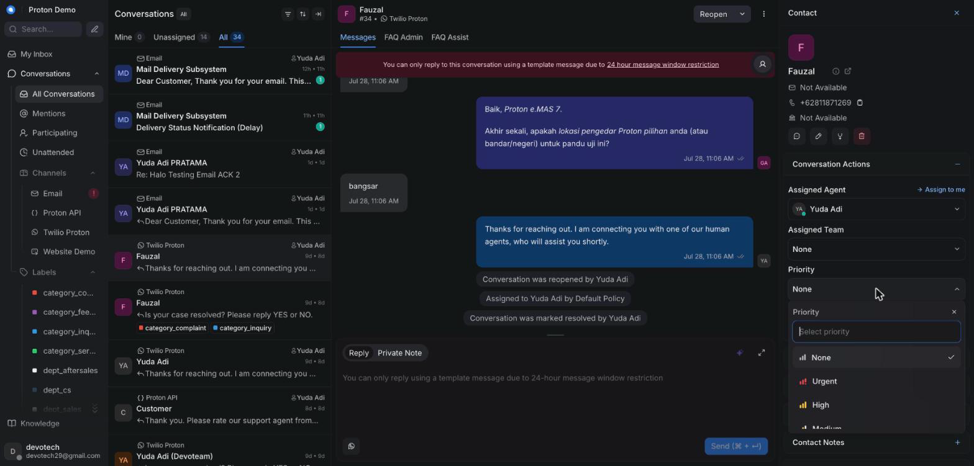
Setting a conversation's priority

Example scenario
A call reporting a vehicle breakdown on the highway is marked Urgent so it surfaces at the top of the queue and gets picked up immediately for roadside-assistance follow-up.

Integrations & automation
A conversation's priority flag is separate from, but complements, the per-agent channel handling order administrators can configure in Administration → Inboxes, which decides which agent gets auto-assigned first for a given channel.

Private notes

What it is
Internal messages attached to a conversation that only agents and administrators can see — never the customer. Used for handoff context, questions to a teammate, or reviewing an AI-drafted reply before sending it.

Where to find it
The reply box's note mode, toggled from the main "reply" mode.

How to use it
1. Open the conversation and click into the reply box.
2. Switch the reply box to its private "Note" mode.
3. Type your note — mention a teammate with @ if you need their input (see Mentions below).
4. Send the note; it posts as private and is visually distinct from a customer-facing reply.
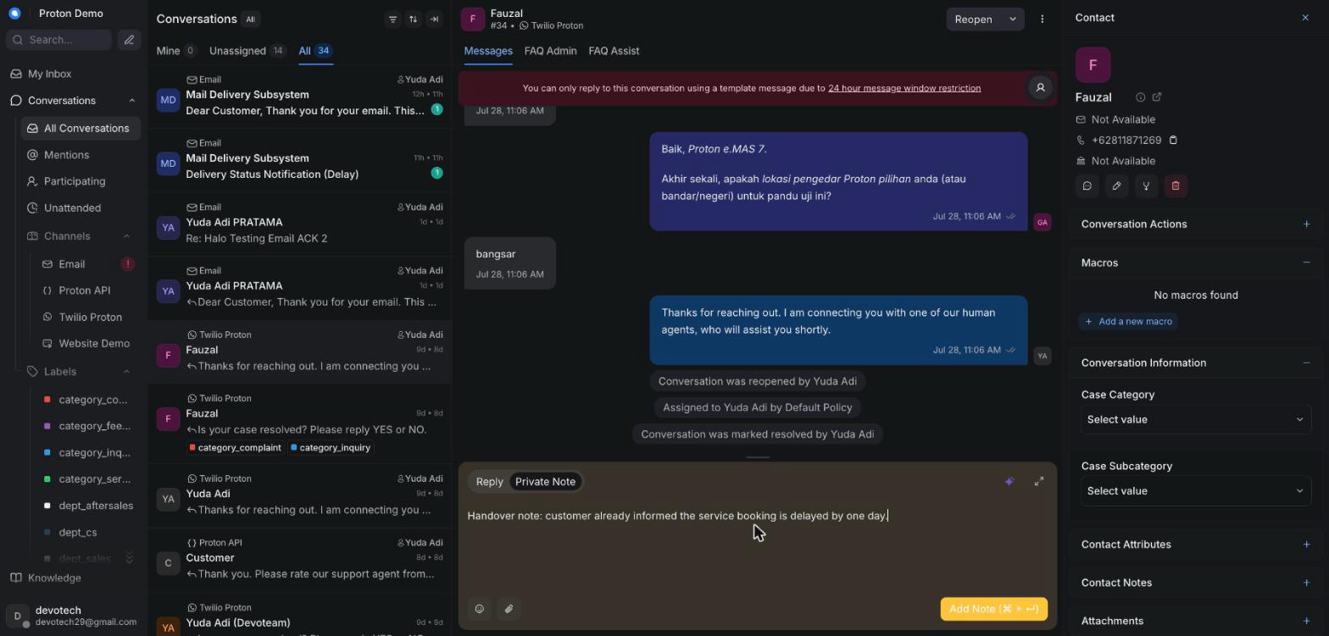
Adding a private note visible only to agents

Example scenario
An agent handing off their shift leaves a private note summarizing that the customer has already been told their service booking is delayed by a day, so the next agent doesn't repeat the same message.

Integrations & automation
Private notes are exactly how an AI-drafted reply arrives when the AI assistant is running in suggest mode (see AI auto-draft below), and where Ask Copilot answers land when inserted into the conversation.

Canned responses

What it is
Pre-written reply snippets for common questions, so agents don't retype the same answer over and over.

Where to find it
A shortcut inside the reply box, typically triggered by typing a character like "/" or clicking a canned-response icon.

How to use it
1. Click into the reply box.
2. Trigger the canned-response search (for example, typing "/").
3. Search by the short code or keyword for the response you need.
4. Select it — it's inserted into the reply box.
5. Edit if needed, then send as normal.

Example scenario
For a frequently asked question about e.MAS charging cable compatibility, an agent inserts the matching canned response instead of retyping the same answer for the tenth time that day.

Integrations & automation
Canned responses are created and maintained by administrators (see the Administration chapter), which keeps the wording consistent across the whole team.

Macros

What it is
A macro bundles a sequence of actions — for example, adding a label, assigning a team, sending a reply, and marking the conversation resolved — so an agent can run all of them in a single click instead of doing each step by hand.

Where to find it
The macro option in the conversation's action menu, inside an open conversation.

How to use it
1. Open the conversation you want to act on.
2. Open the macro menu from the conversation's action area.
3. Pick the macro you want to run from the list.
4. Confirm — its steps run automatically in order (for example: apply a label, send a reply, then resolve).
5. Check the conversation afterward to confirm every step applied as expected.
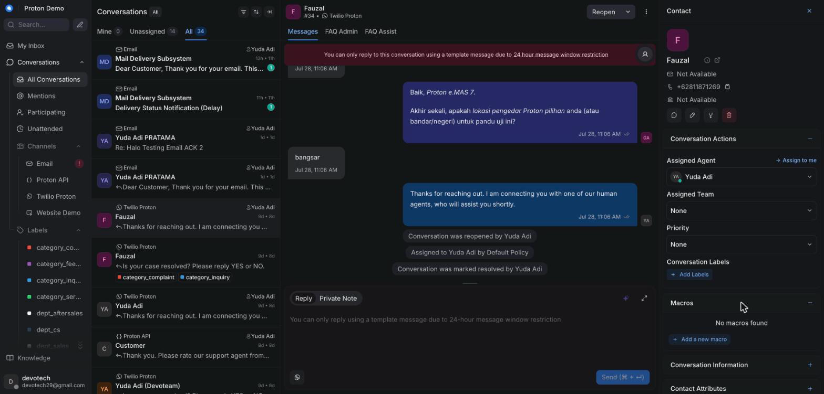
Running a macro from an open conversation

Example scenario
An agent closes out a routine "test drive confirmed" conversation by running a single macro that adds a confirmed label, sends the standard confirmation message, and marks the conversation resolved.

Integrations & automation
Agents can only run macros that already exist — building or editing what a macro does is administrator work, covered in the Administration chapter.

Mentions

What it is
Typing @ followed by a teammate's name inside a private note to notify them directly — useful for handoffs or asking for a second opinion.

Where to find it
Inside the private-note editor in the reply box.

How to use it
1. Switch the reply box to note mode.
2. Type @ followed by the teammate's name.
3. Select them from the suggestion list that appears.
4. Finish writing your note and send it — the mentioned teammate is notified.
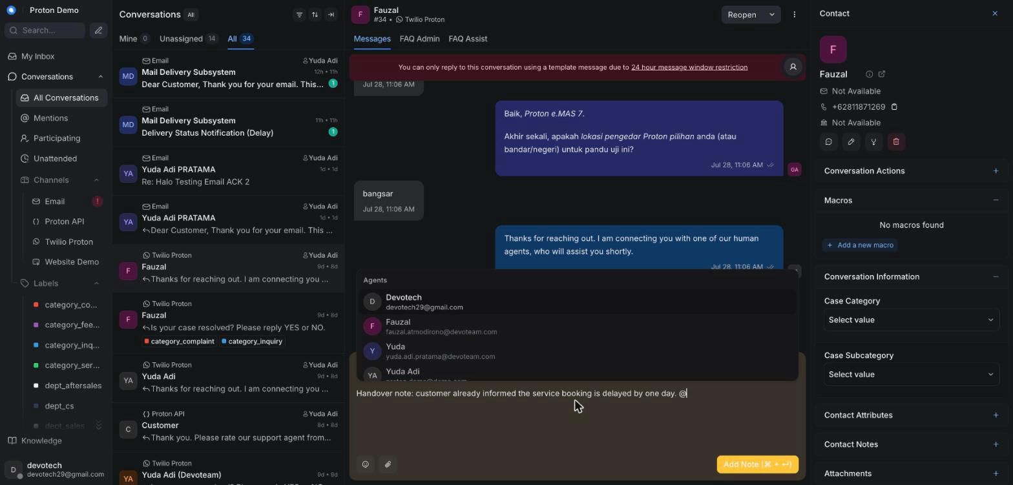
Mentioning a teammate in a private note

Example scenario
Unsure how to answer a question about an extended warranty case, an agent mentions their team lead in a private note to ask for guidance before replying to the customer.

Integrations & automation
Mentions only work inside private notes, so a mentioned teammate is notified without the customer ever seeing it.

Ask Copilot panel

What it is
A chat panel next to the conversation where an agent can ask an AI assistant questions about the customer or the topic at hand, and get answers grounded in the knowledge base. Each answer is followed by a "Looked at" line naming which knowledge tools it consulted, and — when sources are available — a "Sources" line with each source title, shown as a clickable link where one exists or as plain text otherwise.

Where to find it
Opened from a Copilot button above the reply box, on the right side of the conversation.

How to use it
1. Open the conversation you need help with.
2. Click the Copilot button above the reply box.
3. Type your question in the panel's chat box and send it.
4. Read the answer, along with the "Looked at" line noting which knowledge tools (for example, a knowledge-base search) it used to answer, and the "Sources" line underneath when it has one — click a source to open it, or read its title if it isn't linked.
5. Click "Insert into reply" on any answer you'd like to drop straight into your draft.
6. Reset the panel to start a fresh question thread, or close it when you're done.
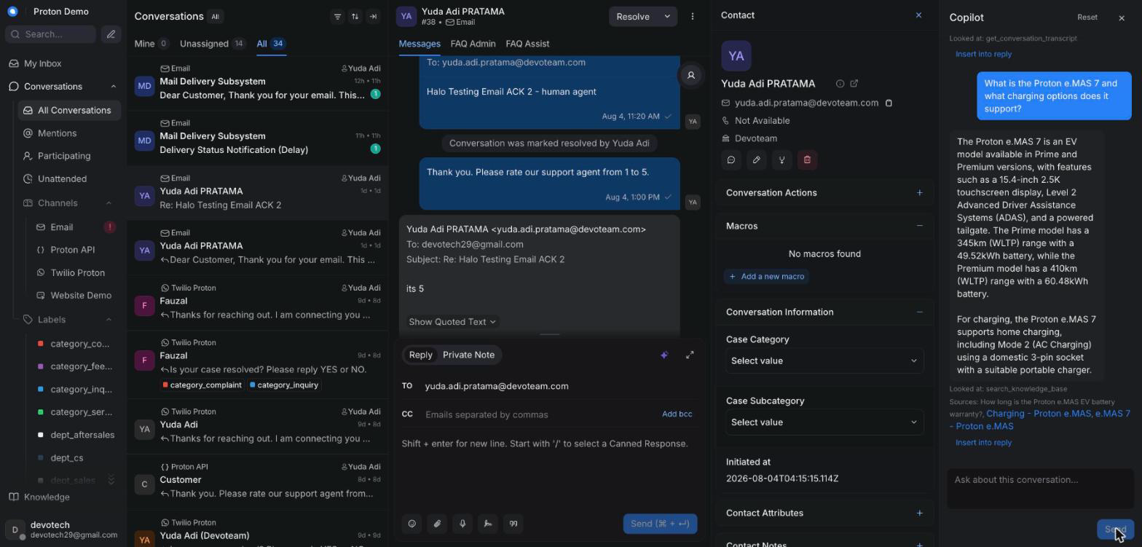
Asking the Copilot panel a question and seeing its "Looked at" line

Example scenario
While handling a report of a charging error code on an e.MAS 5, an agent asks Copilot what the error code means and how it's usually resolved, then inserts the grounded answer straight into their reply.

Integrations & automation
Copilot draws on the same knowledge base and per-inbox assistant configuration covered in the Knowledge chapter and the AI assistant behaviour chapter; it's a feature an administrator can turn on or off per tenant.

Translate

What it is
A one-click action that translates the customer's most recent message into English and posts the translation as a private note — useful the moment a customer writes in Malay, Tamil, Chinese, or any language you're not confident reading, without leaving the conversation to look it up.

Where to find it
A "Translate" button next to Copilot, above the reply box.

How to use it
1. Open the conversation with the message you want translated.
2. Click "Translate" above the reply box.
3. Wait a moment — the translation appears as a new private note on the conversation. It isn't inserted into your reply box, because it isn't meant to be sent to the customer as-is.
4. Read the note, which also names the language it detected the message was written in, then reply to the customer yourself in whichever language fits.

Example scenario
A customer writes an entire complaint in Bahasa Melayu about a delayed delivery; the agent clicks Translate, reads the English private note a moment later, and replies having understood the complaint precisely rather than guessing at it.

Integrations & automation
Translate only ever posts a private note — the same customer-safety rule every other AI-assist action in this chapter follows, so nothing it produces reaches the customer without an agent choosing to send it. It only translates into English; there's no option here to translate an outgoing reply into another language.

FAQ suggestion strip

What it is
A small, dismissible strip that can appear above the reply box showing the single best-matching FAQ answer for the customer's latest message, with an "Apply" button that drops the full answer straight into your reply.

Where to find it
Above the reply box, alongside the other composer actions. It only appears when the CRM has found a confident FAQ match for the latest customer message — it will not appear on every message.

How to use it
1. Watch for the strip after a new customer message arrives — it only shows up when a good match exists.
2. Read the suggested FAQ answer in the strip.
3. Click "Apply" to paste the full answer into your reply box, then edit and send it as normal.
4. Dismiss it if it doesn't fit the case. A dismissed suggestion for that particular message won't reopen, but a later customer message can still surface a fresh one.

Example scenario
A customer asks a common question about charging cable compatibility; the strip surfaces the matching FAQ answer immediately, the agent clicks Apply, adjusts the greeting, and sends — without leaving the conversation to search the Knowledge base by hand.

Integrations & automation
The strip draws on the same knowledge base as Ask Copilot and Suggest-a- reply (see the Knowledge chapter), but it only ever shows a suggestion when the match is confident — a weak or uncertain hit stays silent instead of handing you something that might be wrong.

Suggest-a-reply

What it is
A one-click AI-drafted reply for the conversation you're currently in, based on the conversation so far and the knowledge base, placed directly in the reply box for you to review before sending — with a "Sources" line showing what it was grounded in. It also looks at any photo, video, or voice note the customer has sent in the conversation, not just their typed words.

Where to find it
A "Suggest a reply" action above the reply box.

How to use it
1. Open the conversation.
2. Click "Suggest a reply" above the reply box.
3. Wait a moment for the draft to appear in the reply box. If the customer has sent a photo, video, or voice note, the draft takes that into account too — it can describe what's in a warning-light photo or a video without you having to ask the customer to explain it again.
4. Check the Sources line underneath the draft for the knowledge-base articles it drew on.
5. Edit the draft if needed, then send it like any other reply.
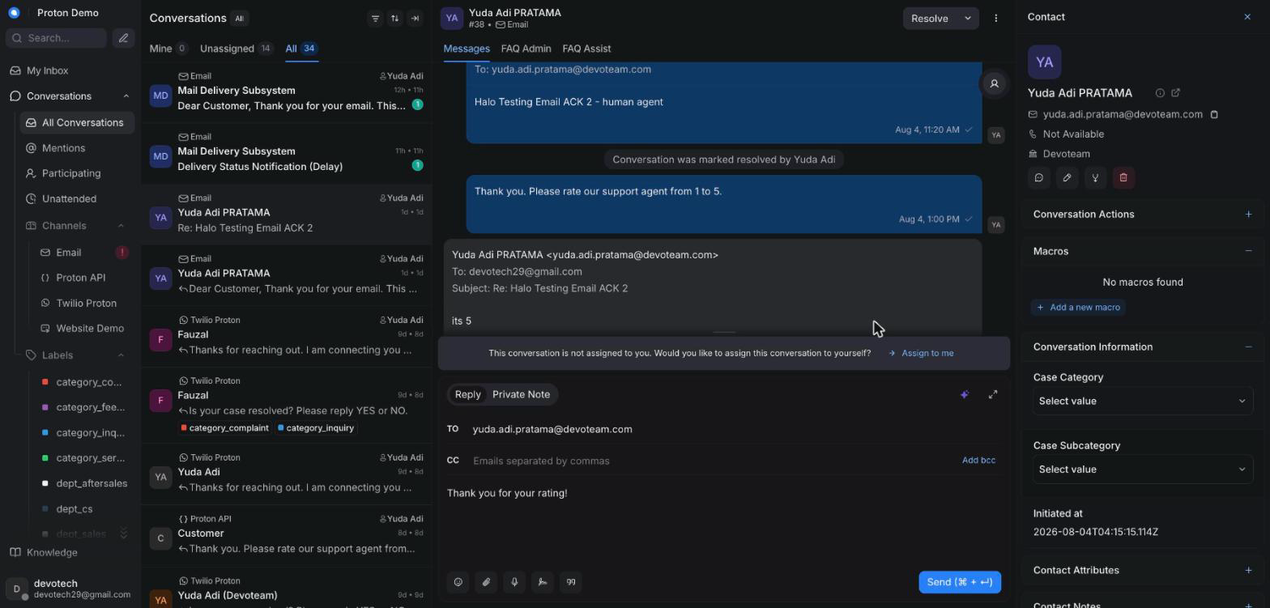
A suggested reply drafted in the reply box with its source citations

Example scenario
A customer asks about the cancellation policy for a service booking; the agent clicks Suggest a reply, receives a draft citing the relevant FAQ article, adjusts the tone slightly, and sends it. In a different case, a customer sends only a photo of a dashboard warning light with no explanation; Suggest a reply still produces a draft, because the icon in the photo — not just the customer's (absent) words — is what led the knowledge-base search this time.

Integrations & automation
Suggest-a-reply draws on the same knowledge base as Ask Copilot and the AI auto-draft behaviour described below; its source citations link back to content covered in the Knowledge chapter. When a conversation has media attached, what's in that media — not only the customer's typed words — leads the knowledge-base search, which is why it can still find the right source article on a photo-only or voice-note-only turn.

Summarize conversation

What it is
Generates a short summary of the conversation so far — useful for a quick catch-up or for handing a conversation off to another agent.

Where to find it
A "Summarize" action above the reply box.

How to use it
1. Open the conversation you want to summarize.
2. Click "Summarize" above the reply box.
3. Wait a moment for the summary to be generated.
4. The summary is inserted into the reply box as a draft, switched to private "Note" mode — it is not posted automatically, so review it and click send yourself to add it to the conversation.
5. Read it before handing the conversation to a teammate, or to refresh your own memory of a long-running case.
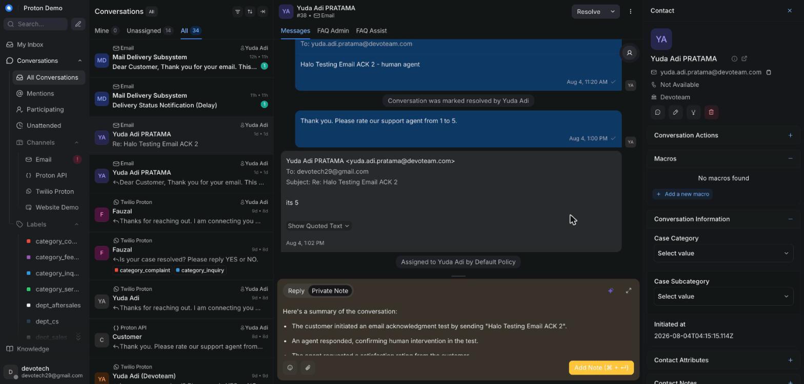
Generating a conversation summary for a quick catch-up or handover

Example scenario
Before going off shift, an agent summarizes a long-running roadside assistance conversation so the next agent can immediately see the vehicle's status and what's already been arranged.

Integrations & automation
The summary is written in English regardless of the conversation's original language, matching Proton's internal reporting standard.

AI auto-draft and suggest-vs-auto mode

What it is
The AI assistant can act on incoming customer messages on its own, without an agent asking it to. It always works in one of two modes, set per inbox by an administrator: auto mode — the tenant-wide default today, unless an inbox has its own override — where it sends its reply straight to the customer; or suggest mode, where it drafts a reply as a private note and reopens the conversation for a human to review and send.

Where to find it
Not something an agent turns on or off — it's configured per inbox by an administrator. Agents simply see its effects appear inside conversations.

How to use it
1. On most inboxes today, the AI's reply is sent to the customer directly — that's auto mode, the tenant-wide default — and the conversation stays in Pending while the AI keeps handling it. It only moves to Open once the AI hands off or an agent steps in.
2. On an inbox an administrator has switched to suggest mode instead, watch for a private note marked as a suggested reply on a conversation the AI has just handled.
3. Read that suggested draft, edit it if needed, then send it yourself as a normal reply. The AI never sends a suggest-mode draft for you.
4. If the AI can't confidently help, it hands the conversation off to a human on its own — reopening it and, if configured, posting a brief acknowledgement to the customer first.
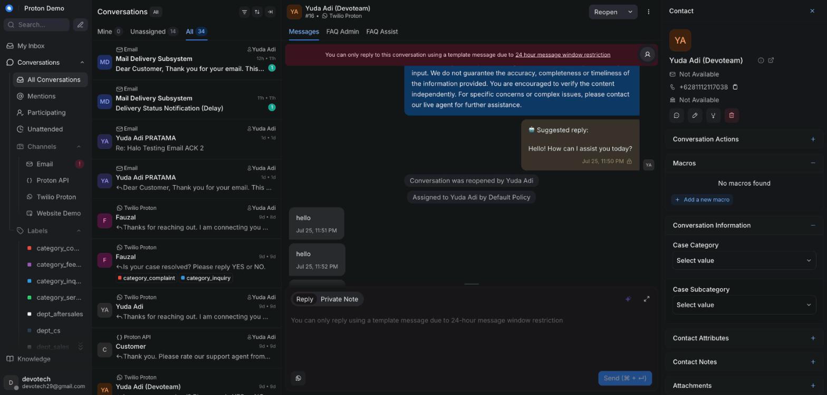
An AI-drafted reply posted as a private note awaiting agent review

Example scenario
On the tenant's default auto mode, a customer asks about the price of an e.MAS X service package on WhatsApp; the AI answers directly, and the conversation stays Pending until the AI hands off or an agent steps in. On an inbox an administrator has switched to suggest mode instead, the same kind of question produces a private-note draft that the on-duty agent reviews, adjusts, and sends as their own reply.

Integrations & automation
Suggest-vs-auto mode is a per-inbox setting administrators manage; when the AI can't answer, it hands off to a human automatically. See the AI assistant behaviour chapter for the full explanation of when it replies, escalates, or hands off.

Contact side panel

What it is
A panel next to the conversation showing the customer's details, past conversations, and notes, so you don't have to leave the conversation to see who you're talking to.

Where to find it
The right side of an open conversation. It now opens by default, rather than needing to be expanded manually each time.

How to use it
1. Open any conversation — the contact panel opens automatically.
2. Scroll through it to see contact details, conversation history, and any existing notes.
3. Collapse or expand it manually if you want more room for the conversation itself; your choice is remembered for next time.
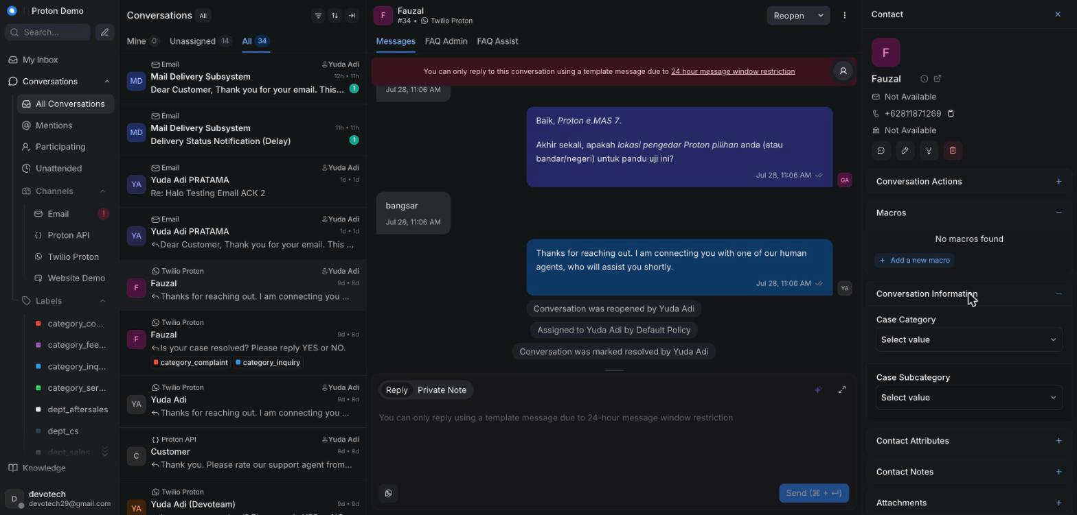
The contact side panel open next to a conversation

Example scenario
While chatting with a returning EV owner about a second service booking, an agent glances at the contact panel to confirm the vehicle model already on file instead of asking the customer to repeat it.

Integrations & automation
The contact panel is the entry point to the fuller contact profile and Customer 360 lookup tools covered in the Contacts chapter.

Resolving, snoozing & transcripts

What it is
The actions that close out a conversation (Resolved), pause it for later (Snoozed), or let you review and export its full message history (transcript).

Where to find it
Action buttons in the conversation header, and a menu option for exporting the transcript.

How to use it
1. Once the customer's issue is fully handled, click Resolve.
2. If you need to come back to a conversation later — for example, waiting on the customer or a dealer — click Snooze and choose when it should reopen.
3. A snoozed conversation reopens automatically at the chosen time, or immediately if the customer replies first.
4. To get a transcript of the conversation, open the conversation's menu and choose the transcript/export option.
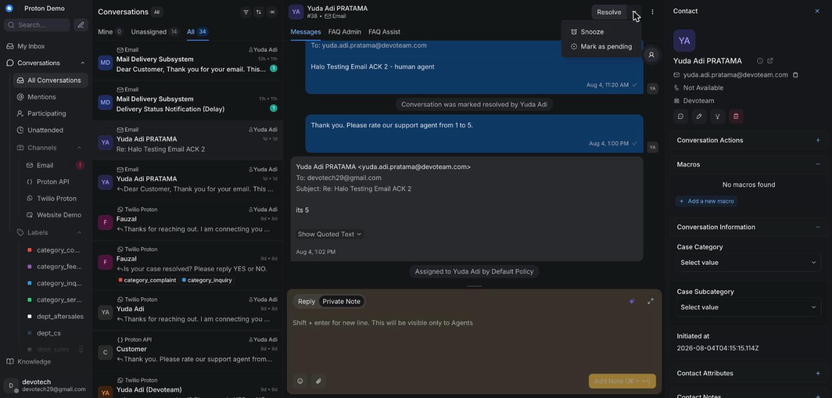
Resolving or snoozing a conversation

Example scenario
A test-drive scheduling conversation is snoozed for two days while the customer checks their calendar; it reopens automatically when they reply, and once the drive is booked the agent marks it Resolved.

Integrations & automation
Conversations can also close automatically due to inactivity timers an administrator sets per inbox — an idle warning is posted first, then an automatic close after a grace period (see the Administration chapter). Resolving a conversation on any of the four live inboxes sends the customer a CSAT satisfaction-rating request — that's the CRM's own, native survey, and it's what the CSAT figures in the Reports chapter are built from. This is a separate mechanism from the AI assistant's own rating prompt (a "rate our AI assistant / support agent from 1 to 5" message the AI itself can send as part of its own resolve flow, covered in the AI assistant behaviour chapter) — that one is not currently switched on for this tenant, so an agent shouldn't expect to see it fire. The satisfaction request each customer actually receives on resolve is the native CSAT one, not that one.

Contacts

Contacts list & search

What it is
The Contacts area lists everyone who has ever messaged in — across WhatsApp, email, and phone/IVR — as a single directory of customers, separate from the Conversations view's per-channel threads.

Where to find it
Contacts in the main sidebar.

How to use it
1. Open Contacts from the sidebar to see the full customer list.
2. Use the search box to find a customer by name, phone number, or email address.
3. Use the available filters to narrow the list (for example, by the channel a customer last used).
4. Click a customer's row to open their contact profile.
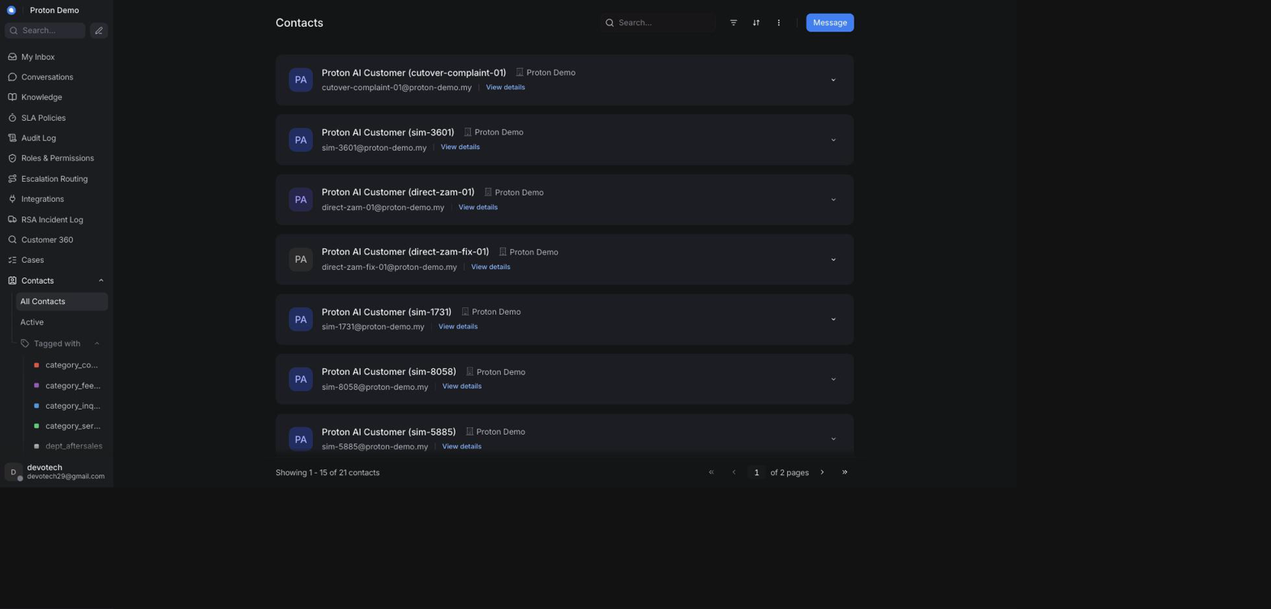
The contacts list with search and filters

Example scenario
An agent taking a phone call for a customer who has previously written in on WhatsApp searches Contacts by the customer's phone number to confirm they're speaking with an existing customer before opening a new conversation.

Integrations & automation
Every contact created through an inbound WhatsApp, email, or phone/IVR message is added here automatically by Chatwoot — there is no separate manual step to add a customer who has already messaged in.

Contact profile & history

What it is
A contact's profile is a single page showing everything the CRM knows about that customer: their basic details and custom attributes (for example, vehicle model), plus every conversation they've ever had across every channel.

Where to find it
Click any customer in the Contacts list, or open the contact side panel from an active conversation and click through to the full profile.

How to use it
1. Open a contact from the Contacts list or from an open conversation's contact panel.
2. Review their contact details and custom attributes at the top of the profile.
3. Scroll the conversation history to see every past conversation with this customer, regardless of channel or status.
4. Click any past conversation in the list to reopen and review it.
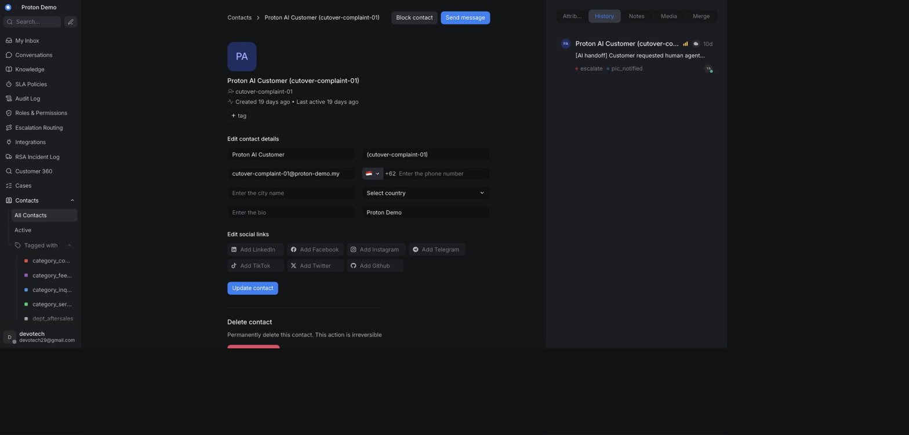
A contact's profile showing their conversation history

Example scenario
Before replying to a new service complaint, an agent opens the customer's profile and sees a previous conversation from three months ago about the same vehicle, giving useful context before responding.

Integrations & automation
Conversation history shown here is what the Customer 360 lookup (below) also draws on when it lists a customer's conversations, so the two views never disagree about which conversations belong to a customer.

Notes & segments

What it is
Notes let staff record customer-level context that isn't tied to a single conversation (for example, a standing delivery preference). Segments are saved contact filters — a named, reusable version of a Contacts search you'd otherwise have to rebuild every time.

Where to find it
Notes live on the contact's profile; segments are created from the Contacts list's filter/search bar and then appear as a saved view in the Contacts sidebar area.

How to use it
1. To add a note, open the contact's profile and use the notes area to record context about that customer.
2. To create a segment, open Contacts, build a filter (for example, by channel or a custom attribute), and save it with a name.
3. Reopen a saved segment at any time from the Contacts sidebar to reapply the same filter without rebuilding it.
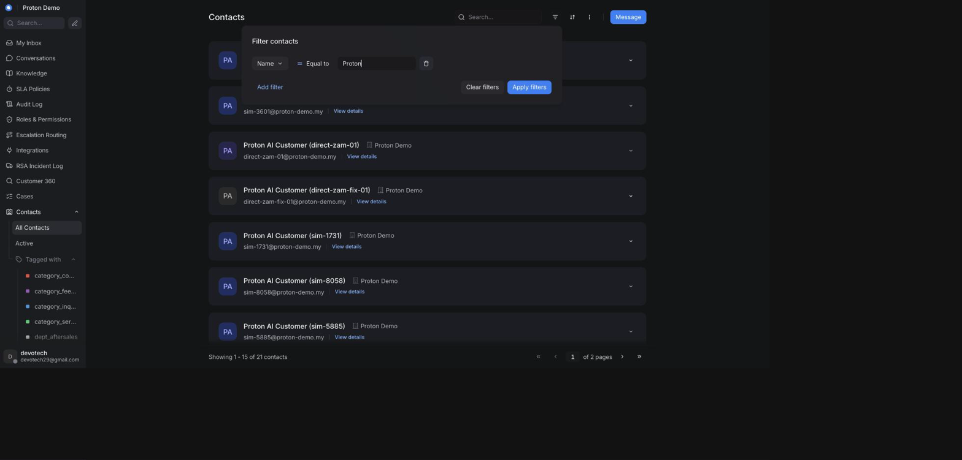
Creating or applying a contact segment

Example scenario
A dealer-relations coordinator saves a segment for customers tagged with a particular dealer's custom attribute, then reopens it weekly instead of re-entering the same filter each time.

Integrations & automation
Notes and segments are contact-level only — they don't feed the AI assistant's replies or any of the reports in the Reports chapter.

Customer 360

What it is
Customer 360 is a single search box that looks a customer up by phone number or vehicle number and brings together, on one page, what the CRM already knows about them: their matching contact record, every conversation they've had across channels, any roadside-assistance (RSA) incidents tied to their vehicle, and — where the DMS/TSP integration is configured (see the Administration chapter's Integrations section) — a vehicle and service-history block. It's read-only: nothing here can be created, edited, or deleted; contact details are still edited from the contact's own profile, and RSA incidents from the RSA Incident Log chapter's page.

Where to find it
Customer 360 in the main sidebar. This page is only visible to administrators who have also been granted the Customer 360 permission (see the Administration chapter's Roles & Permissions section) — an administrator without that permission won't see it in their sidebar.

How to use it
1. Open Customer 360 from the sidebar.
2. Enter a phone number or a vehicle number in the search box (at least two characters).
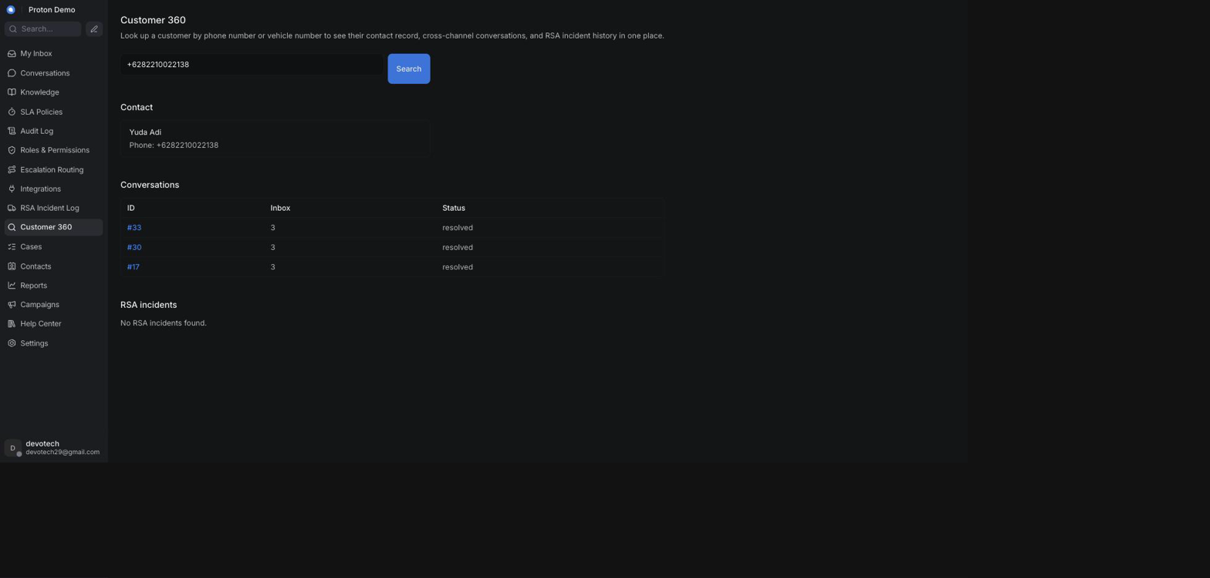
Searching Customer 360 by phone number or vehicle number

3. Click Search.
4. Review the Contact section for the matching customer's name, phone number, and email — searching by phone number looks for an exact match; searching by vehicle number instead matches any conversation whose noted vehicle model contains that value, so the conversations shown can differ slightly between the two search modes for the same customer.
5. Review the Conversations table — every conversation for the matched contact (or matching the vehicle), across any channel or status. Click a conversation's ID to open it.
6. Review the RSA incidents table — any roadside-assistance incidents whose vehicle number matches the search (see the RSA Incident Log chapter).
7. If a DMS / TSP section appears, review the customer's vehicles and service history from the connected dealer-management/telematics system; a "Not connected" notice means the integration couldn't be reached, and a "Mock data" notice means the results shown are demo data rather than a live system.
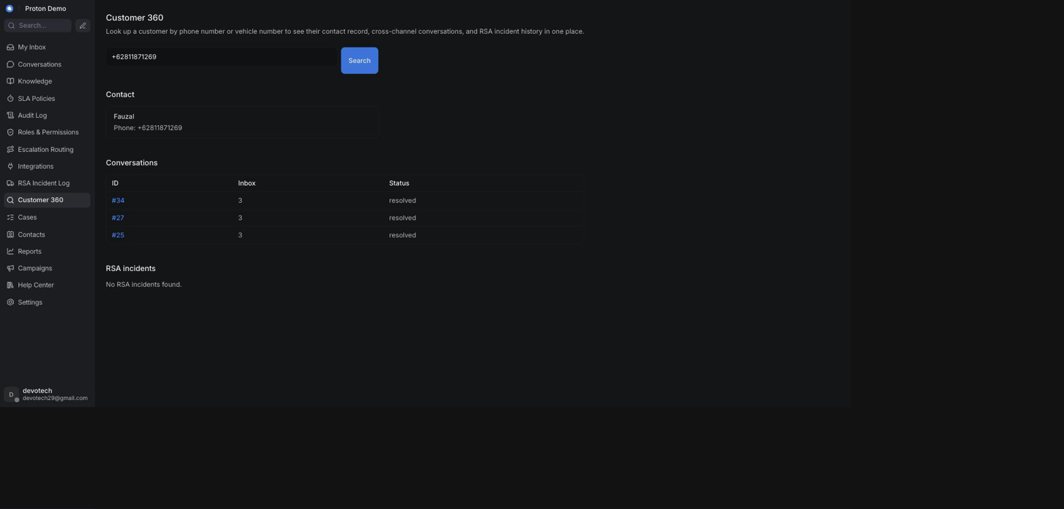
Customer 360 results showing vehicle and service history

Example scenario
A dealer calls asking whether a customer who bought a Proton e.MAS 7 has any open issues. The operator searches Customer 360 by the customer's phone number and sees, in one place, an open WhatsApp conversation about a charging fault, a closed RSA incident from the previous month for the same vehicle, and — since the dealership's DMS/TSP connection is configured — that vehicle's last two service visits, without switching between separate systems.

Integrations & automation
Customer 360 doesn't store anything of its own — it reads live from Chatwoot's contacts and conversations, from the RSA Incident Log (covered in the RSA Incident Log chapter), and, when enabled, from the DMS/TSP connection configured under the Administration chapter's Integrations section. If that connection isn't configured or isn't reachable, Customer 360 still works — it simply shows the CRM's own data without the vehicle/service-history block.

Knowledge
The Knowledge area is where administrators and agents manage everything that shapes how the AI assistant answers customers: the facts it can quote (FAQs, Documents), the personas it can speak as (Assistants), the playbooks and tools it can use (Scenarios, Tools), which inbox it is switched on for (Inboxes), and how it behaves (Settings). It sits in its own section of the left-hand navigation, separate from Conversations and Contacts, because it is configuration rather than day-to-day case work — most of it is used by administrators, though any agent with access can browse it to understand why the assistant answered the way it did.

FAQs

What it is
FAQs is the live, editable question-and-answer knowledge base the AI assistant is grounded on. Each entry pairs a customer question with the exact answer to give, plus optional keywords and tags to help matching. Unlike the Documents corpus (see the next section), FAQ entries are edited directly in the CRM and take effect immediately — there is no separate publishing step.

Where to find it
In the left-hand navigation, open Knowledge and select FAQs.

How to use it
1. Open Knowledge → FAQs. The page lists every entry with its question, answer, keywords, tags, and whether it is active.
2. To add an entry, click + New entry, fill in Question and Answer (both required), and optionally Keywords and Tags as comma-separated lists. Leave Active checked so the entry is usable for grounding, then save.
3. To change an entry, click Edit on its row, update the fields, and save.
4. To remove an entry, click Delete on its row and confirm.
5. Use the filter box at the top to search by question, keyword, or tag across all entries.
6. To add many entries at once, click Bulk upload (CSV), choose a .csv file, and wait for the confirmation message. It reports how many entries were created and, if any rows were skipped, which row numbers and why.
The CSV file must be UTF-8 text with a header row using exactly these column names:
Column | Required | Format | Notes
question | Yes | text | Row is skipped if empty.
answer | Yes | text | Row is skipped if empty.
keywords | No | multiple values separated by ; | Left blank for no keywords.
tags | No | multiple values separated by ; | Left blank for no tags.

Entries created through the bulk upload are always saved as active — if you need an imported entry to start out inactive, edit it afterwards and uncheck Active.
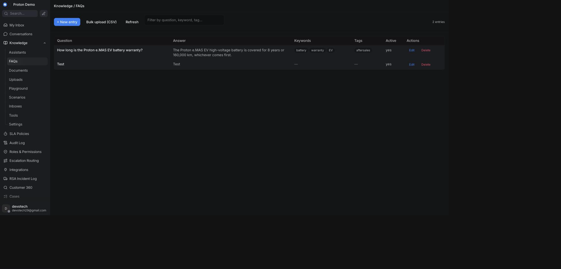
The FAQs list under Knowledge

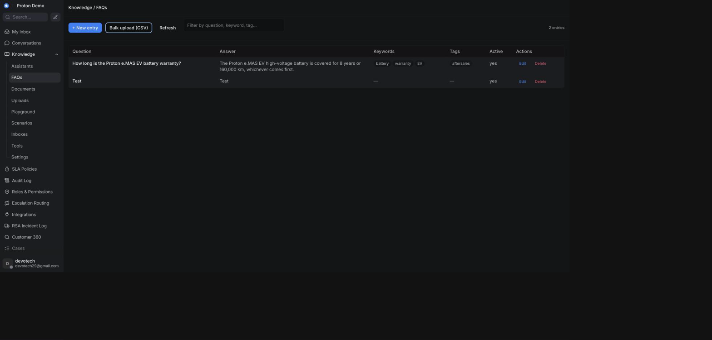
Bulk-uploading FAQs from a CSV file

Example scenario
Proton's service team compiles a spreadsheet of 40 frequently asked questions about the e.MAS 7 warranty ahead of a launch event. Instead of typing each one in by hand, the administrator exports the spreadsheet as a CSV with question/answer/keywords/tags columns and uses Bulk upload (CSV) to import all 40 entries in one go, then spot-checks a few of them in Playground before the launch.

Integrations & automation
FAQ entries are part of the knowledge base the assistant draws on for Suggest-a-reply, the Ask Copilot panel, and AI auto-drafted replies (see Conversations and AI Behaviour). They are also the primary source for the FAQ suggestion strip agents see above the reply box (see Conversations) — an edit made here is what an agent sees suggested on the next matching message, with no publishing delay. Toggling an entry's Active flag off removes it from grounding immediately, without deleting it.

Documents

What it is
Documents covers the larger, bulk knowledge corpus that also grounds the assistant's answers, alongside FAQs. It has two related views in the left-hand navigation:
• Documents — a read-only listing of everything indexed in the tenant's bulk search corpus (product manuals, policies, and similar material loaded outside the CRM), so administrators and agents can see what the assistant can quote from.
• Uploads — where operators add their own text or files directly from the CRM; these are queued for indexing and become searchable once processing finishes.

Where to find it
In the left-hand navigation, open Knowledge and select Documents for the read-only corpus listing, or Uploads to add new material.

How to use it

Browsing the indexed corpus (Documents)
1. Open Knowledge → Documents. Each row shows a document's title, a link to its source (if available), and a short snippet.
2. Use the filter box to search by title, link, or snippet.
3. Click Refresh to reload the list after new material has finished indexing elsewhere.
This view is read-only from the CRM — there is no upload, edit, or delete here; use Uploads instead to add operator-authored material.

Adding operator-authored material (Uploads)
1. Open Knowledge → Uploads.
2. To paste text directly, click + Add text, give it a Title, paste the content into Body, and submit.
3. To upload a file instead, click Upload file and choose a .pdf, .docx, .md, .txt, or .markdown file.
4. Watch the Status column: new documents start as pending while they are processed, then move to indexed once searchable, or failed if something went wrong (hover the badge for the reason).
5. To remove a document you added, click Delete on its row and confirm.
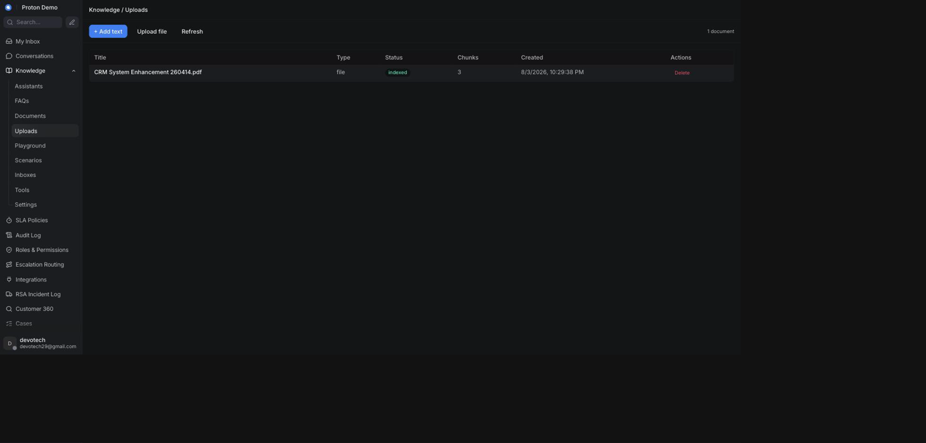
Uploading a document to the knowledge base

Example scenario
An administrator wants the assistant to be able to answer detailed questions about the Proton X50 owner's manual. Rather than writing FAQ entries for every possible question, they upload the manual as a PDF under Uploads and wait for it to reach indexed status, after which the assistant can draw on it directly.

Integrations & automation
Both the read-only corpus and the operator-authored uploads feed the same grounding the assistant uses for Suggest-a-reply, Ask Copilot, Playground answers, and — alongside FAQs — the FAQ suggestion strip (see Conversations). Uploads that finish indexing become available to every assistant persona automatically — there is no separate step to attach a document to a specific assistant.

Assistants

What it is
An Assistant is a named AI persona: its own name, description, and product context, with its own instructions, temperature, guardrails, and tool access, configured on the Settings and Tools pages. Most tenants only need one, and a Default Assistant always exists so nothing has to be configured before the AI works. Larger tenants can create additional assistants — for example, one per product line or department — and pick which one answers on which inbox (see Inboxes).

Where to find it
In the left-hand navigation, open Knowledge and select Assistants.

How to use it
1. Open Knowledge → Assistants to see every assistant, with a default badge on the one used when no other assistant is assigned.
2. To create one, click + New assistant, enter a Name (required), optional Description and Product name, and save.
3. To change one, click Edit on its row, update the fields, and save.
4. To remove one, click Delete on its row and confirm — the default assistant cannot be deleted; make another assistant the default first if you need to retire it.
5. Once an assistant exists, pick it from the Assistant selector shown at the top of the Scenarios, Playground, Tools, and Settings pages to configure or test that specific persona.
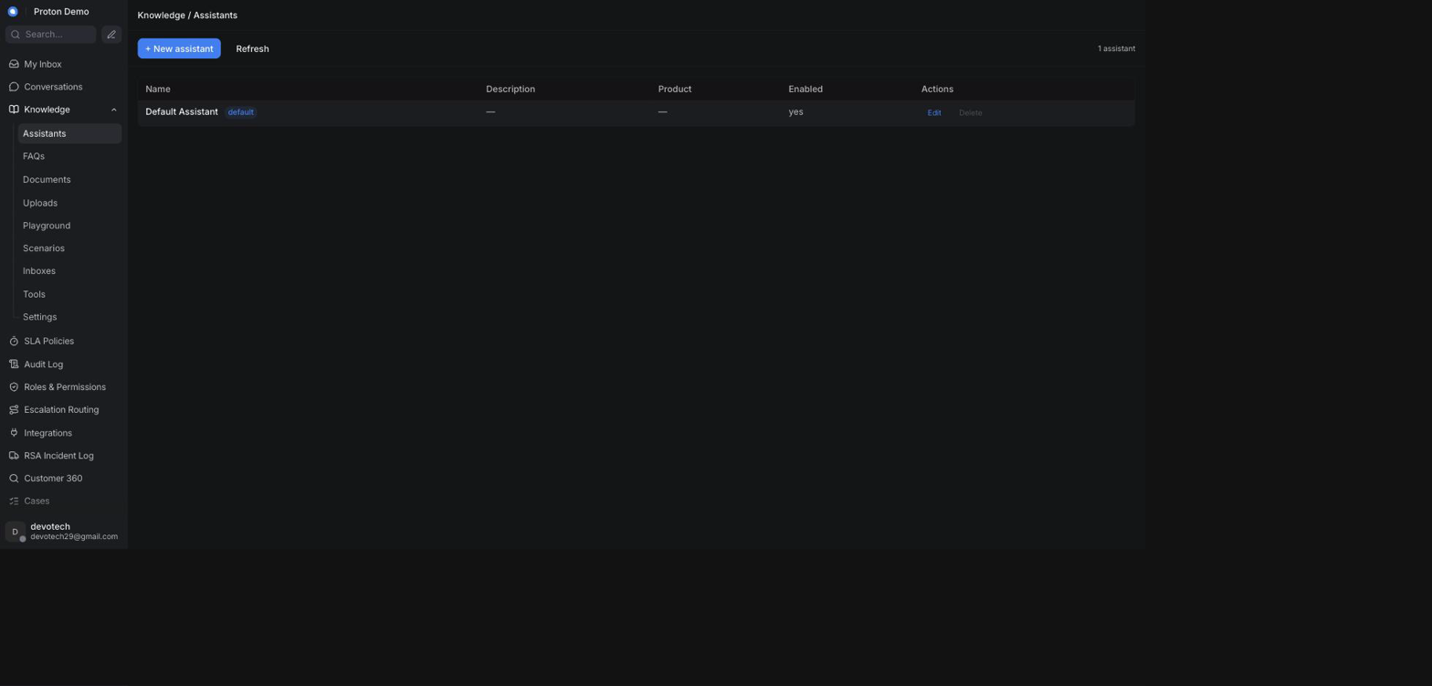
The Assistants list under Knowledge

Example scenario
Proton's dealership arm wants the same CRM tenant to answer both new-car sales questions and after-sales service questions with a different tone for each. An administrator creates a second assistant named "Proton Service Assistant" alongside the default sales-focused one, then assigns it to the after-sales WhatsApp inbox under Inboxes.

Integrations & automation
The assistant selected in the header of Scenarios, Playground, Tools, and Settings is shared across those pages during a session, so switching it in one place carries over to the others. Which assistant actually answers on a given conversation is controlled from Inboxes.

Scenarios

What it is
A Scenario is a named playbook — a block of instructions, scoped to one assistant, that gets added to that assistant's behaviour when the scenario is turned on. Use it to give the assistant extra guidance for a specific situation (for example, how to handle a recall notice or a warranty claim) without rewriting its whole persona. A scenario can also be tied to specific tools so the assistant knows which ones to reach for in that situation.

Where to find it
In the left-hand navigation, open Knowledge and select Scenarios.

How to use it
1. Open Knowledge → Scenarios and pick the assistant you want to manage scenarios for, using the Assistant selector at the top.
2. To create one, click + New scenario, enter a Title (required), an optional short Description, and the Instruction text the assistant should follow when this scenario applies.
3. Optionally tick which Tools the assistant should have available for this scenario, from the built-in and custom tools already registered under Tools.
4. Leave Enabled checked so the scenario is active, then save.
5. To turn a scenario on or off without editing it, use the toggle switch in its row.
6. To change or remove a scenario, click Edit or Delete on its row.
Each assistant can hold up to 20 scenarios, and the instruction text is capped at 4,096 characters — the page shows a character counter and will not let you save past the limit.
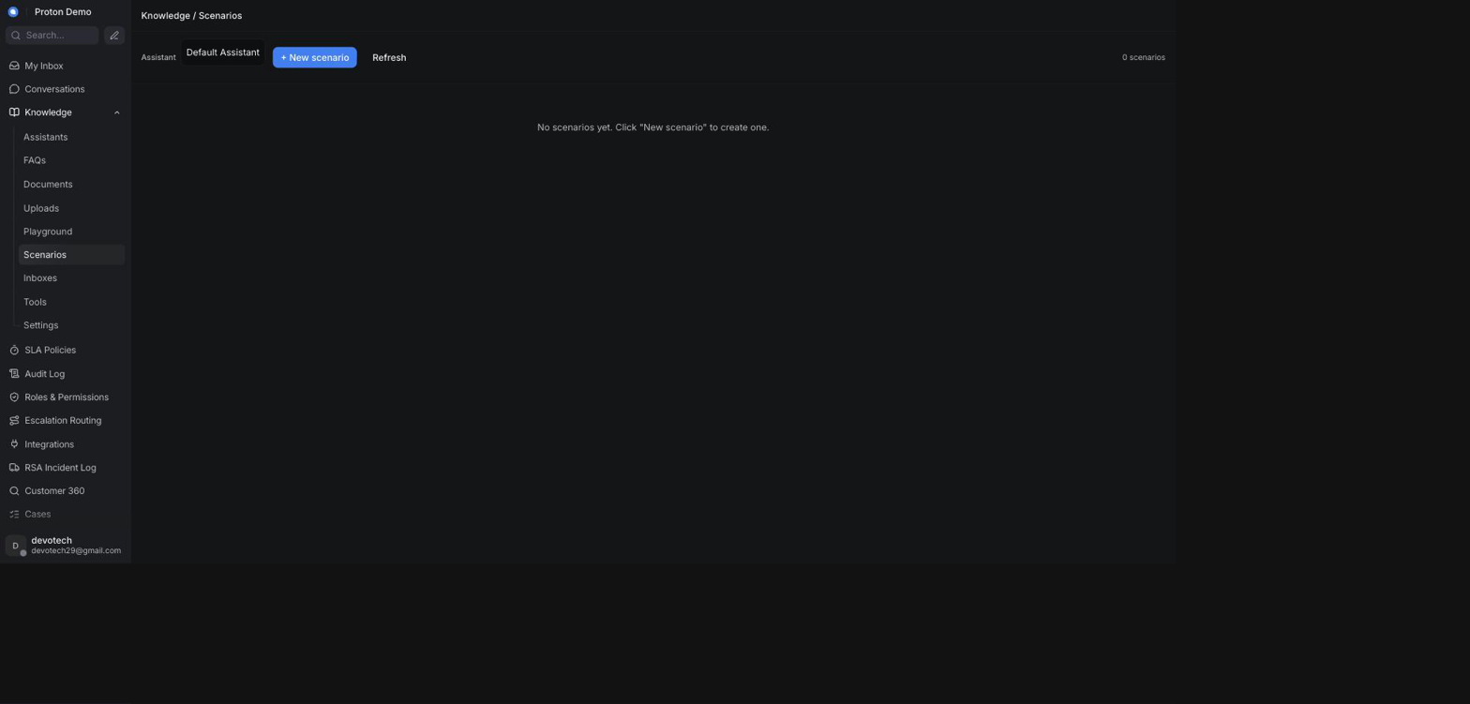
The Scenarios list under Knowledge

Example scenario
Proton issues a service campaign for a steering component on the X70. The administrator creates a "Steering component recall" scenario on the Service Assistant with instructions to ask for the vehicle number, check it against the recall list using the relevant tool, and direct affected customers to book a service appointment.

Integrations & automation
Enabled scenarios are folded into the assistant's behaviour wherever that assistant answers — in Playground testing and in real conversations alike. Disabling a scenario removes its instructions immediately without deleting it, so it can be re-enabled later.

Playground

What it is
Playground is a sandbox for trying out an assistant outside any real conversation. It behaves like the Ask Copilot panel in a conversation — you type a question, the assistant answers using its configured knowledge and tools, and the reply shows which tools it used and any sources it drew on — but nothing here reaches a customer.

Where to find it
In the left-hand navigation, open Knowledge and select Playground.

How to use it
1. Open Knowledge → Playground and pick the assistant to test with the Assistant selector at the top. Switching assistants starts a fresh conversation.
2. Type a question in the box at the bottom and press Enter (use Shift+Enter for a new line) or click Send.
3. Read the reply. If the assistant used a tool, a Looked at: line names it; if it cited sources, they appear as clickable links underneath.
4. Continue the back-and-forth as needed — each new message includes the full thread so far.
5. Click Reset to clear the conversation and start over.
6. Optionally expand Advanced to supply a real conversation ID, which lets you exercise tools that look up customer or ticket context as if you were inside that conversation.
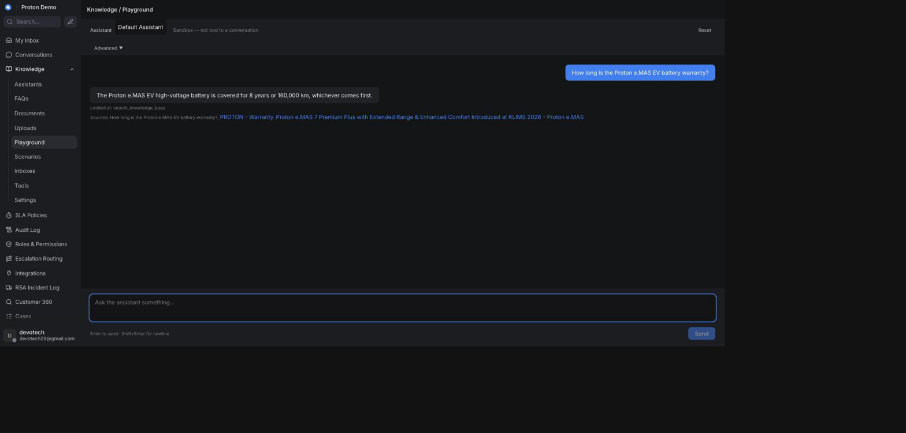
Testing a question in the Playground before it goes live

Example scenario
After bulk-importing new e.MAS 7 warranty FAQ entries, an administrator opens Playground, selects the Sales Assistant, and asks a few of the same questions a customer might ask (for example, "Berapa lama garansi baterai e.MAS 7?") to confirm the assistant answers correctly before customers start seeing it live.

Integrations & automation
Playground uses the same assistant configuration, knowledge base, and tools as real conversations, so a question that works in Playground will behave the same way when a customer asks it for real. Nothing typed in Playground is saved to a real conversation or visible to customers.

Tools

What it is
Tools are the actions an assistant is allowed to take beyond answering from text — looking things up or calling out to another system. There are two kinds:
• Built-in tools — capabilities that ship with the platform; you can only turn them on or off and adjust their description.
• Custom tools — webhook-based tools an administrator defines to call an external HTTPS endpoint (for example, a dealer's own booking or parts-lookup system).
Which of the registered tools an assistant may actually use is then set per-assistant, further down the same page.

Where to find it
In the left-hand navigation, open Knowledge and select Tools.

How to use it
1. Open Knowledge → Tools. The Built-in tools table lists every built-in tool with an editable description and an Enabled checkbox; click Save on a row after changing it.
2. To add a custom tool, click + New custom tool in the Custom tools section and fill in:
◦ Title and Description (shown to the assistant).
◦ Endpoint URL — must start with https://.
◦ HTTP method — GET or POST.
◦ Auth type — none, bearer token, basic (username/password), or an API key header; the corresponding secret fields appear once you pick one, and are never shown again after saving (leave them blank on an edit to keep the existing secret).
◦ Optionally a param_schema (a JSON description of the tool's inputs), a request template, and a response template.
◦ Enabled, so the tool is available to be assigned to an assistant.
3. Save. Custom tools are capped at 15 per tenant, shown as a count next to the section heading.
4. To change or remove a custom tool, click Edit or Delete on its row.
5. Scroll to Per-assistant enablement, pick an assistant with the Assistant selector, tick which built-in and custom tools that assistant may call, and click Save enablement.
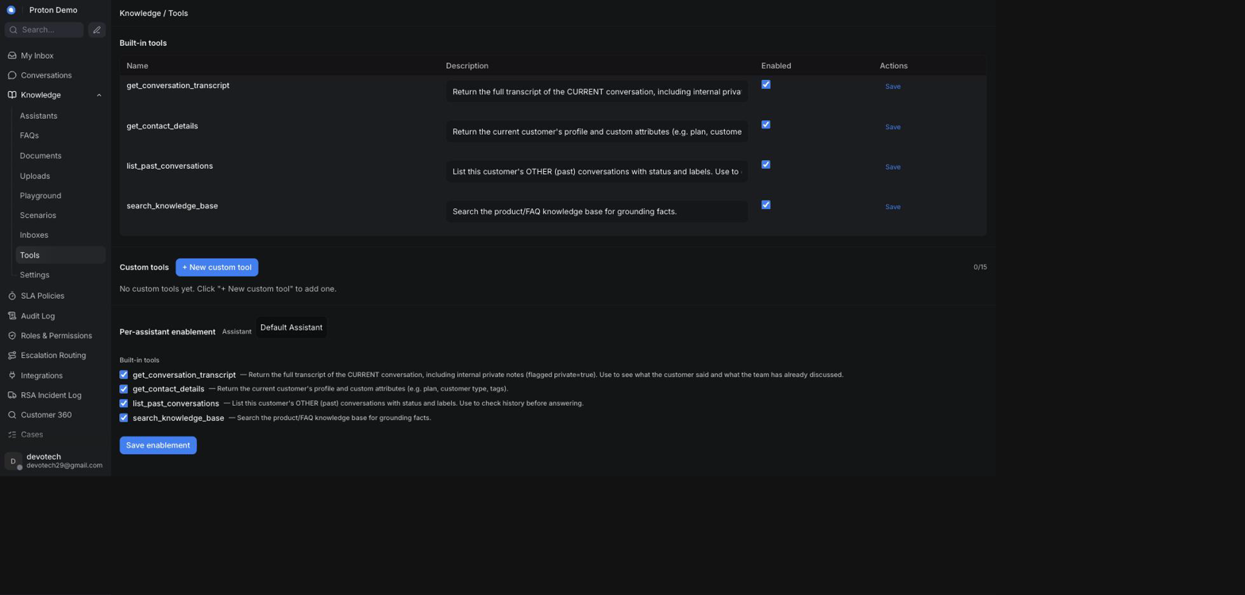
The Tools list under Knowledge

Example scenario
A dealer network wants its WhatsApp assistant to check real-time service-bay availability instead of just telling customers to call in. An administrator registers a custom tool pointing at the dealer's booking system endpoint, enables it for the after-sales assistant under Per-assistant enablement, and references it from a "Book a service" scenario.

Integrations & automation
Tools enabled for an assistant are available to it everywhere it answers — Playground, Ask Copilot, and live conversations — and can be scoped further by attaching them to specific Scenarios.

Inboxes (assignment)

What it is
The Inboxes page controls which assistant answers for each Chatwoot inbox, and in what mode. Every inbox that is not explicitly assigned here falls back to the tenant's default assistant and default mode, shown with a default badge; an inbox with its own assignment shows an override badge instead.

Where to find it
In the left-hand navigation, open Knowledge and select Inboxes.

How to use it
1. Open Knowledge → Inboxes to see every Chatwoot inbox with its channel type, currently assigned assistant, mode, and source badge.
2. To assign an assistant to an inbox, use the Assistant dropdown on its row and pick one — choosing — default — clears the override and goes back to inheriting the tenant default.
3. To change how the assistant behaves on that inbox, use the Mode dropdown: Off (the assistant does not answer on this inbox), Suggest (it drafts privately for a human to review and send), or Auto (it can reply directly).
4. Changes save automatically as soon as you pick a new value — there is no separate save button, and the row's badge switches to override once you have set anything explicitly.
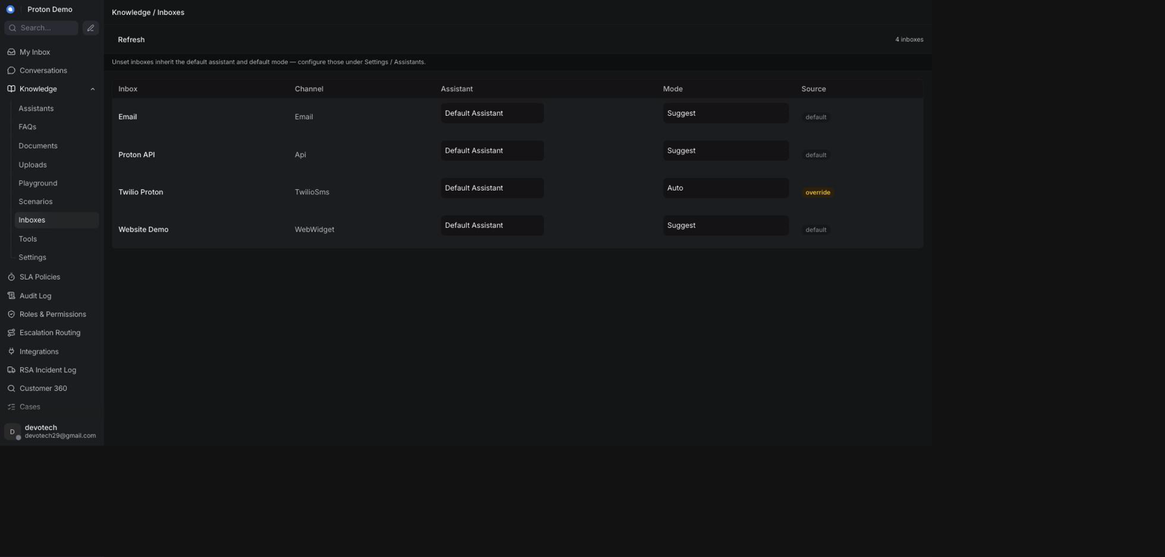
Assigning an assistant to an inbox

Example scenario
Proton adds a new WhatsApp inbox for e.MAS 7 pre-order enquiries and wants it handled by the sales-focused assistant in Auto mode, while the general support WhatsApp inbox stays on the default assistant in Suggest mode so agents can review replies first. The administrator opens Knowledge → Inboxes, finds the new inbox, sets its Assistant to the sales assistant and its Mode to Auto, and leaves the support inbox as-is.

Integrations & automation
The assistant and mode set here determine which persona and knowledge base answer a given inbox, including in the Ask Copilot panel (see Conversations) and in the AI's decision to reply, draft, or hand off (see AI Behaviour). This page only sets which assistant and which mode apply to an inbox — idle-timer minutes and per-inbox message wording are a separate set of controls on that inbox's own settings page under Administration → Inboxes (see the Administration chapter, and the Settings section below), not here.

Settings (persona, language, lifecycle messages, guardrails)

What it is
Settings is where an assistant's persona and tone are configured, along with a smaller set of tenant-wide operational knobs. It has two parts: an Assistant persona panel, scoped to whichever assistant is selected at the top, and a Tenant settings panel that applies across the whole workspace. Leaving any field empty keeps today's default behaviour — nothing here needs to be filled in for the assistant to keep working as it already does.

Where to find it
In the left-hand navigation, open Knowledge and select Settings.

How to use it
1. Open Knowledge → Settings and pick an assistant with the Assistant selector at the top to edit its persona.
2. Under Basic, set the assistant's Name, Description, Product name, and Language. The assistant always mirrors the language the customer actually writes in — this field never overrides that. It only acts as a tie-breaker preference for when the customer's language is unclear; leave it empty to let the assistant fall back to whatever language it judges best in that case, or set it (for example, to Bahasa Melayu) to tell it which language to prefer as that fallback.
3. Under System, write System instructions describing who the assistant is and how it should behave — this is the core of its persona. Adjust Temperature from precise (0) to creative (1); leaving it as-is keeps the current balance.
4. Under Guardrails, add short rules the assistant must never break (for example, "never quote a price that is not in the price list"). These are enforced on top of the system instructions.
5. Under Response guidelines, add style and tone preferences (for example, "always reply in short paragraphs" or "always end with a follow-up question").
6. Under Messages, fill in the wording the assistant sends at key moments of a conversation: a Welcome message when it starts and a Handoff message when it hands off to a human agent — plus five more lifecycle messages: an Idle warning message (sent after a period of inactivity), an Idle close message (sent if the conversation is then closed for inactivity), a Resolution prompt message (asking whether the issue is resolved), and CSAT survey prompts split by who handled the chat — a Survey AI message and a Survey agent message — plus a Thanks message after a rating and an Assign agent message when a human is assigned. Leaving any of these blank keeps the platform's built-in default wording for that moment. A Resolution message field is also available on this page, but it is saved for future use only — nothing in the current build sends it to a customer.
Editing a message's wording here does not turn its lifecycle step on — each step is switched on or off tenant-wide, independently of what you type into these boxes. What is actually live on this tenant today: the idle warning, the automatic close, and the "is your case resolved?" prompt are on. The opening Welcome message is off — filling it in here currently does nothing. On the WhatsApp and Email inboxes, a customer starting a new conversation does still get an immediate acknowledgement, but it comes from Chatwoot's own native per-inbox greeting, not from this field — see the note below. On the other two inboxes, a new conversation opens straight into the assistant's answer, with no greeting from either mechanism. The Survey AI and Survey agent messages (and the Thanks message that follows a rating) are also off — resolving a case, by the bot or by hand, does not trigger this page's own rating request. Customers still receive a satisfaction-rating request when a conversation is resolved: that one comes from the CRM's own native CSAT survey, a separate mechanism enabled per inbox rather than per assistant (see the AI Behaviour chapter). Ask your administrator which of these steps are switched on before telling a customer any particular message will reach them.
A related set of overrides — per-inbox idle timers, an on/off switch for the idle-warning/auto-close step on that one inbox, and per-inbox wording for these same messages — lives outside Knowledge entirely, on each inbox's own settings page under Administration → Inboxes (see the Administration chapter). Where both are set, the inbox-level override wins over the assistant persona message set here.
The native greeting is a separate setting again, on that same inbox settings page. It is currently on for the WhatsApp and Email inboxes and off for the other two. It is not this Welcome message, it is not affected by anything on this Settings page, and it does not go through the assistant at all — it is Chatwoot's own inbox-level acknowledgement. If you need to change the wording a WhatsApp or Email customer sees the moment they start a conversation, edit the greeting on that inbox's own settings page; editing the Welcome message here will have no effect on it. 7. Under Features, toggle whether this assistant uses knowledge-base/FAQ grounding, conversation memory context, source citations in its answers, and contact-attribute context. 8. Click Save assistant to apply the persona changes. 9. Below the persona panel, Tenant settings lets an administrator override a fixed set of workspace-wide values, each shown with whether it is currently on the platform's default (env) or has been overridden (override), and a Reset to return it to default individually: - Assist Gemini model — which model Suggest-a-reply uses. - Copilot Gemini model — which model the Ask Copilot panel uses. - Copilot max tool iterations — how many tool calls Copilot may make while answering a single question. - AI assist enabled, Copilot enabled, AI drafts enabled — tenant-wide toggles for Suggest-a-reply, the Ask Copilot panel, and AI auto-drafted replies respectively. - Default mode — the fallback Suggest/Auto mode used for any inbox that does not have its own explicit mode set under Inboxes. - Debounce seconds — how long the AI waits after a customer's message before answering, so a quick burst of messages is answered once instead of many times. - Inbound auto-acknowledgement template — the message sent the first time a new email thread arrives, when the inbound auto-acknowledgement is turned on for the tenant. - Escalation acknowledgement template — the message sent to the customer as part of the two-thread escalation email (see the AI Assistant Behaviour chapter's Escalation labels & the escalation email section).
Leaving either template blank keeps the platform's built-in default wording, exactly like the other fields on this panel. Editing one only changes the wording it sends — it doesn't turn the underlying feature on if it's currently off for your tenant.
Click Save settings to apply changes.
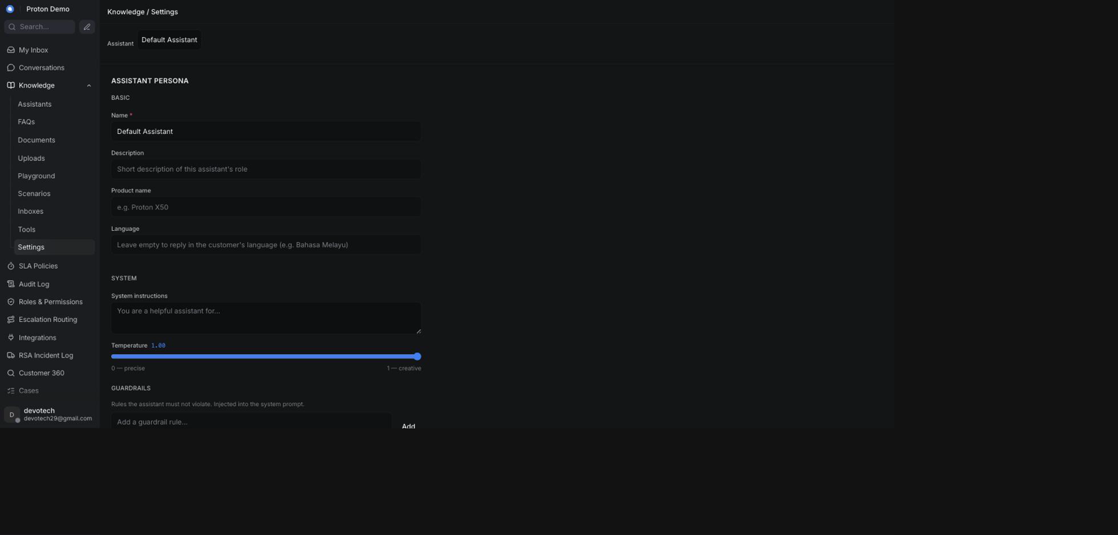
The assistant Settings page: persona, language, and lifecycle messages

Example scenario
Proton's brand team feels the sales assistant sounds too formal for WhatsApp. An administrator opens Knowledge → Settings, selects the Sales Assistant, adds a response guideline of "use a warm, casual tone and keep replies under three sentences," adds a guardrail of "never promise a delivery date," and saves — the next Playground test immediately reflects the new tone.

Integrations & automation
The persona, guardrails, response guidelines, and lifecycle messages configured here feed the assistant everywhere it operates: Playground testing, the Ask Copilot panel, Suggest-a-reply, AI auto-drafted replies, and the lifecycle messages sent during a conversation (see Conversations and AI Behaviour). An empty field anywhere on this page means the platform's built-in default is used instead — nothing has to be filled in for the assistant to work.

Cases

Case list

What it is
The Cases list is a single filterable table that shows every conversation as a "case" — Division, Concern, Purchased From, Escalated To, Agent, Car Plate, Aging (in days), and Status — so a supervisor can scan the whole book of work without opening conversations one at a time. It doesn't add a separate case record: it reads the same conversations shown in the Conversations chapter and displays their category, contact, assignment, and status information as table columns. Conversations that predate this vocabulary, or were never categorized, simply show a dash in the columns that don't apply — an unassigned case shows a dash in the Agent column the same way.

Where to find it
Cases in the main sidebar. This page requires the same permission as Customer 360 (see the Contacts chapter) — an administrator who hasn't been granted that permission won't see it.

How to use it
1. Open Cases from the sidebar.
2. Use the Division, Case type, Status, Channel, and Dealer filters at the top to narrow the list, or use Reset filters to clear them.
3. Read the table: Case ID, Division, Concern, Purchased From, Escalated To, Agent, Car Plate, Aging (days), and Status. Agent shows the name of whoever the underlying conversation is assigned to, or a dash if it's unassigned.
4. Click a Case ID to open the underlying conversation.
5. If a banner appears saying the list is showing only the first N of a larger total, the list has reached its display limit — the filters and totals shown no longer reflect every case in the account.
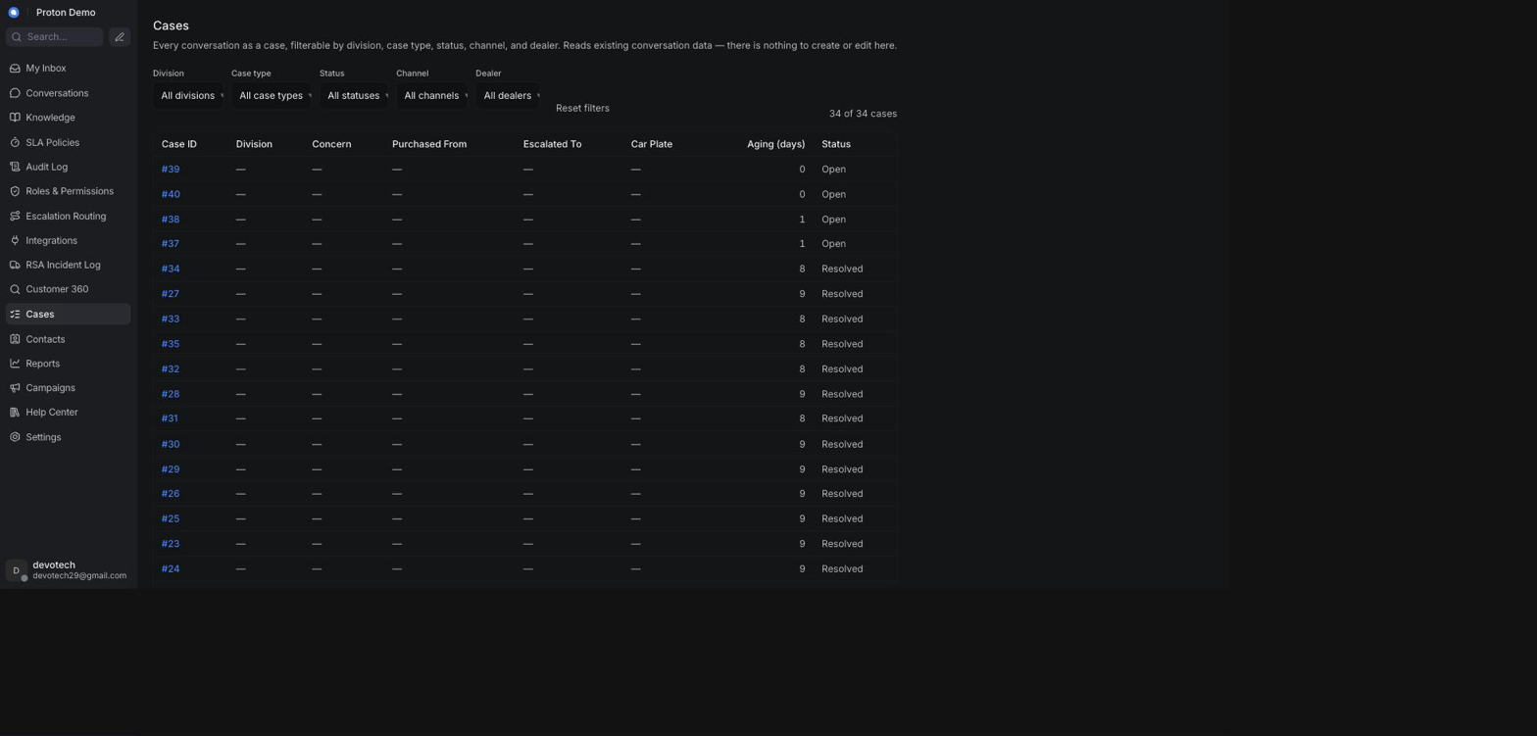
The Cases list page, including the Agent column

Example scenario
A supervisor filters the Cases list to the Aftersales division and the Complaint case type to see every open aftersales complaint across all dealers at a glance, then sorts by Aging to prioritize the oldest ones first — glancing at the Agent column to see, without opening a single conversation, which of the oldest cases don't have anyone assigned yet.

Integrations & automation
The Division, Concern, Case type, Channel, and Dealer values shown here come from the same conversation categorization covered in Case categories (below) — the AI assistant sets these automatically while handling a conversation (see the AI Assistant Behaviour chapter), and an agent can correct them the same way. Car Plate and Purchased From come from the customer's own contact record, and Agent simply mirrors the conversation's own assignee (see the Conversations chapter's Assignment & teams section). The Agent column is a Cases-list-only addition — it does not (yet) appear on the conversation card in the regular Conversations inbox view, so if you need to see who owns a case at a glance outside of Cases, open the conversation itself.

Case categorisation (five fields)

What it is
New since the last edition of this guide. Every conversation can now carry five separate case-categorisation fields, each a single-select dropdown in the conversation's custom attributes panel, matching the client's RFP taxonomy exactly (RFP 2026_028, Appendix A):
Field | What it is | RFP tier | Values | Example
Case Type | Inquiry, Complaint, or Compliment & Feedback | — | 3 | Compliment & Feedback
Case Category | Division | Division | 8 | Sales
Case Subcategory | Level 1 | Level 1 | 89 | Sales: Delivery
Case Detail | Level 2 (with Level 3/4 folded in) | Level 2–4 | 246 | Sales: Delivery: No Estimated Time Delivery
Vehicle Model | Which vehicle the case concerns | — | 4 | e.MAS 5

Only three of these five cascade together: Case Category → Case Subcategory → Case Detail. Picking a Case Category narrows the Case Subcategory list to only that division's Level 1 values; picking a Case Subcategory narrows Case Detail the same way one level further. Changing a value anywhere in that chain clears anything below it that no longer matches, the same "clears a stale child" behaviour the previous edition of this guide described for category/subcategory alone. Case Type and Vehicle Model are independent, ordinary dropdowns — they don't filter each other or the category chain, and picking one has no effect on any of the other four fields.
Case Subcategory and Case Detail values are prefixed with their full parent path, not just their own name, because the same Level 1 (or Level 2) name recurs under different divisions with different meanings — for example Refund exists under both Sales and Charging, and Booking under both Sales and Charging too. Without the prefix those would be indistinguishable in the dropdown. So Case Subcategory reads <Division>: <Level 1> (e.g. Sales: Delivery), and Case Detail reads <Division>: <Level 1>: <Level 2> (e.g. Sales: Delivery: No Estimated Time Delivery). Where the RFP source row also has a Level 3 and/or Level 4, those are folded into that same Case Detail value — never a sixth or seventh dropdown — appended with an em dash (—), in order: Sales: Refund: Booking — Status — Dealer Refund. Not every Level 1 has a Level 2 in the source RFP; where it doesn't, there's simply no Case Detail option for it and Case Subcategory alone is as specific as that case gets.
Case Detail is not set automatically. The AI assistant can classify Case Category, Case Subcategory, Case Type, and Vehicle Model on its own (see Integrations & automation, below) — but nobody has wired an automatic classifier for Case Detail, the most granular field. Expect to always pick it by hand.

Where to find it
The conversation's custom attributes panel, alongside the conversation (the same panel used for any other custom attribute). Case Type and Vehicle Model are new rows in that same panel — before this edition, neither had a custom-attribute definition at all, so those two dropdowns didn't render there yet.
Administrators also see a separate Case Taxonomy page in the sidebar, new since the last edition, for managing where Case Category, Case Subcategory, and Case Detail's option lists themselves come from — see Integrations & automation, below.

How to use it
1. Open the conversation you want to categorize, and open its custom attributes panel.
2. Choose a value for Case Type — Inquiry, Complaint, or Compliment & Feedback. This doesn't affect any other field.
3. Choose a value for Case Category (the division — for example Sales, Aftersales, Charging, Apps, Product, Network, Marketing, or Others).
4. Choose a value for Case Subcategory — only Level 1 values belonging to the division you just picked are offered, each shown with its <Division>: prefix.
5. Choose a value for Case Detail — only Level 2 (and folded Level 3/4) values belonging to the subcategory you just picked are offered, each shown with its full <Division>: <Level 1>: prefix. If the subcategory has no Level 2 in the source taxonomy, this list is empty and there's nothing further to pick — that's expected, not an error.
6. Choose a value for Vehicle Model if the case concerns a specific vehicle (e.MAS 5, e.MAS 7, e.MAS 7 PHEV) or Not Applicable otherwise. This also doesn't affect any other field.
7. Changing Case Category after Case Subcategory/Case Detail are already set clears both, since they no longer match the new division — reselect them from the narrowed lists. The same happens one level down if you only change Case Subcategory.
8. Save, or move on — most CRM attribute panels save automatically as soon as a value is picked.
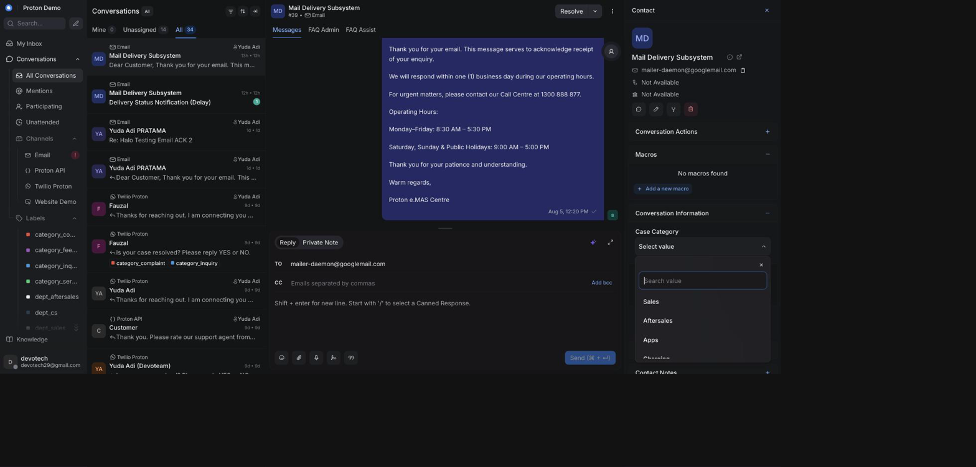
The Case Category / Case Subcategory / Case Detail cascade, narrowed by division and then by Level 1

Example scenario
A customer emails complaining that their new e.MAS 5's delivery has no estimated date. The agent sets Case Type to Complaint, Case Category to Sales, which narrows Case Subcategory to Sales' Level-1 list, where they pick Sales: Delivery; that narrows Case Detail to Delivery's Level-2 list, where they pick Sales: Delivery: No Estimated Time Delivery; and Vehicle Model to e.MAS 5. The case now shows up correctly filtered in the Cases list, and counts toward the Sales division in reporting at exactly the granularity the client's RFP Appendix A specifies.

Integrations & automation
New since the last edition of this guide: Case Category, Case Subcategory, and Case Detail's option lists are now administered from the dedicated Case Taxonomy page (see Where to find it, above), reachable only to administrators granted the case-taxonomy permission — not every administrator has it. There, an administrator builds a four-level tree — labelled Type, Division, Category, and Detail — entry by entry, giving each one a label and, optionally, the escalation department it belongs to. Saving a change updates the dropdown values agents see immediately, with no restart or redeploy. A value is never permanently deleted, only retired — a case created before a value was retired keeps showing it correctly, and retiring a value doesn't retire anything beneath it in the tree, so the page walks the administrator through re-homing or retiring those separately rather than leaving them invisible by accident.
The page's four tier labels don't map onto the conversation's dropdowns one-for-one — read this before adding anything. Add or edit a division at the tier labelled Type: that is what fills the conversation's Case Category dropdown (Sales, Aftersales, and so on), not the tier labelled Division. Division and Category together fill Case Subcategory — Category holds the value's own name, and its Division parent supplies the prefix automatically. Detail fills Case Detail directly. The conversation's own Case Type field (Inquiry / Complaint / Compliment & Feedback) is a different field, edited elsewhere (see below) — this page's Type tier does not touch it.
Because the Case Taxonomy page treats its own list as the complete, authoritative one and rewrites it in full every time an administrator saves or retires a node there, don't add or edit Case Category, Case Subcategory, or Case Detail values from the general Custom Attributes settings page anymore (see the Administration chapter) — a value added that way can be silently overwritten the next time anyone uses the Case Taxonomy page. Case Type and Vehicle Model aren't part of this taxonomy tree and have no dedicated admin page of their own; keep provisioning those two as flat option lists under Administration → Custom Attributes, same as before, sourced from RFP 2026_028 Appendix A.
Case Category, Case Subcategory, Case Type, and Vehicle Model are also set automatically by the AI assistant when it classifies an incoming or just-resolved conversation (see the AI Assistant Behaviour chapter) — an agent reviewing the case can always correct a misclassification here, the same as before. Case Detail is never set by the AI; it's always an agent's own pick. These five values feed the Cases list (above) and the Departments & PIC and Case Lifecycle reports (see the Reports chapter).

Case lifecycle & status

What it is
A case doesn't have a lifecycle of its own — its Status column simply shows the underlying conversation's status (for example Open, Pending, Snoozed, or Resolved). Resolving, reopening, or snoozing the conversation does the same thing to the case; there's no separate case state to keep in sync.

Where to find it
The Status column in the Cases list; the same status is also shown and changed on the conversation itself (see the Conversations chapter).

How to use it
1. In the Cases list, use the Status filter to see cases in a particular state (for example, only Open cases).
2. Open a case's conversation (click its Case ID) to change its status — resolve it, snooze it, or reopen it, exactly as covered in the Conversations chapter.
3. Return to the Cases list (or refresh it) to see the Status column reflect the change.
4. Watch the Aging (days) column alongside Status — it counts days since the conversation was created regardless of status, so a case can be both "old" and already resolved.
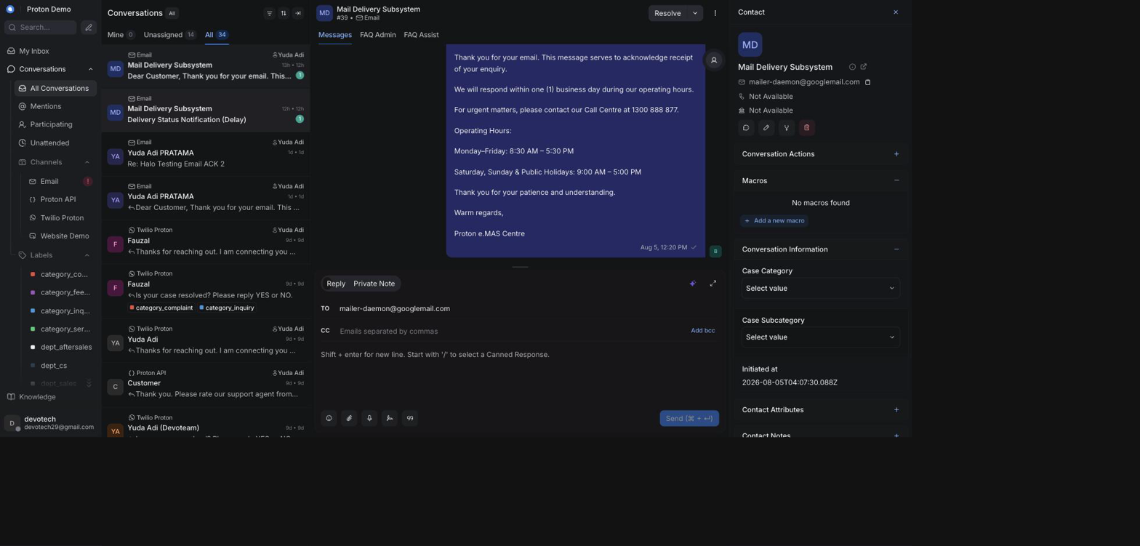
A case moving through its lifecycle statuses

Example scenario
A warranty complaint case sits with Status "Open" for several days while the dealer investigates. Once the dealer confirms the repair, the agent resolves the conversation from the conversation view; the next time anyone opens the Cases list, that same case now shows Status "Resolved".

Integrations & automation
Because a case's status is just its conversation's status, anything that changes conversation status elsewhere — an agent action, an automation rule, or the AI assistant resolving a conversation it handled — is reflected here automatically, with nothing to configure specifically for Cases.

How cases relate to conversations

What it is
There is no separate "case" record behind the scenes — every conversation is a case. The Cases list is simply a different view of the same conversations shown in the Conversations chapter, built from each conversation's category/subcategory, labels, status, and contact information.

Where to find it
Anywhere a conversation lives: the Conversations view, the conversation's custom attributes panel, and the contact's own record all feed what the Cases list displays.

How to use it
1. Treat categorizing a conversation (see Case categories, above) as the same action as categorizing its case — there's nothing extra to do.
2. Make sure the contact's vehicle number and dealer/purchase details are filled in on their profile (see the Contacts chapter), since the Cases list's Car Plate and Purchased From columns are read from there.
3. Once a conversation has these details, it appears correctly in the Cases list the next time the list loads — no separate publishing step.
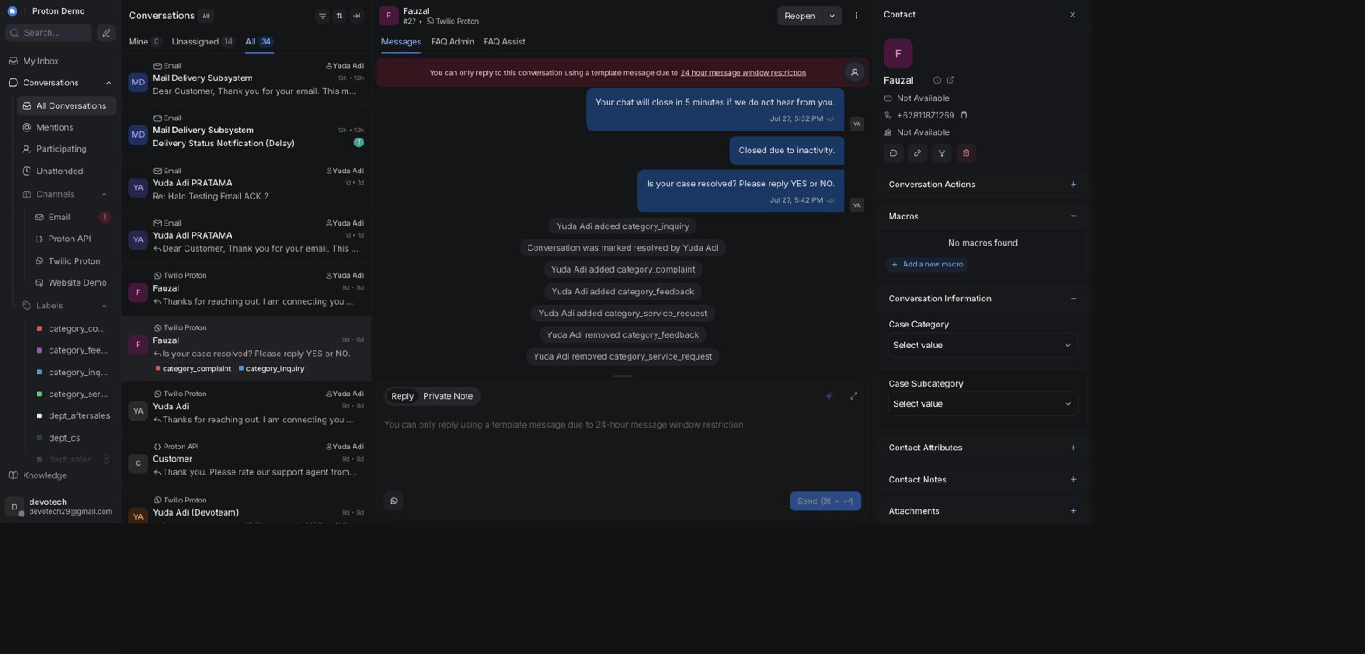
A case category set on a conversation

Example scenario
Several different customers each report the same software update problem in separate conversations, on separate days, through different channels. Because every agent categorizes their conversation under the same case category and subcategory, a supervisor filtering the Cases list by that category sees every affected customer's case together in one place, even though each one started as an unrelated conversation with a different contact.

Integrations & automation
Because a case is a conversation, everything that already applies to conversations — labels, escalation emails, AI auto-drafted replies (see the Conversations and AI Assistant Behaviour chapters) — applies to its case as well, with no separate synchronization step between the two.

Escalation status on a case

What it is
A case that's been escalated by email carries the same labels its underlying conversation does, so a supervisor scanning the Cases list can tell an escalation's state without opening it: whether it's simply been escalated (escalate), whether the dealer or PIC has since replied (escalation_replied), and which dealer it went to (the Escalated To column, and any dealer_<slug> label).

Where to find it
The Escalated To column in the Cases list, and the conversation's own labels once you open it — see the Conversations chapter's Labels and Escalation replies sections for the full mechanics.

How to use it
1. In the Cases list, look at Escalated To for cases that have already been forwarded somewhere.
2. Open a case whose escalation you want to check on. If the dealer or PIC has replied, the conversation carries the escalation_replied label and two private notes — the dealer's reply and an AI-drafted customer reply waiting for review (see the Conversations chapter's Escalation replies section for what those look like and how to act on them).
3. If a case shows escalate but no escalation_replied after a reasonable wait, that's your signal to follow up with the dealer/PIC directly rather than assume the CRM will surface a reply that hasn't arrived yet.
4. Use the Agent column (above) alongside this to see who's responsible for following up on a stalled escalation.

Escalation labels visible on rows in the Cases list

Example scenario
A supervisor reviewing the Cases list at the end of the week filters to cases carrying escalate and sorts by Aging, to spot any escalated case that's been open more than three days without an escalation_replied label — a sign worth chasing up with the dealer directly rather than waiting on the CRM.

Integrations & automation
This is the Cases-list view of the same escalation mechanics covered in the Conversations chapter (Labels, Escalation replies) and the AI Assistant Behaviour chapter (Escalation labels & the escalation email); nothing here needs separate configuration.

RSA Incident Log

Logging an RSA incident

What it is
The RSA Incident Log is a standalone page for recording roadside-assistance (RSA) incidents — breakdowns, accidents, and similar callouts — as they're reported. Each incident is its own record with the vehicle, the reported cause, and where and when it happened. It's manual data entry: logging an incident here doesn't dispatch a tow truck or notify anyone by itself.

Where to find it
RSA Incident Log in the main sidebar. In the current release this page shares its visibility with the SLA Policies page — an administrator needs the same permission that controls SLA Policies (see the Administration chapter) to see it.

How to use it
1. Open RSA Incident Log from the sidebar.
2. Review the Cases by cause and Cases by dealer summary at the top of the page for a running total of incidents logged so far.
3. Under Log an incident, fill in Incident date, Vehicle no., and Cause (all required).
4. Fill in whichever of the optional fields you already know: Vehicle model, Purchased from, Breakdown location, Arrived location, Customer called-in time, Towing assigned time, Time arrived breakdown area, Time arrived outlet, Total km, Late reason, and Remarks.
5. Click Log incident to save it. It appears in the incidents table below, and the cause/dealer summary at the top updates immediately.
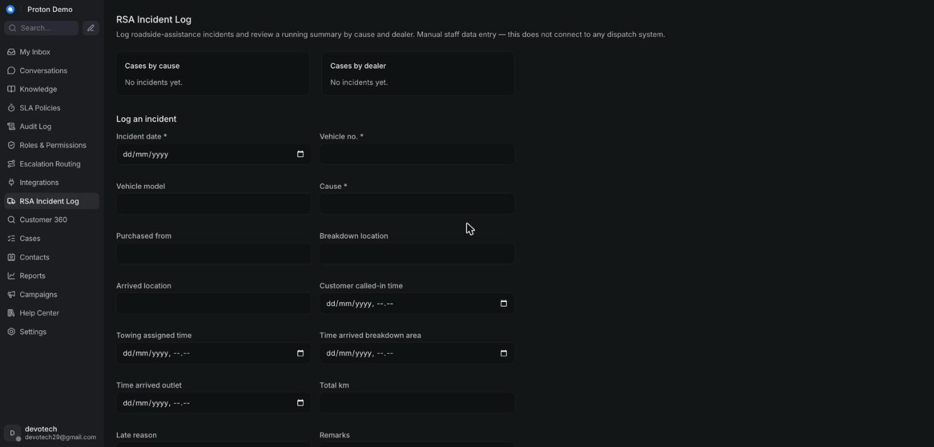
Creating a new RSA incident record

Example scenario
A customer calls the roadside-assistance line about a flat battery on the Jakarta–Cikampek toll road. Staff open the RSA Incident Log, log a new incident with today's date, the vehicle's plate number, cause "Flat battery / SOC 0%", and the breakdown location, leaving the still-unknown timing fields blank for now.

Integrations & automation
There's no dispatch-system integration behind this form — logging an incident is a record for tracking and reporting, not an automatic trigger to send a tow truck. What you log here is what later appears in Customer 360 and in reporting (see the sections below).

Incident statuses & updates

What it is
Rather than a single status label, an incident's progress is tracked through the timestamp fields captured when it was logged — when the customer called in, when towing was assigned, when the tow arrived at the breakdown location, and when the vehicle arrived at the outlet — plus free-text Late reason and Remarks fields for anything that needs explaining. As new information comes in, staff update the same incident record rather than creating a new one.

Where to find it
The incidents table at the bottom of the RSA Incident Log page; each row has Edit and Delete actions.

How to use it
1. Find the incident in the table and click Edit.
2. Fill in each stage's field as it happens — for example, Towing assigned time once a tow truck is dispatched, then Time arrived breakdown area and Time arrived outlet as the vehicle progresses.
3. Add Total km and a Late reason if relevant.
4. Click Save to update the record, or Cancel to discard the changes.
5. Use Delete to remove a record entered in error — this cannot be undone.
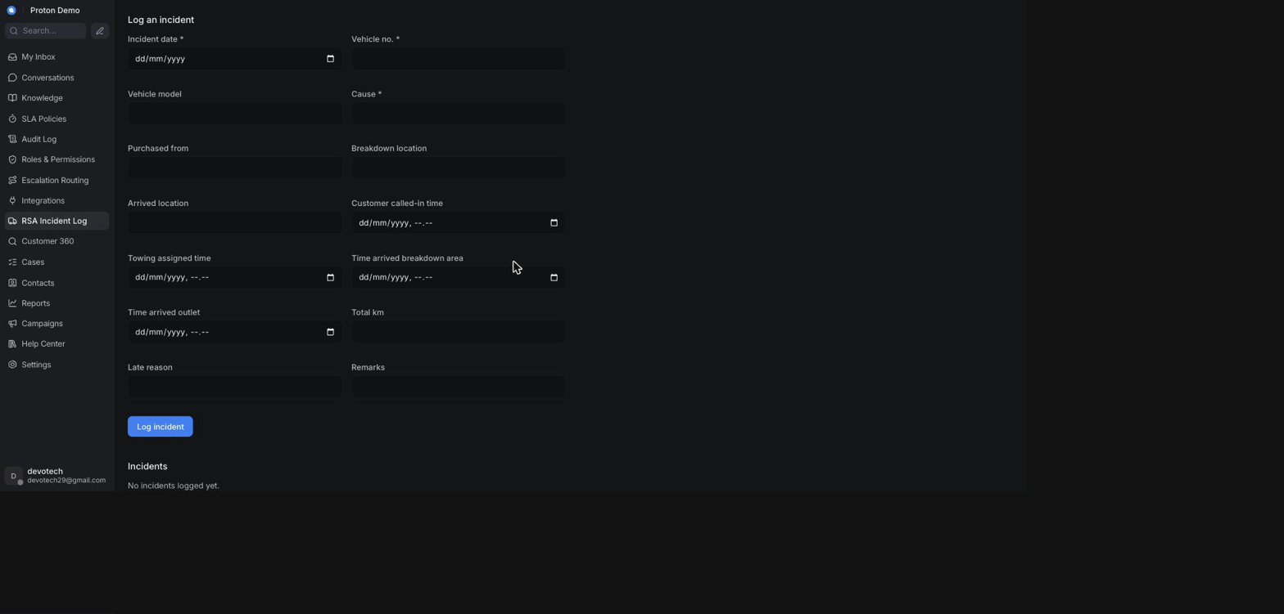
Updating the status of an RSA incident

Example scenario
After logging the initial callout, staff assign a tow truck and edit the incident to add the Towing assigned time. Once the vehicle reaches the dealer's service outlet, staff edit the same incident again to fill in Time arrived outlet and Total km, completing the record without creating a second one.

Integrations & automation
Every edit is reflected immediately in the Cases by cause and Cases by dealer summary at the top of this page, since that summary is calculated from the current incident records, not a separate log.

RSA in Customer 360 & reports

What it is
Incidents logged here surface in exactly two other places: an operator searching Customer 360 by a vehicle number sees any matching incidents alongside that customer's contact and conversations, and this page's own Cases by cause/Cases by dealer summary (above) totals the same incident records. RSA incidents are their own separate record, kept apart from conversation data — they are not part of what feeds the Reports chapter's Departments & PIC or Case Lifecycle reports, so an incident logged here will not show up on either of those report pages.

Where to find it
The RSA incidents table inside a Customer 360 lookup (see the Contacts chapter), and the Cases by cause/Cases by dealer summary on this page — see What it is, above, for why the Reports chapter's own report pages aren't a third place to look.

How to use it
1. Go to Customer 360 and search by the vehicle's number.
2. Review the RSA incidents table in the results — it lists the same fields as this page's incident table.
3. Alternatively, stay on the RSA Incident Log page and use the Cases by cause/Cases by dealer summary for a running total without doing a per-vehicle lookup.

An RSA incident surfaced in a Customer 360 lookup

Example scenario
A breakdown call comes in for a customer's vehicle; staff log the incident, arrange towing, and update the record as the vehicle reaches the dealer outlet. Weeks later, that same dealer calls asking about the customer's vehicle history; staff open Customer 360, search the vehicle's plate number, and the completed incident — with its full timeline — appears alongside the customer's conversations.

Integrations & automation
Customer 360's vehicle-number search matches against each incident's Vehicle no. field, so entering that field accurately when logging an incident (see Logging an RSA incident, above) determines whether it will be found later from Customer 360.

Reports

Standard reports (Overview, Conversation, CSAT, Agent, Label, Inbox, Bot)

What it is
Chatwoot's built-in reporting pages — Overview, Conversation, CSAT, Agent, Label, Inbox, and Bot — give numbers on conversation volume, response and resolution times, customer satisfaction, and per-agent, per-label, and per-inbox performance. On top of a few of these native pages, Proton adds its own extra section that pulls cross-channel numbers (every channel combined, not just one inbox at a time) from the CRM's reporting warehouse:
• The Agent report gets a Tasks per Agent (Proton) table — cases, average first response, average resolution, and resolved count per agent/PIC.
• The Bot report gets a Proton AI & Channel Analytics section — bot-resolved percentage, volume by channel, bot-vs-agent resolution split, response speed, fallback and bounce rate, quality, first-response and resolution time by channel, and peak hours.
• The CSAT report gets a Cross-Channel CSAT & NPS section — blended CSAT and NPS scores, CSAT by channel, NPS respondent split, and NPS by agent.
There's a second thing to know about every Proton-built section on this page, and about five of the standalone report pages later in this chapter (Anomaly, Departments & PIC, Case Lifecycle, Weekly Report, and the cross-channel sections on the SLA reports page, including Dealer Escalation Turnaround): they all read from one shared cross-channel reporting connection, separate from Chatwoot itself, and that connection has not yet been switched on for this account. Until it is, those sections show a fixed set of illustrative example numbers rather than Proton e.MAS's actual conversations — and today nothing on the page marks them as illustrative; the tables and charts render exactly as they will once the connection goes live. Chatwoot's own native numbers are unaffected and always reflect this account's real activity — conversation counts, native CSAT, the native SLA table, and any table that reads straight from Chatwoot conversations (the Weekly Report's Per-Case Detail, for instance). Treat any number inside a section labelled "Proton" on these pages as a preview of that report's layout, not as this account's real performance, until we confirm the connection is live.
Two of those tiles need reading precisely, because their labels promise more than the underlying data can say:
• The Bot report's "bot-resolved" percentage and "bot-vs-agent resolution split" do not measure AI versus human. The field they are built on is derived from the case's status alone, so the two numbers under those labels are, in fact, resolved and not yet resolved. The labels are left as they are because existing dashboards read them, but they must not be quoted as the AI's share of the work. No report on this platform currently answers the AI-versus-human question directly; ask us before quoting one that appears to.
• The NPS tiles are empty, and will stay empty. The end-of-conversation NPS survey is not running on this platform, so the question is never asked automatically — a score can only reach the tile if someone submits one through the API by hand. An empty NPS tile means the question was never asked, not that customers declined to answer.

Where to find it
Reports in the left sidebar. The Proton sections above appear at the bottom of their respective native report page — no extra navigation is needed to see them.

How to use it
1. Open Reports from the sidebar.
2. Pick the report tab you need (Overview, Conversation, CSAT, Agent, Label, Inbox, or Bot).
3. Set the date range and any filters the page offers (agent, inbox, label).
4. On the Agent, Bot, or CSAT report, scroll to the bottom to see the added Proton section — it loads independently of the filters above it.
5. Use the native download/export option, where the page offers one, to save the numbers for offline reporting.
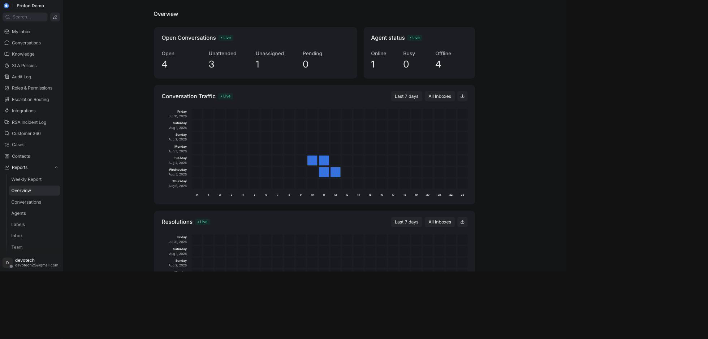
The standard reports overview page

Example scenario
Pak Andi, the Proton e.MAS operations lead, opens the Agent report every Monday morning to see which service advisors handled the most cases last week. He scrolls past the native chart to the Tasks per Agent (Proton) table, which stacks WhatsApp, email, and phone caseload for each PIC into one comparison instead of him checking each channel separately.

Integrations & automation
These pages read from Chatwoot conversation data and, for the Proton sections, from the CRM's reporting warehouse — see the note above about that connection's current status. Once it is live, a brief warehouse outage fails the extra sections quietly (an empty section, not a broken page) rather than surfacing an error.

Anomaly report

What it is
A page that flags channels whose recent conversation volume looks unusual — spiking or dropping well beyond that channel's own recent baseline — so an operator can catch a possible outage, campaign side-effect, or data problem early instead of noticing it days later in a monthly total.

Where to find it
Reports → Anomaly in the left sidebar.

How to use it
1. Open Reports → Anomaly.
2. Check the Flagged Channels count at the top — this is how many channels currently show anomalous volume.
3. Read the table below it: each row is a channel with its current volume, its normal baseline (mean and standard deviation), and a deviation score.
4. Treat a deviation badge in the yellow or red range as worth investigating — it means the channel's current volume sits well outside its usual pattern.
5. If a channel is flagged, cross-check the relevant Inbox report or ask the on-duty agents whether something changed (a broken integration, a marketing blast, a public holiday).
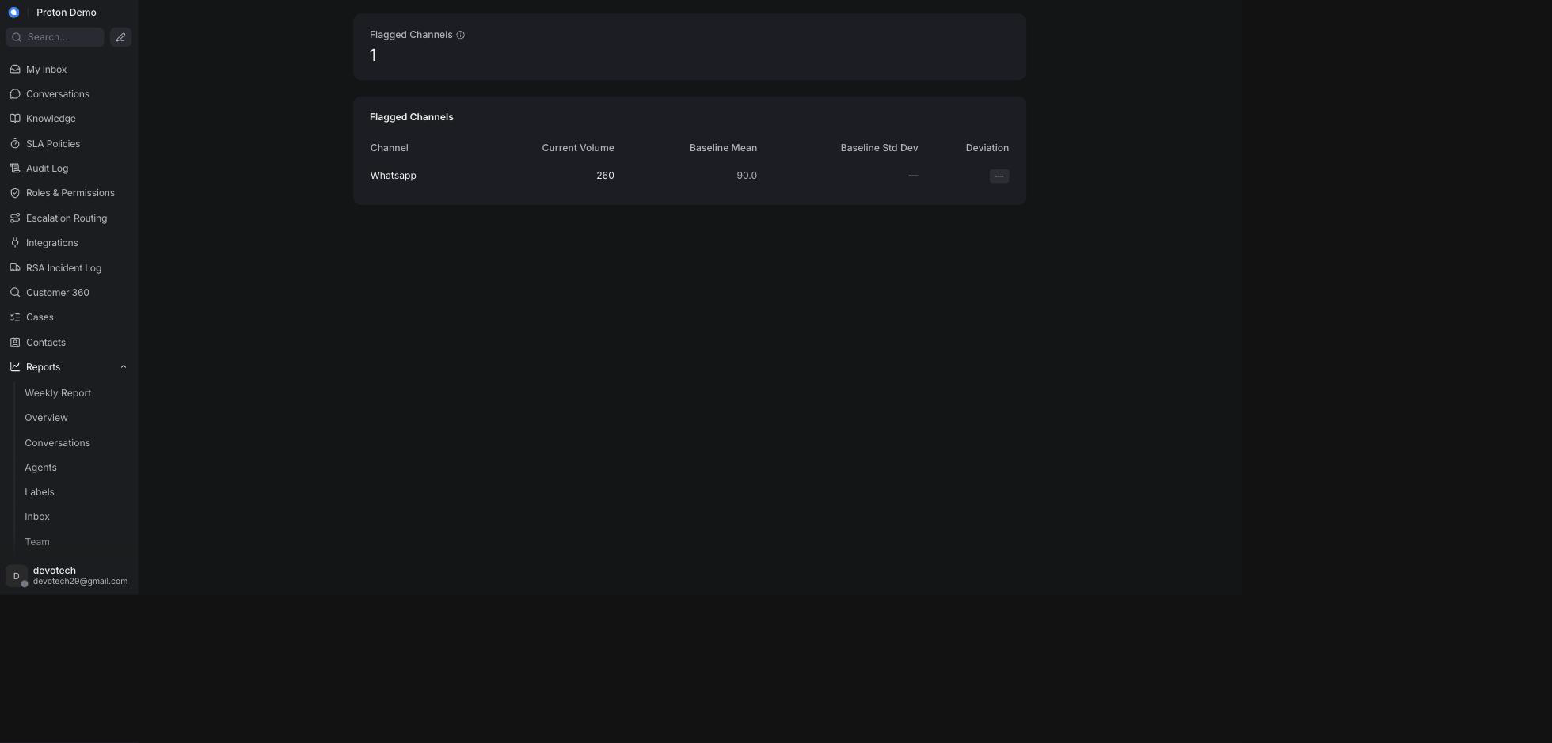
The Anomaly report page

Example scenario
On a Tuesday morning, Ibu Rina notices the WhatsApp channel flagged with a sharply higher deviation score. She finds that a service reminder blast went out overnight, driving an unusual spike in booking inquiries, and asks the on-shift team to add temporary coverage rather than assuming something is broken.

Integrations & automation
The Anomaly report is read-only reporting; it doesn't trigger any automated action on its own. It reads from the same reporting warehouse connection described under Standard reports — until that connection is switched on for this account, the channels and figures shown here are illustrative, not this account's real traffic. Once it's live, use the page as an early-warning signal alongside the standard Inbox and Overview reports.

Departments & PIC report

What it is
A page that breaks conversation volume and performance down by department and by the person-in-charge (PIC) handling each case, plus how often resolved cases get reopened, and how case categories line up against vehicle models.

Where to find it
Reports → Departments & PIC in the left sidebar.

How to use it
1. Open Reports → Departments & PIC.
2. Review the Department / PIC Performance table — cases, average first response, average resolution, and resolution rate per department/PIC pair.
3. Check Top Departments by Cases for a quick visual of where volume concentrates.
4. Review Reopen / Case Reopen Rate (CRR) to see which dealer/department/PIC combinations have the most cases reopened after resolution — a high reopen rate can point to a quality problem, not just a busy team.
5. Use Category × Vehicle Model to see which complaint or inquiry categories cluster around specific vehicle models.
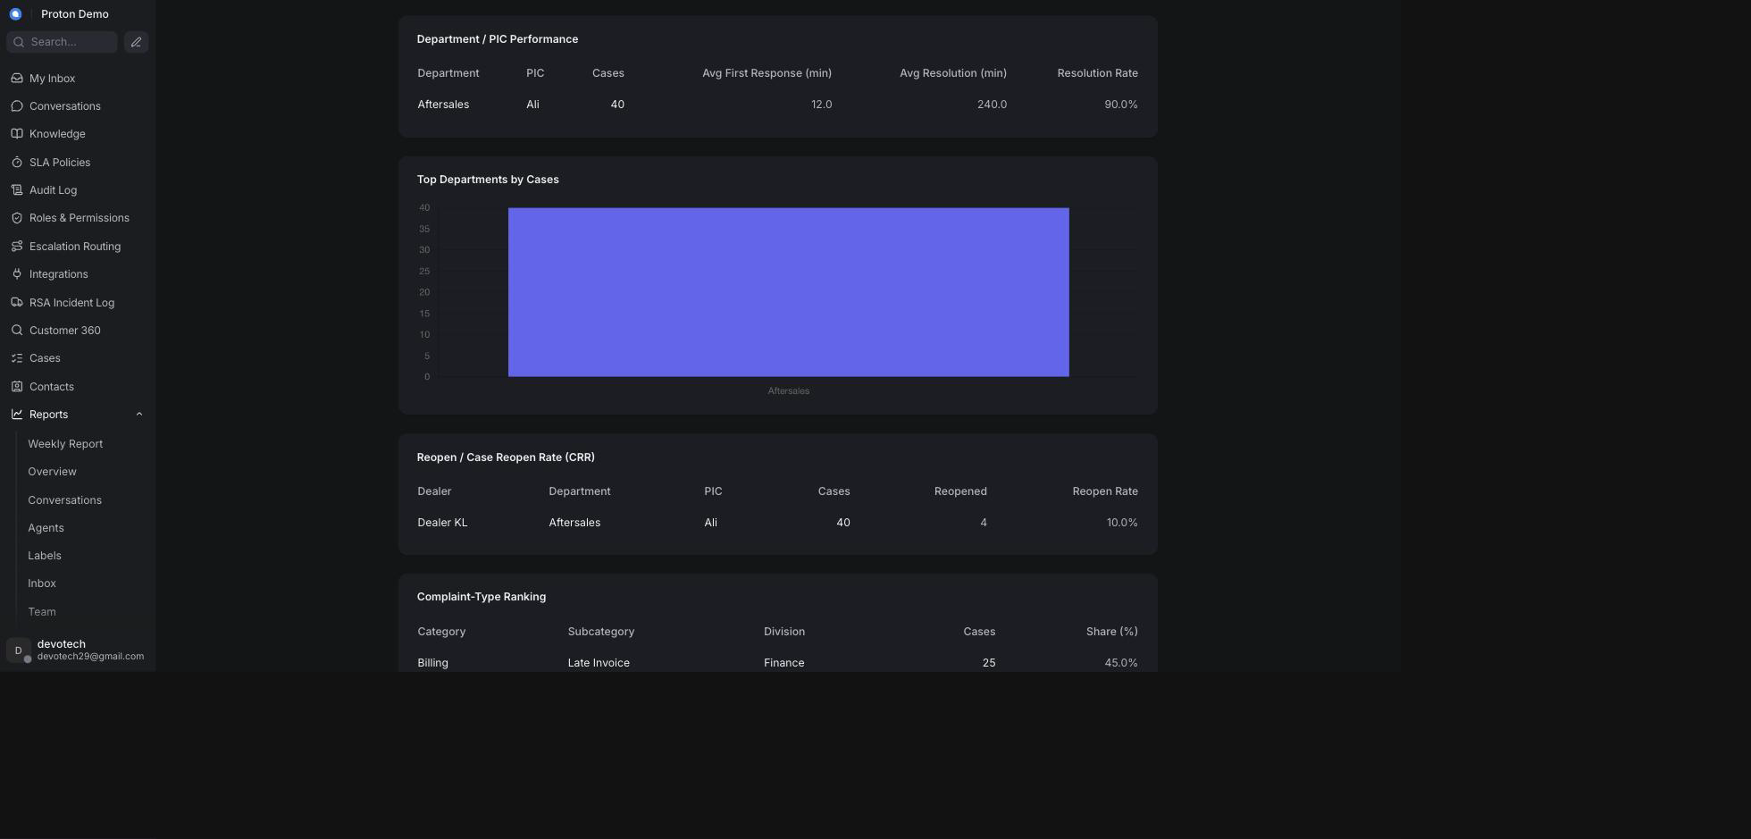
The Departments & PIC report page

Example scenario
During the weekly ops review, Pak Hendra pulls up Departments & PIC and sees the Service department's reopen rate at Dealer Bandung Timur is noticeably higher than other dealers, prompting a follow-up with that dealer's PIC about whether repairs are properly verified before a case is closed.

Integrations & automation
In principle this report reflects case categories and dealer/department labels that agents apply during normal conversation handling, with no separate configuration step. Today, though, it reads from the same not-yet-connected reporting warehouse described under Standard reports — so what's on screen is illustrative rather than a live reflection of how cases are actually being handled, until that connection is switched on.

Case Lifecycle report

What it is
A page showing how long cases take to resolve and how cases move through their statuses over time, plus a running list of recent cases and, further down the same page, a work-in-progress / case-aging view of cases still open.

Where to find it
Reports → Case Lifecycle in the left sidebar.

How to use it
1. Open Reports → Case Lifecycle.
2. Review Resolution-Time Distribution to see how cases bucket across resolution-speed bands, from under 30 minutes up to more than 24 hours.
3. Review Case State Trend to see how the mix of case statuses has moved month over month.
4. Scroll to Recent Cases for a per-conversation table (channel, department, dealer, status, resolution time) for the most recently created cases.
5. Scroll further to Work-in-Progress / Case Aging for currently open or pending cases sorted by how many days old they are, bucketed so aging cases are easy to spot.
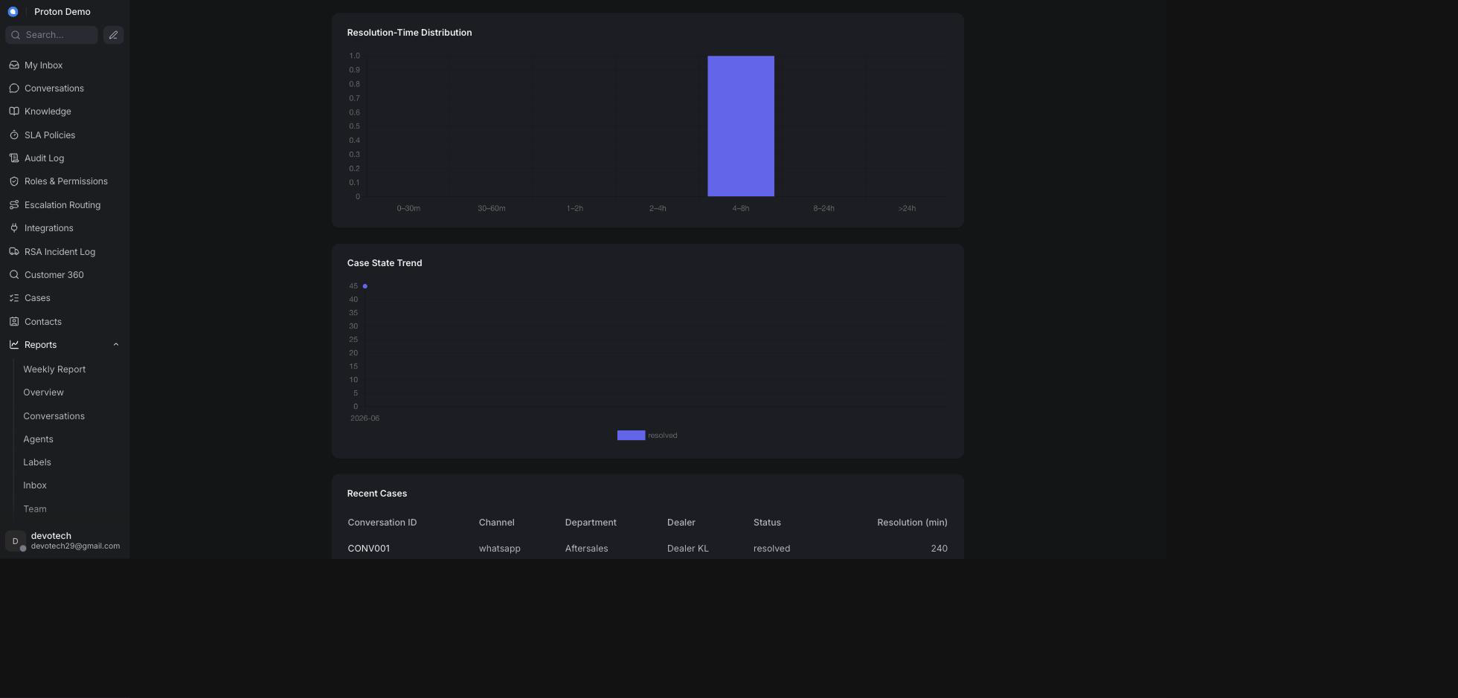
The Case Lifecycle report page

Example scenario
Ibu Sari, reviewing open RSA follow-ups, uses the Work-in-Progress / Case Aging table to find any case older than a week that's still open, and escalates those to the relevant PIC before they slip further.

Integrations & automation
Case status and category come from how agents and administrators manage conversations day to day (see Cases and RSA), with no separate setup of its own — but this report also reads from the same not-yet-connected reporting warehouse described under Standard reports, so its numbers are illustrative rather than live until that connection is switched on.

Weekly Report

What it is
A single page that reconciles the numbers in Proton's own weekly reporting routine — case volume, case status trend, department/PIC performance, call-centre and SLA performance, dealer escalation turnaround, SLA compliance, work-in-progress aging, and a per-case detail table — all against a chosen 7-day window, so a weekly reporting habit doesn't require collating several report pages by hand.

Where to find it
Reports → Weekly Report in the left sidebar.

How to use it
1. Open Reports → Weekly Report.
2. Use the week picker at the top to choose the window you're reporting on. It defaults to the current Monday–Sunday week, but its start date can be set to any day — useful if your own weekly routine runs on a different 7-day cycle (for example Friday-to-Thursday).
3. Read Case Volume for total cases in the window, the week-over-week change, and a breakdown by channel and by case type/division.
4. Read Case Status Trend for how cases split across statuses within the window.
5. Scroll through Inquiry / Complaint / Feedback Detail — Departments & PIC, Call Centre & SLA Performance, Work-in-Progress / Case Aging, and Dealer Escalation Turnaround — each section carries a small badge saying whether it's scoped to "This week" or "All time", so it's clear which numbers are windowed and which are running totals.
6. Check Per-Case Detail at the bottom for the individual conversations behind the week's numbers.
The page notes that Per-Case Detail (read live from current conversations) and the Case Volume total above (read from the reporting warehouse) can legitimately show slightly different counts, since they come from two different data sources — this is expected, not a bug.
Right now those two sources aren't just "different" — one of them isn't live yet. Per-Case Detail reads straight from Chatwoot and is always real. Case Volume, Case Status Trend, Departments & PIC Detail, Call Centre & SLA Performance, Work-in-Progress / Case Aging, and Dealer Escalation Turnaround all read from the reporting warehouse connection described under Standard reports, which has not yet been switched on for this account — so those sections currently show illustrative figures rather than this account's real week. Per-Case Detail is the one section on this page you can already read as real today.
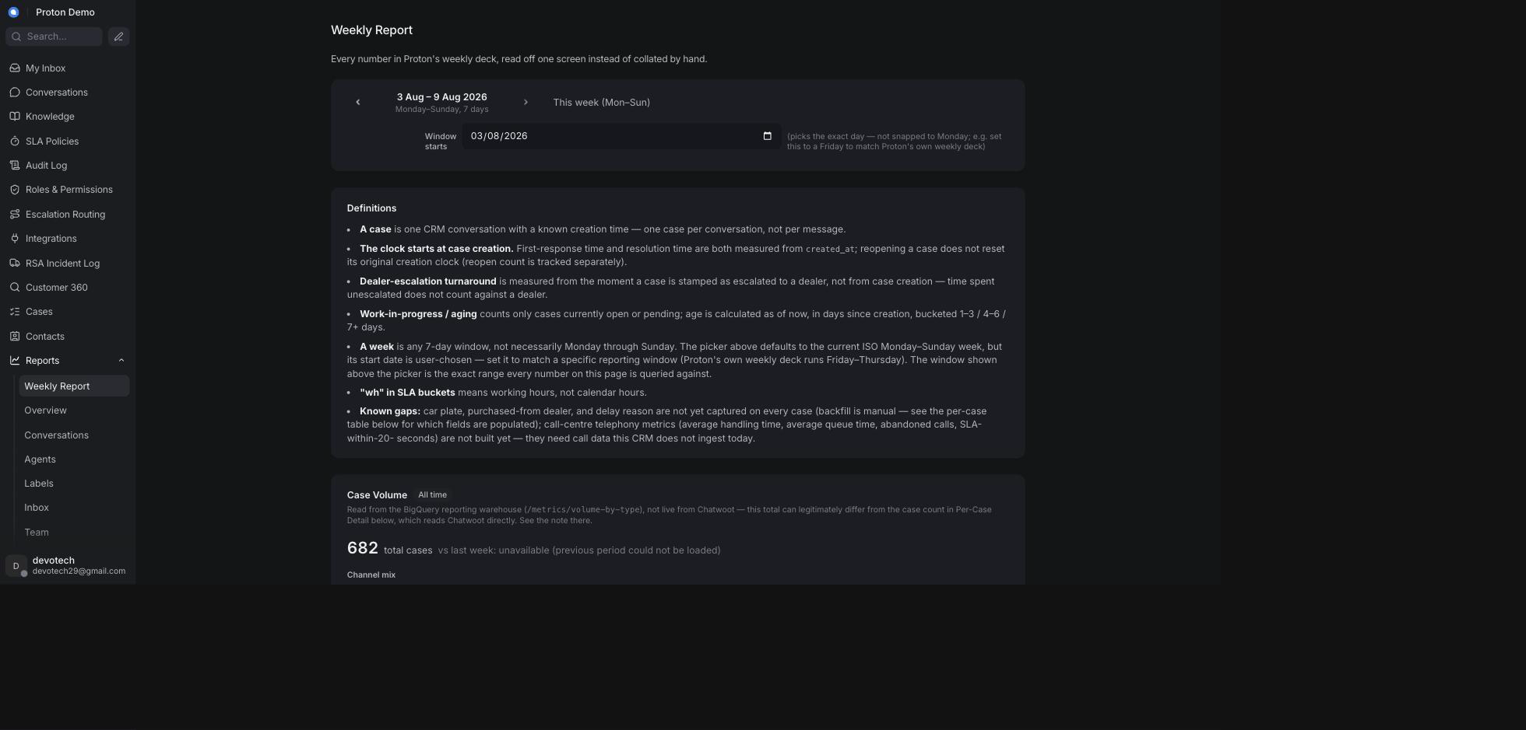
The Weekly Report page

Example scenario
Every Friday, Ibu Dewi sets the Weekly Report's window to the just-finished reporting period, notes the Case Volume and Departments & PIC numbers for the client's weekly update, and checks the Dealer Escalation Turnaround table before the call to flag any dealer whose average turnaround has crept up.

Integrations & automation
The Weekly Report reads from the same reporting warehouse and live case data as the other report pages — see the note above about the warehouse connection's current status. There is no export button on the page itself, so figures are typically copied by hand into a weekly deck, or pulled in bulk via BI/reporting exports for a larger dataset (see the Integrations chapter).

SLA reports

What it is
Chatwoot's native SLA report, showing which conversations met or missed their assigned SLA policy, plus a Proton section beneath it that rolls SLA achievement up across every channel and shows SLA compliance broken down into time buckets. This is a different page from SLA Policies under Administration, which is where SLA rules are configured rather than reported on.

Where to find it
Reports → SLA in the left sidebar.

How to use it
1. Open Reports → SLA.
2. Review the native SLA table for individual conversations that hit or missed their SLA.
3. Scroll down to Cross-Channel SLA Achievement for the overall met/missed percentage across every channel, plus a per-channel breakdown chart.
4. Continue to SLA Compliance by Bucket for a chart of how many cases fall into each SLA time bucket, split by case type.

Example scenario
Pak Yudi checks Cross-Channel SLA Achievement before a monthly client review to confirm the team is holding above its committed percentage, then drills into SLA Compliance by Bucket to see whether one particular case type is dragging the average down.

Integrations & automation
The native table at the top measures SLA achievement directly against whichever SLA policy is applied to a conversation (configured on the SLA Policies admin page, see Administration) — no separate setup, and it's live today. Cross-Channel SLA Achievement and SLA Compliance by Bucket below it read from the same not-yet-connected reporting warehouse described under Standard reports, so treat their numbers as illustrative until that connection is switched on.

Dealer escalation turnaround

What it is
A measurement of how long a dealer takes to act on a case escalated to it. The clock starts the first time a case is marked as escalated to a specific dealer — not from when the case was originally created — and stops when the case is resolved. This keeps time spent before escalation from unfairly counting against the dealer.

Where to find it
The Dealer Escalation Turnaround table appears on the SLA reports page and again on the Weekly Report, both showing the same underlying numbers.

How to use it
1. Open the SLA reports page or the Weekly Report.
2. Find the Dealer Escalation Turnaround table: cases escalated, average turnaround, and P50/P90 turnaround in days, per dealer.
3. Check the Slowest cases sub-table for the specific conversations taking the longest to turn around — these are the ones worth following up individually.
4. Compare dealers to spot ones consistently slower than the group, and raise it with that dealer's PIC via Escalation Routing (see Administration).

Example scenario
An agent applies a dealer label to a customer's complaint about a delayed repair, forwarding it to Dealer Kelapa Gading. The moment that label is applied, the case's escalation clock starts; once the case is later resolved, the elapsed time appears against Dealer Kelapa Gading in the turnaround table, letting Ibu Sari track that dealer's responsiveness over time.

Integrations & automation
The turnaround clock starts automatically, once, the first time a dealer label is applied to a conversation — an agent doesn't need to do anything extra beyond applying the label as part of normal escalation handling (see Labels, and Escalation labels & the escalation email in the AI Behaviour chapter). That timestamp is written straight onto the conversation and is always real. The turnaround table itself — averages, percentiles, and the Slowest Cases list — is one of the sections fed by the reporting warehouse connection described under Standard reports, so until that connection is switched on for this account, what's on screen there is illustrative rather than computed from these real timestamps.

Campaigns & Help Center

Campaigns

What it is
Chatwoot's native campaigns feature, used to proactively message contacts rather than only waiting for them to write in. Campaigns come in two kinds: one-off campaigns, sent once to a target audience over a channel such as WhatsApp or SMS, and ongoing campaigns, which trigger automatically for website-chat visitors who match a condition (for example, visiting a specific page).

Where to find it
Campaigns in the left sidebar.

How to use it
1. Open Campaigns from the sidebar.
2. Choose whether to create a one-off or an ongoing campaign.
3. For a one-off campaign, pick the inbox/channel, write the message, and select or upload the audience to send it to.
4. For an ongoing campaign, pick the website inbox, set the trigger condition (page URL, time on page, and similar), and write the message shown to matching visitors.
5. Save and activate the campaign, then monitor delivery and responses from the campaign's detail page.

Example scenario
Ahead of a service promotion, the marketing team sets up a one-off WhatsApp campaign reminding customers whose last service was six months ago that a check-up is due, giving the service department a head start on inbound bookings.

Integrations & automation
Campaigns send through whichever inbox/channel they're attached to (for example, a connected WhatsApp inbox); there's no separate setup beyond that channel already being connected (see the Integrations chapter).
Campaigns may not be enabled or visible for every Proton deployment — confirm on the live tenant whether this menu is present for your account before relying on it in training material.

Help Center portal

What it is
Chatwoot's native Help Center (knowledge-base portal) feature for publishing self-service articles that customers can read without contacting an agent, organized into categories.

Where to find it
Help Center in the left sidebar, or under account settings depending on the tenant.

How to use it
1. Open Help Center from the sidebar (or Settings).
2. Create or select a portal, then add categories to group related articles.
3. Create an article inside a category and write its content; it starts as a draft.
4. Preview the article, then publish it so it becomes visible on the public portal.
5. Keep articles up to date as procedures change, and unpublish or archive ones that are no longer accurate.

Example scenario
The knowledge team publishes a "How to book a service appointment" article in the Help Center's Service category, so customers who search for the answer online can self-serve instead of opening a new conversation, while agents draw on the same underlying information via Knowledge → FAQs when a customer asks directly instead.

Integrations & automation
Help Center content is separate from the Knowledge → FAQs, Documents, and Assistants features covered in the Knowledge chapter: the Help Center portal is a native, public-facing self-service site, while Knowledge feeds the AI assistant's answers inside conversations. The two typically need to be kept in sync manually, since they serve different audiences.
The Help Center menu may not be enabled for every Proton deployment — confirm on the live tenant whether this feature is active before relying on it in training material.

Administration (Settings)
This chapter covers the pages an administrator uses to configure the CRM itself, rather than to handle a customer conversation. Most of these pages require an administrator account; the Proton-specific pages that sit in the main left-hand navigation — SLA Policies, Audit Log, Roles & Permissions, Escalation Routing, Integrations, Case Taxonomy, Customer 360, Cases, the RSA Incident Log and Workforce — additionally require a specific permission to be granted to your role. If you don't see one of these items in the left-hand navigation, ask an administrator to grant you the matching permission from Roles & Permissions. One entry in that list works the other way round: My status is deliberately available to ordinary agents, because setting your own availability is part of an agent's own working day.

Agents

What it is
The list of everyone who can log in to this CRM as staff, together with their role (agent or administrator) and which teams/inboxes they belong to.

Where to find it
Open Settings (the gear icon) and select Agents.

How to use it
1. Open Settings → Agents to see everyone with access to this CRM.
2. To add someone, click Add Agent, enter their name and email, and pick a role (Agent or Administrator). An invitation is sent to that email address.
3. To change someone's role or the inboxes/teams they can see, click on their row and update the settings, then save.
4. To remove someone's access, open their row and choose the remove/deactivate option, then confirm.

Example scenario
Proton hires a new customer-service agent, Sari, to cover WhatsApp and email support. An administrator adds her under Settings → Agents with the Agent role, then assigns her to the After-Sales team and the relevant inboxes so conversations can be routed to her.

Integrations & automation
An agent's role here is what Roles & Permissions (below) grants extra permissions on top of, and which teams they can be part of under Teams.

Teams

What it is
A named group of agents (for example, one team per department) used to route and assign conversations as a group rather than to individuals one by one.

Where to find it
Open Settings (the gear icon) and select Teams.

How to use it
1. Open Settings → Teams to see the existing teams.
2. To add a team, click Add Team, give it a name and description, and choose whether conversations assigned to the team round-robin between its members automatically.
3. Add or remove agents from the team on its detail page.
4. To retire a team, open it and use the remove/delete option, then confirm.

Example scenario
Proton organizes its support desk into Sales, After-Sales, and RSA teams so that a complaint about a service appointment can be assigned to the After-Sales team as a whole, and picked up by whichever of its agents is free, instead of waiting for one named person.

Integrations & automation
Teams are used as assignment targets in Automation rules below, and as a grouping in reports (see the Reports chapter's Departments & PIC report).

Inboxes (incl. inactivity timing)

What it is
An inbox is one connected communication channel — a WhatsApp number, an email address, the website widget, and so on. Each inbox has its own settings: which agents can see it, its working hours, whether it sends the CRM's own greeting and satisfaction-survey messages, and (Proton additions) how long an idle conversation waits before the customer is warned and the conversation is auto-closed, plus which channel each agent handles first.
Three of these are worth calling out because they are the switches operators most often assume are somewhere else:
• The greeting message is a per-inbox setting here, not part of the AI assistant's own wording. It is the acknowledgement a customer gets when they first write in.
• The satisfaction-rating request sent when a conversation is resolved is also a per-inbox setting here — again separate from the AI assistant's own rating prompt, which is a different message configured in a different place (see the Knowledge chapter).
• Agent channel priorities are edited on this page too, on the collaborators tab of an individual inbox, even though what they steer is automatic assignment across the account.

Where to find it
Open Settings (the gear icon) and select Inboxes, then choose the inbox you want to configure.

How to use it
1. Open Settings → Inboxes and select the inbox to configure.
2. Use the inbox's general settings to control its name and the agents/teams assigned to it, and to switch the greeting message and the resolution satisfaction survey on or off and set their wording.
3. Open the tab that hosts business hours to set working hours for the inbox.
4. On the same tab, scroll to Inactivity & auto-close. Toggle Enable inactivity & auto-close for this inbox on or off.
5. Set Warn after idle (min), Close grace — in business hours (min), Close grace — out of hours (min), and Resolution-confirm grace (min). Leave any of these blank to inherit the tenant-wide default instead of setting a per-inbox value.
6. Optionally customize the wording of the Idle warning message, Chat closed message, Resolution prompt, Assign-to-agent message, AI rating survey, Agent rating survey, and Thank-you message sent to the customer at each stage. Leave a field blank to use the default wording. Note that the last three of those seven — the two rating surveys and the thank-you — belong to the AI assistant's own survey step, which is switched off account-wide today, so wording entered there is stored but nothing sends it. The first four are live.
7. Click Update to save — this single action saves both the business hours and the inactivity-timing settings together.
8. To set which channel an agent picks up first, open the inbox's collaborators tab and use the Agent Channel Priorities table (see below).
Agent Channel Priorities. The table lists every agent with their current availability, one Primary channel, and any number of Also handles channels, chosen from WhatsApp, Call, Email, Social and Web. Primary is always first in an agent's priority order, so the chip for an agent's current primary channel is deliberately not selectable as an extra — a channel cannot be both. A Save button appears on a row only once you have actually changed it; a row you have saved shows a Saved tick and an untouched row shows a dash, so at a glance you can see which rows still hold unsaved work. The table is account-wide even though it is reached through one inbox: the priorities you set here steer automatic assignment everywhere (see the Conversations chapter).
Where each per-inbox switch stands today, so nobody plans around the wrong one:
• The greeting message is on for the WhatsApp and Email inboxes and off for the API and website-demo inboxes.
• The resolution satisfaction survey is on for all four inboxes — this is the rating request customers actually receive when a conversation is resolved.
• The idle warning, automatic close and "is your case resolved?" prompt are live account-wide.

Example scenario
Proton's WhatsApp inbox is set to warn a customer after 10 minutes of no reply ("Warn after idle (min)"), then auto-close 5 minutes later during business hours, but wait longer overnight when no agent is on duty — set via a larger out-of-hours grace value on the same inbox. On the same inbox's collaborators tab, an administrator sets Sari's Primary channel to WhatsApp and ticks Email under Also handles, so she is offered WhatsApp work first and email only when WhatsApp is quiet; the row shows a Save button until she clicks it, then a Saved tick.

Integrations & automation
The inactivity timers work together with the AI assistant's lifecycle messages (see the AI Behaviour chapter) to keep conversations moving without an agent having to manually chase or close every idle chat — and where both are set, the wording entered on this page wins over the assistant's own. The greeting and satisfaction-survey switches on this page are the CRM's own, and run whether or not the AI assistant's equivalent messages are enabled; the two are easy to confuse and are covered side by side in the Knowledge chapter. Agent channel priorities feed the automatic assignment described in the Conversations chapter, and an agent's availability — the status shown beside their name in that table — is what decides whether they are offered new work at all (see Agent Availability & Workforce Dashboard, below).

Labels

What it is
Labels are short, colour-coded tags administrators define for use across conversations — including the escalate label and the dealer labels that drive escalation notifications (see the Conversations and AI Behaviour chapters).

Where to find it
Open Settings (the gear icon) and select Labels.

How to use it
1. Open Settings → Labels to see every label defined for the account.
2. Click Add Label, give it a name, description, and colour, then save.
3. To change a label's name, description, or colour, click on it and update the fields.
4. To remove a label, use its delete option and confirm. This removes the label from any conversation it was applied to.

Example scenario
An administrator creates a dealer_jakarta-selatan label so that conversations escalated to that dealer can be tagged consistently by agents and picked up automatically by the escalation routing described later in this chapter.

Integrations & automation
Labels drive automation rules (below), the escalation email flow, and dealer-turnaround reporting (see the Reports chapter).

Custom Attributes

What it is
Custom Attributes let administrators define extra fields on conversations or contacts beyond what the CRM ships with by default — for example, the five case-categorisation fields used by Cases (see the Cases chapter's Case categorisation section): Case Type, Case Category, Case Subcategory, Case Detail, and Vehicle Model, all rendered as single-select ("List") conversation attributes. Case Type and Vehicle Model are new since the last edition of this guide — before this edition, neither had a definition here at all, so neither dropdown rendered in the conversation sidebar. Case Category/Case Subcategory/Case Detail values are matched to the client's RFP 2026_028 Appendix A taxonomy exactly, including Case Detail's em-dash convention for folding in the RFP's Level 3/4 rows (see the Cases chapter for the full explanation) — these lists are large (246 Case Detail values alone) and are provisioned from that source file, not hand-typed one at a time.
This page is no longer where three of those five are maintained, and the previous edition of this guide said otherwise. Case Category, Case Subcategory and Case Detail are now owned by the separate Case Taxonomy admin page (see the Cases chapter, which explains its four-tier structure and the trap in its tier names). That page treats its own tree as the complete, authoritative list and rewrites all three option lists in full every time anyone saves or retires a node on it. So a value you add to any of those three from this page can be silently overwritten the next time an administrator touches Case Taxonomy — no error, no warning, the value is simply gone. Add and edit those three on the Case Taxonomy page instead. Case Type and Vehicle Model are not affected. Neither is part of the taxonomy tree, neither is touched by that page's sync, and neither has an admin page of its own — they stay here, as ordinary List attributes, and editing them here is correct.

Where to find it
Open Settings (the gear icon) and select Custom Attributes.

How to use it
1. Open Settings → Custom Attributes.
2. Click Add Custom Attribute, choose whether it applies to conversations or contacts, give it a name and a type (text, number, list, checkbox, etc.), and save.
3. To edit an attribute's options, click on it and update the fields. Do not edit Case Category, Case Subcategory or Case Detail here — use the Case Taxonomy page (see the box above, and the Cases chapter). Case Type and Vehicle Model are edited here as normal, though treat even those as occasional rather than routine maintenance: both are matched one-for-one against the RFP source, and a hand edit here won't update that source file, so the two can drift apart.
4. To remove an attribute that is no longer needed, use its delete option and confirm.

Example scenario
Proton's five case-categorisation fields (used on the Cases page) are defined here as conversation-level custom attributes, so any conversation can be tagged with the same structured Case Type/Category/Subcategory/ Detail/Vehicle Model values used in Case reporting. An administrator asked to add a new vehicle model adds it here; an administrator asked to add a new case category adds it on the Case Taxonomy page instead, and the value reaches this page automatically.

Integrations & automation
Custom attributes back the Cases feature's five categorisation fields (see the Cases chapter) and can also be used as conditions in Automation rules below. Three of the five — Case Category, Case Subcategory and Case Detail — have the Case Taxonomy page as their source of truth and are written into this page's definitions from there; the other two are maintained here directly.

Automation

What it is
Automation lets administrators define "when X happens, do Y" rules that run without an agent having to act — for example, applying a label automatically when a conversation matches certain conditions.

Where to find it
Open Settings (the gear icon) and select Automation.

How to use it
1. Open Settings → Automation to see the existing rules.
2. Click Add Automation Rule, choose an event to trigger on (for example, a conversation being created), add one or more conditions, and choose the action(s) to run (add a label, assign a team, send a message, etc.).
3. Save the rule. It applies to matching conversations going forward.
4. To adjust a rule, click on it and edit its conditions or actions.
5. To stop a rule from running, disable or delete it.

Example scenario
An administrator sets up a rule that automatically applies a "Priority: High" label whenever a new conversation arrives on the RSA (roadside assistance) inbox, so those conversations stand out in the inbox view without an agent tagging them by hand.

Integrations & automation
Automation rules can use labels and custom attributes (both covered above) as conditions, and can trigger the same kinds of actions an agent could take manually from a conversation.

Macros

What it is
Macros bundle a sequence of actions — such as adding a label, assigning a team, sending a reply, and resolving — into one saved, one-click action. This page is where those macro steps are created and edited; running a saved macro from an open conversation is covered in the Conversations chapter.

Where to find it
Open Settings (the gear icon) and select Macros.

How to use it
1. Open Settings → Macros to see the existing macros.
2. Click Add Macro, give it a name, and add the steps it should run in order (for example: apply a label, then send a reply, then resolve).
3. Save the macro. It becomes available to agents from the macro menu inside any open conversation.
4. To change a macro's steps, click on it, edit the step list, and save.
5. To retire a macro, delete it — this does not affect conversations it was already run on.

Example scenario
An administrator builds a "Test drive confirmed" macro that applies a test-drive label, sends a confirmation reply, and marks the conversation resolved, so agents handling this routine request can finish it in one click instead of three separate steps (see the Conversations chapter for the agent-side view of running this macro).

Integrations & automation
Macros created here are run by agents from the conversation view (see the Conversations chapter's Macros section) — this page is the admin-only counterpart to that agent-facing feature.

Canned Responses

What it is
Canned Responses are reusable message templates agents can insert into a reply instead of typing the same answer out each time.

Where to find it
Open Settings (the gear icon) and select Canned Responses.

How to use it
1. Open Settings → Canned Responses to see the existing templates.
2. Click Add Canned Response, give it a short code/shortcut and the full message text, then save.
3. To edit a template's text or shortcut, click on it and update the fields.
4. To remove a template that is no longer needed, use its delete option and confirm.

Example scenario
An administrator creates a canned response for the standard warranty explanation on the e.MAS 7, so every agent can insert the same accurate wording instead of retyping it for each customer who asks.

Integrations & automation
Canned responses are inserted by agents from the reply box during a conversation (see the Conversations chapter); this page controls what is available to insert.

Integrations (incl. DMS / TSP connection)

What it is
This covers two related areas: the native Settings → Integrations page for connecting third-party apps and webhooks to the CRM, and a separate, permission-gated Integrations page in the main left-hand navigation where the Dealer Management System / Telematics Service Provider (DMS/TSP) connection is configured. The DMS/TSP connection is what lets the Customer 360 lookup (see the Contacts chapter) show a customer's vehicle and service history.

Where to find it
For general integrations/webhooks, open Settings (the gear icon) and select Integrations. For the DMS/TSP connection, look for Integrations in the main left-hand navigation (visible only if your role has been granted the "Manage DMS/TSP integration settings" permission — see Roles & Permissions below), then open the DMS / TSP card.

How to use it
1. From the main left-hand navigation, open Integrations, then click the DMS / TSP card. Its status badge shows Checking status… while it loads, then Not connected, Enabled, or Status unavailable — it never claims to be actively connected, since that can only be confirmed with the Test connection button described below. Even an Enabled badge carries a caption saying reachability has not been verified.
2. Check Enabled to turn the connection on.
3. Fill in a Provider label (a friendly name for your own reference), the Auth type (Bearer token, Basic auth, or API key header — the third option names the header it sends), and the Base URL of the DMS/TSP system (must start with https://).
4. Click Replace next to Credential to enter the API key/secret for this connection. Once saved, the credential always shows as masked (••••••••) and is never displayed again — click Replace again later to change it.
5. Optionally set an Extra header name and Extra header value if the DMS/TSP system requires an additional custom header. Unlike Credential, the extra header value is stored and shown in plain text, so avoid putting a second secret there.
6. Set the Timeout (seconds) the Customer 360 lookup should wait for a response before giving up and showing CRM data only (between 0.1 and 30 seconds).
7. Click Save, then click Test connection to confirm the saved configuration can actually reach the DMS/TSP system. Test connection runs against the saved configuration, not what is on screen, so save first if you have just edited the form. A successful test reports Reachable; a failure names the reason — authentication failed, timed out, an unexpected response, or not configured yet.

Example scenario
Proton's IT team receives API credentials from its DMS provider ahead of a pilot. An administrator with the integration-management permission opens Integrations → DMS / TSP, enables the connection, enters the base URL and credential, saves, and clicks Test connection to confirm it returns Reachable before telling the After-Sales team that vehicle history will now appear in Customer 360.

Integrations & automation
Once enabled and reachable, this connection feeds the DMS/TSP vehicle and service-history section of the Customer 360 lookup (see the Contacts chapter). It has no effect anywhere else in the CRM until it is enabled.

SLA Policies

What it is
SLA Policies define the response and resolution time targets the CRM tracks per conversation — either a single tenant-wide default, or an override for a specific inbox — plus two related timing settings: how long an unresolved breach waits before re-alerting a second time (Tier-2), and how much advance warning a case gets before it actually breaches. These targets are also what the always-on SLA breach engine checks a conversation against: when a case on the Email inbox goes past its target, the CRM posts a private note on it and emails the department's PIC group — see the Conversations chapter's SLA breach alerts section for what that looks like from an agent's side.

Where to find it
In the main left-hand navigation, select SLA Policies (visible only if your role has been granted the "Manage SLA policies" permission — see Roles & Permissions below).

How to use it
1. Open SLA Policies. Use the Scope dropdown to choose Tenant default or a specific inbox.
2. Set the Response window (hours) — how quickly a first reply is expected — and the Resolution window (hours) — how quickly the conversation is expected to be resolved.
3. Set Tier-2 re-alert after (hours) if you want a second, level-2 alert to fire when a case is still unresolved that many hours after its first breach — leave it blank to inherit the deployed default.
4. Set Warn before breach (minutes) to have the CRM raise an early warning that many minutes before a case is about to breach its resolution target, rather than waiting for the breach itself — leave it blank to inherit the deployed default.
5. Optionally set Per-channel ACK minutes (JSON) for a channel-specific acknowledgement target, for example {"whatsapp": 15}, and a PIC WhatsApp number to notify.
6. Use the Engine enabled override checkbox to switch SLA tracking off for this scope entirely — useful for an inbox that should not be measured against a target at all.
7. Leave any field empty on an inbox's policy to inherit the tenant default (or the deployed default, for Tier-2/warning) instead of setting an inbox-specific value. Setting a field back to empty after you have typed in it can be rejected on save; if that happens, ask us to clear the value rather than fighting the form.
8. Click Save. The new targets apply from the next check onward. A breach that has already been recorded is never recomputed or removed, and a conversation already resolved is not re-examined — so lowering a threshold cannot retrospectively create or erase a breach.

Example scenario
Proton sets a tenant-wide default of a 1-hour response window and an 8-hour resolution window, then overrides the Email inbox specifically with a 30-minute response window and a Warn before breach of 30 minutes, so the team gets a heads-up while there's still time to respond before an Email case actually breaches and triggers the PIC-group alert.

Integrations & automation
A policy breach is what the SLA breach alert engine (Conversations chapter) actively notifies the PIC group and posts a private note about, on the Email inbox today — that part is live and reads this account's real conversations.
The targets set here are also what the SLA reports in the Reports chapter measure performance against, but read that chapter's opening note before using those pages to judge whether a target is being met: the cross-channel reporting connection those sections read from has not yet been switched on for this account, so the "Proton" sections on the reports pages currently show illustrative example numbers rather than this account's real performance. Editing a target here changes what the live alert engine enforces immediately; it does not make an illustrative report page real.

Audit Log

What it is
A read-only, filterable trail of what has happened to a case — who moved it from one state to another, and when — used to review a case after the fact.
It records more than an agent changing a status by hand, which is worth knowing before you read a row and can't place it. The same trail also carries the SLA engine's own breach and Tier-2 markers, the moment an agent first replied, whether an escalation email actually went out, an escalation being acknowledged, and a supervisor reassigning a case from one agent to another. Rows whose actor is not a person are the system recording something it did.

Where to find it
In the main left-hand navigation, select Audit Log (visible only if your role has been granted the "View the audit log" permission — see Roles & Permissions below).

How to use it
1. Open Audit Log to see the recorded entries, newest first. The five columns are At (when), Ticket (which case), Actor (who or what), Transition (the move from one state to another), and Remark.
2. To narrow the list, enter an Actor, and/or a From/To date range. Actor is an exact match, not a partial one — a half-typed name returns nothing rather than a shortlist. The To date is inclusive of the whole day you pick.
3. Click Filter to apply the filters.
4. The page shows the most recent entries matching your filter rather than the entire history, so narrow the date range if you are looking further back.

Example scenario
A customer disputes when their case was marked resolved. An administrator opens Audit Log, filters by the case's date range, and finds the exact transition, who made it, and the remark left at the time — and, a few rows above it, the SLA engine's own breach marker showing the case had already run past its resolution target before anyone touched it.

Integrations & automation
The audit log is the historical trail behind the case status shown in the Cases chapter, the SLA breach alerts in the Conversations chapter, and the escalation email in this chapter's Escalation Routing section — not a separate data source, and not a copy that can disagree with them. Unlike the report pages in the Reports chapter, it reads live records rather than the reporting warehouse.

Roles & Permissions

What it is
This page controls which capabilities each role grants: both the CRM's own native access controls (which conversations a role can see, and whether it can manage contacts, reports, or the help centre) and the Proton-specific permissions (SLA Policies, Audit Log, Roles & Permissions itself, Escalation Routing, Case Taxonomy, Customer 360, Workforce, the DMS/TSP integration and more). It replaces the need to edit any configuration file to change what a role can do.
The page was redesigned since the last edition of this guide, and the steps below have changed with it. The most important change is that nothing you tick is written when you tick it: every change is staged against a local draft and only applied when you press Save changes. Creating a role is the one exception — that happens immediately.

Where to find it
In the main left-hand navigation, select Roles & Permissions (visible only if your role has been granted the "Manage roles and permission assignments" permission).

How to use it
1. Open Roles & Permissions. Roles are listed down the left as cards, each showing how many permissions and how many members it has — click one to open it. To add a role, click + New role, enter a Name, check the Id the page derives from it, and click Create. The id is permanent and cannot be changed later, so read it before you confirm.
2. Under Chatwoot access, choose one Conversation visibility option: Default access (no CRM-side restriction at all — visibility stays whatever the account already does for that person), All conversations, Unassigned + own, or Own conversations only. Then, under Sections, toggle whether the role can manage Contacts, Reports, and/or the Knowledge base. Read the warning below before you change either of these on a role that any administrator belongs to — the other three visibility options and the Sections toggles do not narrow an administrator's access, they replace it. For a role that exists only to grant Proton permissions, leave visibility on Default access and every Sections toggle off, and go straight to step 3.
3. Under Permissions, grant or revoke the Proton permissions. They are grouped — Knowledge & AI, Cases & taxonomy, Routing & escalation, Workforce, Alerts, Customer data and Administration — with a count of how many in each group are granted, a Grant all / Revoke all button per group, and a search box for finding one by name. That is the full set of groups; you may well see fewer. A group only appears if the platform is currently offering at least one permission belonging to it, so the page reflects what this account can actually grant today rather than a fixed list. A group you expected and cannot find is a question for us, not something to work around.
4. Under Members, click + Add member and search for the person by name or email, or click Remove on a row to take the role away. A staged addition or removal is marked as such and can be undone before you save.
5. Click Save changes in the bar at the bottom of the page — or Discard to throw the draft away. Navigating away, or clicking a different role, with unsaved changes asks you first.
Never switch on a Chatwoot-access restriction for a role that administrators belong to. This is the one mistake on this page that cannot be undone by the people it affects. Choosing any Conversation visibility option other than Default access, or ticking any of the Sections toggles, does not narrow what an administrator can do — it replaces their administrator access with exactly what that role grants. Everyone assigned to the role loses the Settings area and every administrative page in this chapter, including this one, so they cannot put it back themselves; it takes someone else with administrator rights, or us. This has happened on a live account, so treat it as a rule rather than a caution. If you need a role that only grants Proton permissions — which is the usual case — leave Conversation visibility on Default access and leave every Sections toggle off. The Chatwoot-access controls are for shaping agent roles.
Two things the page tries to catch for you. If a save would leave you without the "Manage roles and permission assignments" permission through any role, the page warns you that this removes the page from your own navigation and cannot be undone from inside the product. That check has to work out which account is yours by matching your email address against the staff directory, and where it cannot, it stays quiet — so treat it as a useful catch for the obvious case, not as a guarantee you will always be stopped. Read back what you are about to save. Separately, if a save partly fails, the page tells you how many of your changes went through and leaves the rest staged, so you can fix the problem and save again rather than guessing at a half-applied state — that one does not depend on identifying you.

Example scenario
Proton onboards a new agent, Budi, who should only handle his own assigned conversations and never see administrative pages. An administrator either assigns him the existing Agent role, or clicks + New role, names it Front-desk, sets Conversation visibility to Own conversations only, leaves every Proton permission group at zero granted, adds Budi under Members, and clicks Save changes. That visibility setting is safe here precisely because the role's members are agents; the same setting on a role an administrator belongs to would take that administrator's own access away.

Integrations & automation
Every Proton page in this chapter — SLA Policies, Audit Log, Roles & Permissions, Escalation Routing, Case Taxonomy, the DMS/TSP integration page, and the Workforce dashboard below — only appears in the navigation for a user whose role has been granted the matching permission here. The same is true of Customer 360, the Cases list and the RSA Incident Log covered in earlier chapters. My status is the deliberate exception: its permission is granted to the default Agent role, so ordinary agents can set their own availability.

Escalation Routing

What it is
Escalation Routing maintains two directories used to route notifications: which person-in-charge (PIC) to notify for each department, and which dealer group — a named group with one or more member email addresses — represents each dealer, for SLA breaches and escalated conversations. Every member of a dealer group receives the escalation forward, not just one address.
This page is the reason an escalation reaches anyone at all, so read what happens when a row is missing. Applying a department label and then escalate stamps the conversation and looks, from the conversation view, exactly like a successful escalation — whether or not that department has a contact configured here. A department with no PIC, or a dealer group with no members, sends the escalation email to nobody, silently, with no error visible anywhere in the CRM. There are six department labels — dept_sales, dept_engineer, dept_pre_sales, dept_aftersales, dept_cs and dept_technical — plus one row per dealer group. Check this page rather than assume every department is covered; the directory is editable at any time, so what was complete last month may not be today. Nothing about how you apply the labels has changed (see the Conversations chapter's Labels section).

Where to find it
In the main left-hand navigation, select Escalation Routing (visible only if your role has been granted the "Manage PIC/dealer escalation routing" permission).

How to use it
1. Open Escalation Routing. It has two sections: Department PICs and Dealer groups.
2. To add a department's PIC, fill in Department, PIC name, PIC email, optionally PIC WhatsApp, and optionally Members (CC) (comma-separated email addresses to CC on that department's escalation email), then click Add PIC.
3. To change an existing PIC, click Edit on its row, update the fields — including adding or removing addresses from Members (CC) — and click Save; or click Delete and confirm to remove it.
4. To add a dealer group, fill in Group name and Members (one or more email addresses, comma-separated — everyone listed is forwarded the case) under the Dealer groups section, then click Add dealer.
5. To change a dealer group's membership — adding a new staff member or removing someone who's left — click Edit on its row, update the comma-separated Members list, and click Save; or click Delete and confirm to remove the whole group.
6. Changes take effect immediately for new escalations — there is no redeploy or waiting period. Any department or dealer not yet edited here falls back to the defaults configured when the tenant was set up.
7. To confirm a department actually routes before relying on it, scroll Department PICs and check that its row shows a PIC email — and, for any dealer you intend to escalate to, that its Dealer groups row lists at least one member. A row that is absent, or present with no PIC email or no members, is exactly the silent-dead-end case described above. Do this for all six department labels before a launch or a campaign rather than discovering a gap from a customer complaint.

Example scenario
The After-Sales PIC at Proton changes when a new department head, Ibu Ratna, takes over. An administrator opens Escalation Routing, clicks Edit on the After-Sales row, updates the PIC name and PIC email to hers, and clicks Save — the next escalation email for After-Sales goes to her immediately, without needing IT to change anything outside the CRM. Separately, when a dealer outlet adds a second service advisor who should also see escalated cases, an administrator opens the matching dealer group, adds the new advisor's address to Members alongside the existing one, and saves — both now receive every future forward to that dealer.
Escalating to a department or a dealer group, from an agent's side, is the same eight-second action every time — apply a department label, then a dealer label if there is one, then escalate (see the Conversations chapter's Labels section). Which slug goes with which kind of case:
1. A pricing/financing question that needs Pre-Sales: apply dept_pre_sales, then escalate. The Pre-Sales PIC's email is who receives it.
2. A vehicle fault needing engineering judgement: apply dept_engineer, then escalate. Routes to the Engineer PIC.
3. A completed-sale delivery/booking complaint: apply dept_sales, then escalate. Routes to the Sales PIC.
4. A warranty/service complaint: apply dept_aftersales, then escalate. Routes to the After-Sales PIC.
5. A general enquiry with no clear department: apply dept_cs, then escalate. Routes to the CS PIC.
6. A software/app/infotainment fault: apply dept_technical, then escalate. Routes to the Technical PIC.
7. A case that also needs a specific dealer outlet looped in: apply that dealer's label alongside whichever department label fits, before escalate. Every member of that dealer group is forwarded the case, and the dealer's turnaround clock starts at the same moment.
Each of those routes to whatever this page currently holds for that department or dealer — and to nobody, silently, where a row is missing or empty. That is why step 7 above is worth doing before you rely on any of them.

Integrations & automation
This directory is what the escalation email (see the AI Behaviour chapter's escalation-labels section) and dealer-labeled conversations use to decide who gets notified, and what the dealer-turnaround report (see the Reports chapter) uses to attribute a handoff to a specific dealer. It is also the allowlist that the escalation reply loop (see the Conversations chapter's Escalation replies section) checks against — a reply that lands from an address not listed here as a PIC or a dealer-group member is not linked back onto the case.

Agent Availability & Workforce Dashboard

What it is
Two related things, both new since the last edition of this guide and both live on this account.
First, an extended set of availability statuses an agent can choose beyond the three the CRM offers natively (Online, Busy, Offline): Available, Busy, Lunch, Break, Coaching, Training, Toilet and Prayer. Second, a supervisor Workforce dashboard showing, live, who is in which status, how long they have been in it, how their day has been split across statuses, their availability against the working day, and how many cases they currently have open.
Three things about how this is presented are deliberate, and knowing them prevents a supervisor drawing the wrong conclusion from the page:
Named statuses mirror into the CRM's own Online/Busy/Offline. Selecting "Lunch" shows as Busy to colleagues in the conversation list, and as Lunch on the Workforce dashboard. This is deliberate: the CRM's own availability field only has three values, and mirroring means an agent is still correctly excluded from being offered new work even if the named-status service is unavailable. Availability history is derived from going offline and coming back. It is not a login/logout record — an agent who closes their laptop without setting themselves offline stays shown as available until their next change. Where the dashboard cannot measure something it shows a blank, never a zero. In particular the Cases closed today column is always blank: nothing in the platform records a date-filtered "resolved today" count that can be read cheaply enough to refresh every half minute, and a zero there would be a statement about the team's output rather than about what is instrumented. Open cases can also come back blank, for a different reason: if the count could not be established on that refresh, every row blanks rather than showing everyone as idle. Read a blank as "not measured", never as "none".
Two capabilities in this area are built but not switched on for this account, and neither should be described to agents as though it were working:
• The absence alerts do not fire. The design behind them is real — Lunch, Break, Toilet and Prayer are marked as "counts as unavailable", and the My status page even shows an "(alerts)" marker beside them, which is why this needs saying plainly. But the alerting itself is switched off on this account, so nobody is notified when an agent stays in one of those statuses. Ask us before you plan a shift-supervision process around it.
• After-Call Work is not switched on. Nothing places an agent into a wrap-up state automatically when a phone call ends, and the status is not offered as a choice.
Average handling time is not part of this either. It depends on call queue statistics the platform does not yet receive from the telephony side — the same gap that leaves several call-related rows of the monthly report unmeasured.

Where to find it
Agents set their status in two equivalent places: the availability control in the profile menu, which now offers the named statuses rather than only the CRM's three, and a dedicated My status page in the main left-hand navigation. Supervisors open Workforce in the same navigation.
Each entry appears only if your role has the matching permission — "Set your own availability status" for My status, which the default Agent role carries, and "View the workforce/presence dashboard" for Workforce, which it does not. If an agent cannot see My status, check on the Roles & Permissions page that they have been assigned a role at all.

How to use it
1. As an agent, open the availability control in your profile menu, or the My status page, and pick the status that matches what you are doing — Lunch when you step out, for example. You do not need to also set yourself Busy: choosing Lunch does that for you, which is why colleagues see you as Busy while the supervisor's dashboard shows the reason. Offline stays exactly as it always was and is still how you say you are off shift.
2. Check the My status page when you want to know what you are currently set to. The profile-menu control shows the underlying Online/Busy/ Offline dot rather than the named status, so after picking "Lunch" it still reads Busy — that is correct, not a fault. The My status page is the one that says Currently: Lunch — for 55 min.
3. Set yourself back to Available when you return. Anything other than Available means new conversations are not routed to you.
4. As a supervisor, open Workforce to see the live grid: Agent, Current status, Elapsed in status, Time in status today, Availability % (working day), Open cases, Cases closed today, and Availability history. Leave the page open — it re-reads roughly every half minute. This is a polled view of current data, not a pushed live feed.
5. Read Time in status today and Availability % (working day) together: the percentage is measured against the inbox's configured working hours, not against a flat 24 hours, so an agent who worked their whole shift reads near 100% rather than around a third. An agent with no recorded history at all shows a blank rather than a zero.
6. To add a status of your own — a shift pattern or an activity specific to your team — an administrator opens the Status catalogue section at the bottom of the My status page and clicks Add status. Give it a key, a label, a colour, which of the CRM's three native statuses it should mirror into, whether an agent in it can still receive new conversations, and whether it should count as unavailable. Existing statuses are edited the same way. Statuses are never deleted, because past history refers to them — retire one by marking it as not receiving new conversations, and it stays readable on old dashboard rows.
7. In that catalogue, a row marked Default is one of the built-in statuses that has not been saved on this account yet; saving it writes it. Counts as unavailable is the setting that would arm the absence alerts if they were switched on — leave it off for scheduled activities like Coaching and Training, on for stepping away.

Example scenario
An agent sets herself to Lunch at 10:45. Proton's after-sales supervisor opens Workforce at 11:40 and sees she has been in Lunch for 55 minutes while three cases sit open against her name. The dashboard is where the reason is visible; in the conversation list that agent simply reads as Busy. Because absence alerting is not switched on for this account, nothing will page the supervisor about it — noticing it on the dashboard is the mechanism today. She reassigns the most urgent of the three cases to a colleague from the conversation view.

Integrations & automation
Availability is what conversation routing already reads to decide who can be offered new work (see the Conversations chapter), so a named status takes effect on routing through the native status it mirrors into — which is why routing keeps behaving correctly even if the named-status service is unavailable. The agent availability shown beside each name in the Agent Channel Priorities table earlier in this chapter is the same value.
Three separate permissions, all granted from Roles & Permissions, govern this area, and the split matters: setting your own status belongs to the Agent role by default, because it is part of an agent's own working day; viewing the workforce dashboard and editing the status catalogue or setting another agent's status are administrator permissions. An agent cannot mark a colleague as being on Lunch — that would take the colleague out of routing under their own name.
Unlike the report pages in the Reports chapter, this dashboard reads live records on every refresh rather than the reporting warehouse, so its numbers are this account's own.

AI Conversational Quality

What it is
A set of adjustments to how the AI reads and answers customers. Two of them are live on this account and appear in the reply composer; the rest are configuration your administrator asks us to switch on, rather than checkboxes inside the CRM, because each one changes what customers receive.
Live today:
1. Translate, for the agent. A Translate action in the reply composer renders the customer's latest message in English as a private note on the conversation. The translation is never sent to the customer — the only thing the platform can do with it is add a note. See the Conversations chapter for the agent-side view.
2. The FAQ suggestion strip above the reply box, offering a single best-matching FAQ answer with an Apply button. Also covered in the Conversations chapter.
Built, deployed, and switched off on this account:
3. Sentiment on every conversation. The AI would record how the customer sounds — positive, neutral, negative or urgent — on the conversation itself, using the same request it already makes to answer the message. No extra AI call and no extra delay.
4. Tone matched to that sentiment: a measured, apologetic register for an angry customer, a brisk one for an urgent safety issue. It does nothing without sentiment recorded first, and a sentiment older than about a quarter of an hour is ignored, so an hour-old complaint does not make a cheerful "thanks, all sorted" come back apologetic.
5. Photo and video diagnosis. When a customer sends a photo or video, the AI would be asked to describe what is actually visible, name the likely fault, state how confident it is and ask at most one follow-up question — instead of a generic "please describe the issue". Voice notes are deliberately excluded: there is nothing to look at.
6. Resolved-case summaries. When a case is resolved, the AI can post a summary of it as a private note, and can separately add that summary to a searchable store of previously resolved cases. The two are independent.
A seventh adjustment is already in effect at a setting that changes nothing: a keyword-overlap score can be blended into FAQ ranking, to help product codes and model names (e.MAS 7, for instance) that match poorly on meaning alone. It ships at zero weight, which reproduces today's suggestions exactly, entry for entry.
Two of these carry limits that must be read before they are switched on.
Tamil. Inbound Tamil translation — so an agent can read a Tamil message — is what the live Translate action gives you. Outbound Tamil replies to customers remain deliberately disabled, pending an evaluation of thirty real Tamil enquiries scored by a Tamil speaker. Switching it on before that evaluation sends unverified machine translation to customers. Resolved-case suggestions are not approved guidance. They are generated from summaries of previously resolved cases — what a colleague did last month, not what the manual says — and are labelled as such wherever they are shown. The store holds summaries rather than transcripts, and the summariser is instructed to omit customer identifiers, but that is a mitigation, not guaranteed removal of personal data. Two things about it are worth knowing precisely: nothing checks or edits a summary before it is stored, and an operator's own persona guardrails are placed ahead of that instruction in the same request — so a guardrail saying the opposite ("always include the customer's full name") is text the AI may prefer. Anyone who can edit the persona can weaken the mitigation without any software change.

Where to find it
The Translate action and the FAQ suggestion strip are in the reply composer, inside a conversation. Everything else on this list is a setting in the account's configuration, not a page in the CRM: there is no admin screen that toggles them, which is deliberate — each one changes what customers receive, so switching it on is a deployment decision with a record, not a checkbox. Ask your administrator.
Where sentiment is switched on, it appears on the conversation's custom attributes. Where resolved-case summaries are switched on, they appear as private notes in the conversation.
Not yet demonstrated. The photo-and-video diagnosis wording has never been tried against a real photo sent through a real WhatsApp number. It is switched off today, and we would want that test before switching it on for a live account — please ask for it rather than assuming it has been done.

How to use it
1. Use Translate to read, not to reply. It posts a private note. To answer a Malay, Chinese or Tamil customer, write the reply as you normally would — the AI already answers in the language the customer wrote in.
2. Ask for sentiment before tone. Tone selection does nothing on its own: with no sentiment recorded there is nothing to choose a tone from, and the assistant keeps its standard wording.
3. Sentiment on its own is not a no-op, so expect one side effect. A case whose customer sounded negative or urgent is treated as open rather than resolved, and that reading is not time-bounded — so one angry turn keeps later turns in the same conversation reading as open, including a closing "thanks, all sorted". The replies themselves are unchanged. Tell us if that is unwanted, rather than discovering it in a report.
4. Leave the FAQ keyword weight at zero until you have a measurement. Zero reproduces today's ordering and today's scores exactly. A large weight would damage the common case — ordinary questions, which already match well — in order to fix the rare one.
5. Do not switch on outbound Tamil. See the note above.
6. The two resolve settings are independent. The private-note summary needs no database and can be used on its own. The searchable store of resolved cases needs the knowledge database, which this account does have; if it were not configured, the summary note would still post and the store would simply be skipped. Either way, resolving the case always succeeds — resolving is the agent's action, and the summary is an addition to it that can never fail it.
7. A case reopened and resolved again gets a second summary, appended rather than overwriting the first, because the first summary is a true record of the first resolution.
8. Emptying the resolved-case store is not self-service yet. It is deliberately kept separate from your authored FAQs, so clearing it can never remove curated content — but there is no button or command for it today, so ask us before you need it in a hurry.

Example scenario
A customer messages in Tamil about a warning light. The agent, who does not read Tamil, clicks Translate: a private note appears in the conversation with the English text, and the customer sees nothing. She answers in her own words and the assistant's FAQ suggestion strip offers the standard warranty wording, which she applies with one click. Later, Proton asks whether the assistant could also read the dashboard photo the customer sent and name the warning symbol — that is the photo-diagnosis setting above, and the answer is that it is built and switched off, and we would want to try it against a real photo first.

Integrations & automation
Sentiment, where enabled, is written to the conversation's own custom attributes, so it is available to automation rules and to reporting exactly like any other case field — no new integration surface. The resolved-case summary is produced by the same summariser the Summarize button in the composer already uses, so there is one summariser and one set of wording to review rather than two that can drift apart, and it is posted through the same private-note mechanism as escalation notes.
Translate has its own permission ("use translation"), granted to the default Agent role rather than kept administrator-only: reading a customer's own message is part of an ordinary agent's job.
Two limits on what has been delivered, recorded here because both read as delivered if nobody says so:
• Nothing yet shows resolved-case suggestions to an agent. Summaries would be stored and labelled, and the labelling exists so that whichever panel eventually adds them cannot present them with a curated FAQ's authority — but no panel queries that store today. Switching it on builds the corpus; it does not yet surface it.
• No before-and-after accuracy figures exist. The evaluation sets and the runner for them are built and are part of the delivery, but they have never been run against the real AI service, so the accuracy tables read "unmeasured". Any percentage produced by the test harness in its current form is a property of the harness, not of the model, and must not be quoted as a result.

Account settings

What it is
Account-wide settings that are not specific to any one inbox, team, or agent — for example the account name, default timezone, and other platform-level preferences.

Where to find it
Open Settings (the gear icon) and select Account Settings.

How to use it
1. Open Settings → Account Settings.
2. Update the account name, timezone, or other available preferences as needed.
3. Save your changes.

Example scenario
When Proton's support desk switches its reporting to WIB (Indonesia Western time), an administrator updates the account timezone under Account Settings so timestamps shown across the CRM match local business hours.

Integrations & automation
Account-level settings such as timezone affect how timestamps are displayed across reports and the audit log elsewhere in this chapter.

AI Assistant Behaviour

When the AI replies vs. hands off to a human

What it is
The AI assistant only acts on a conversation while it is genuinely waiting for a first response — a Pending conversation with a new incoming customer message. It ignores its own earlier replies and never touches a conversation that's already Open, Snoozed, or Resolved; that territory belongs to a human. When a burst of messages arrives quickly (a customer typing several lines in a row), the assistant waits a brief moment after the last one before deciding, so the whole burst gets one answer instead of several.
Each time it decides, it settles on one of two outcomes from your side: it either replies (see Suggest mode vs. Auto mode, below), or it hands the conversation off to a human — reopening it so an agent can take over. Internally the assistant can flag two different reasons for handing off (for example, "this needs a specialist" versus simply "I'm not sure"), but since this CRM keeps every escalation inside Chatwoot rather than a separate ticketing system, both reasons produce exactly the same thing you see: a reopened conversation, ready for an agent.
When a customer's message includes a photo, video, or voice note, the assistant reads that media as part of the same decision, on WhatsApp as well as other channels — and when it does, the terms it draws from that media, not just the customer's typed words, are what lead its search of the knowledge base for an answer. A warning-light photo with no caption at all can still steer the assistant to the right article, and to the right reply. This is the same media-grounded search that powers an agent's manual "Suggest a reply" click (see the Conversations chapter); here it happens automatically, as part of the assistant deciding what to say or whether to hand off.

Where to find it
Not something an agent switches on or off. Whether the assistant is active at all on a given inbox, and in what mode, is set by an administrator under Knowledge → Inboxes (see the Knowledge chapter).

How to use it
1. Watch the conversation list: a conversation the assistant is still working on stays Pending; once it hands off, the conversation reopens (moves out of Pending) so a human can see it needs attention.
2. If the assistant hands off, it may first post a short acknowledgement message to the customer (an administrator-configured handoff message) before reopening the conversation — don't be surprised to see that message already sent when you open the conversation.
3. When a handoff conversation is reopened, it's often assigned to an agent automatically as part of the handoff, rather than staying unassigned.
4. Treat a conversation the assistant handed off the same way you would any other reopened conversation — read the thread, and reply or take whatever action the customer needs.

Example scenario
A customer messages the after-sales WhatsApp inbox asking for a refund on a cancelled service package. The assistant recognizes this needs a human decision, posts a brief "we'll connect you with an agent" message, and reopens the conversation, which is then automatically assigned to the on-duty agent.

Integrations & automation
This behaviour works together with the AI auto-draft feature covered in the Conversations chapter, and its persona, guardrails, and messages are configured under Knowledge → Settings (see the Knowledge chapter). Which inbox the assistant is active on, and in what mode, is set under Knowledge → Inboxes.

Suggest mode vs. Auto mode

What it is
Every inbox where the assistant is active runs in one of two modes, chosen by an administrator: Auto mode — the tenant-wide default today, unless an inbox has its own override — where the assistant sends its reply straight to the customer and the conversation stays Pending while it continues handling the conversation on its own; or Suggest mode, where the assistant drafts a reply as a private note and reopens the conversation for a human to review and send. On this tenant today, a customer's default experience is a reply that reaches them without a human reading it first. Suggest mode exists and can be set per inbox, but it is the exception here, not the rule.

Where to find it
Set per inbox under Knowledge → Inboxes, with a tenant-wide default mode under Knowledge → Settings — currently Auto — that applies to any inbox without its own override (see the Knowledge chapter for both).

How to use it
1. On most inboxes today, the assistant's reply is sent to the customer directly, with no human review step — that's Auto mode, the tenant-wide default — and the conversation stays Pending while the assistant keeps handling it on its own.
2. On an inbox an administrator has switched to Suggest mode instead, watch for a private note marked as a suggested reply on a conversation the assistant has just handled — that private note, reviewed and sent by a human, is the only place in this flow a reply is checked before a customer sees it.
3. As an agent, you can tell which mode an inbox is running by what you see: a suggested draft arriving as a private note (Suggest mode) versus a reply already sent to the customer with the conversation still Pending (Auto mode).
4. In either mode, if the assistant can't confidently answer, it hands off to a human instead (see the section above) rather than guessing.

Example scenario
On the tenant's default Auto mode, a customer asks the after-sales WhatsApp inbox about a delayed spare-part order; the assistant answers directly and the conversation stays Pending until it hands off or an agent steps in — nobody reviewed that reply before the customer read it. On an inbox an administrator has switched to Suggest mode instead, the same kind of question produces a private-note draft that the on-duty agent reviews, adjusts, and sends as their own reply.

Integrations & automation
The mode set here is what the Conversations chapter's "AI auto-draft and suggest-vs-auto mode" section describes from an agent's point of view. Whichever mode is active, replies are grounded in the same knowledge base covered in the Knowledge chapter.

Escalation labels & the escalation email

What it is
Applying the escalate label to a conversation on an Email inbox triggers an automatic two-part escalation email: a short acknowledgement sent to the customer, and a separate forward containing the case details sent to the responsible department PIC and/or dealer group. This only applies to Email-channel conversations — applying the label on a WhatsApp, web chatbot, or phone conversation doesn't send an email, since there's no email thread for it to join. Label order matters: the handler reads whatever department/dealer labels are already present the moment escalate is applied, so applying escalate before the department label means that leg silently doesn't fire for that trigger — apply the department label, then the dealer label if there is one, then escalate, in that order.
Separately, on an Email-channel conversation with no department label applied yet, the assistant may post a private note suggesting a department — never applying the label itself. That's a deliberate limit, not an oversight: applying escalate after a department label fires the escalation email automatically, and an AI guess is not something that should be able to send that email on its own — so the suggestion always waits for a human to read it and add the label by hand. See the Conversations chapter's AI-suggested escalation department section for the full walkthrough.
This is no longer a one-way notification. The escalation email carries a hidden reference back to its conversation, so when the dealer or PIC replies, the CRM links that reply back onto the original case automatically — as a private note, with an AI-drafted customer-facing reply beside it for an agent to review and send. A customer who instead replies to their own acknowledgement email rejoins their case too and the conversation reopens — but (correction from the previous edition) not as a normal incoming message: Chatwoot only accepts a synthetic incoming message on an Api-channel inbox, and this loop only ever runs on the Email channel, so that post is always rejected and the CRM falls back to a private note carrying the customer's own words instead. See the Conversations chapter's Escalation replies section for the full walkthrough, including exactly what that note looks like and what to do with it.
Separately, the first time a dealer label is applied to any conversation (on any channel, with or without the escalate label), the CRM stamps a one-time timestamp used to measure how long that dealer takes to act on the case — this is what feeds the dealer turnaround figures in the Reports chapter. And separately again, an always-on SLA breach engine watches the Email inbox for cases that miss their response or resolution target and alerts the department's PIC group by email plus a private note on the case — see the Administration chapter's SLA Policies section and the Conversations chapter's SLA breach alerts section.

Where to find it
Applied like any other label, from an open conversation's label control (see the Conversations chapter's Labels section).

How to use it
1. Open the Email conversation you need to escalate.
2. Apply a department label first — dept_sales, dept_engineer, dept_pre_sales, dept_aftersales, dept_cs, or dept_technical — then the relevant dealer label if one is involved. Check the Escalation Routing page in the Administration chapter rather than assume every department or dealer is covered — one with no contact configured there sends the escalation email to nobody, with no error anywhere to warn you. You may see a private note suggesting a department first — see the Conversations chapter's AI-suggested escalation department section.
3. Apply the escalate label last.
4. The acknowledgement email to the customer and the internal forward to the PIC/dealer group are sent automatically; there's nothing further to click.
5. If you only need the case attributed to a dealer for turnaround reporting (no escalation email needed, or the conversation isn't on an Email inbox), apply just the dealer label — the turnaround clock still starts.
6. Watch the conversation afterward for a dealer/PIC reply — it arrives as a private note, not a new task you have to go find (see the Conversations chapter's Escalation replies section).

Example scenario
A customer emails about a recurring charging fault that the support team can't resolve directly. The agent applies the department label, then the relevant dealer's label, then escalate; the customer receives an acknowledgement email while every member of the dealer group receives the case details by email, and the dealer's turnaround clock starts running from that moment. Two days later, the dealer replies confirming the fix — the agent finds that reply waiting as a private note on the same conversation, along with a drafted customer update ready to review and send.

Integrations & automation
This ties directly into the Escalation Routing directory (Administration chapter), which determines who actually receives the PIC/dealer email and doubles as the allowlist for the reply loop, and into the Dealer Escalation Turnaround figures shown in the Reports chapter. See also the Integration Overview chapter's Email section, and the Conversations chapter's Escalation replies and SLA breach alerts sections for the agent-facing side of both flows.

Lifecycle messages

What it is
The assistant sends a set sequence of automatic, customer-facing messages across a conversation's life, separate from anything it says while answering a question: an opening welcome/disclaimer message when a conversation starts (or, on an Email inbox, a simple acknowledgement of receipt instead), an idle-warning message if the customer goes quiet, a closing message if the conversation is then auto-closed for inactivity, a prompt asking whether the case is resolved, a satisfaction survey (worded differently depending on whether the AI or a human agent handled the conversation), a thank-you after the customer rates it, and a message letting the customer know a human agent is being assigned if the case isn't resolved yet.

Where to find it
The wording of each message is set per assistant under Knowledge → Settings (see the Knowledge chapter's Messages section), and the timing — how long to wait before warning or closing an idle conversation — is set per inbox under Administration → Inboxes (see the Administration chapter), which can also override the wording for that inbox specifically.
Each message in that sequence is switched on or off independently, so which of them a customer actually receives differs per tenant. Read the list above as what the platform can send, and the note below as what it sends today.
What is running on this tenant, as configured. The idle warning, the automatic close and the "is your case resolved?" prompt are on. The opening welcome/disclaimer message is off — a new chat conversation begins with the assistant's answer, not a disclaimer. The assistant's own satisfaction surveys are off, both the AI-handled and the agent-handled variants. Ratings still reach the CSAT report, because the CRM's own native satisfaction survey is enabled on every inbox — that is a separate mechanism, configured per inbox rather than per assistant. On the WhatsApp and Email inboxes, a customer's immediate acknowledgement when a conversation starts comes from that inbox's own native greeting instead — a further separate mechanism again, on for those two inboxes and off for the web chatbot and the Proton API inbox. It is not the assistant's Welcome message, doesn't go through the assistant at all, and its wording lives on that inbox's own settings page, not here. Ask your administrator before telling a customer that any of these will reach them.
1. If a customer stops replying mid-conversation, expect an idle-warning message once the configured wait time passes, followed by an automatic close if they still don't respond within the grace period.
2. When the customer's issue looks resolved, expect an "is your case resolved?" prompt. A "yes" closes the case; a "no", or an unclear answer, reopens it for a human instead.
3. With the surveys switched on, a "yes" would also bring a satisfaction rating request and a thank-you, and a human resolving a case directly would bring the agent-specific survey. Neither happens today.
4. On WhatsApp or Email, don't be surprised to see a customer already greeted before the assistant sends its first answer — that's the native greeting above, not a sign the Welcome message has quietly turned back on.
5. Treat these messages as normal, expected parts of the flow — they don't need an agent to trigger them.

Example scenario
A customer messages the WhatsApp support line late at night. The assistant answers the initial question, then the customer goes quiet; after the configured idle period they receive a warning message, and since they never reply again, the conversation auto-closes without ever needing an agent to step in.

Integrations & automation
These messages work together with the inactivity/auto-close timers covered in the Administration chapter's Inboxes section, and their wording is configured alongside the rest of an assistant's persona in the Knowledge chapter's Settings section. A conversation resolved through this flow shows up the same way as any other resolved conversation in the Conversations chapter.

Voice bot behaviour (the AI-answered part of a call)

What it is
Inbound phone calls to Proton's support line are answered by the same AI assistant used on other channels, using a voice conversation rather than text: it can hold a natural back-and-forth, answer vehicle questions from the same knowledge base used on WhatsApp, and ask the caller to rate the call 1–5 at the end. There is no traditional press-1-for-sales phone menu — callers speak naturally and the assistant works out what they need.

Where to find it
There is no separate phone/IVR configuration screen inside the CRM. What you see is the result each call leaves behind: a conversation in the Conversations view with the call's transcript as its messages, updating close to real time during the call on tenants configured for it, or appearing all at once at hangup otherwise.

How to use it
1. When a customer calls in, the assistant answers and the call appears as a new conversation in the Conversations view, with the spoken exchange logged as a transcript.
2. Read that transcript conversation the same way you would a WhatsApp or web conversation, including after the call has ended.
3. The assistant is instructed to answer in English, Bahasa Melayu, or Chinese and switch languages mid-call to match the caller — but reliable Bahasa Melayu on a live call is a known, unresolved issue specific to this voice pipeline (the text channels don't have this problem). Don't promise a Bahasa-speaking caller the assistant will stay in Bahasa for the whole call; if they get stuck in English, apologize and hand the call to a human rather than calling it fixed.
4. At the end of the call, the caller is asked to rate the interaction 1–5; that rating feeds the CSAT report (see the Reports chapter) the same way a text-channel rating does.
5. Treat everything beyond the greeting, KB answers, and rating survey as unconfirmed. Those three were demonstrated live on a real call; live transcript streaming, call classification, call recording, and a real transfer to a human (see the Phone handoff behaviour section, below) are built and code-reviewed but have not yet been run against a real incoming call. If asked, describe them as "should work, unconfirmed," not as proven.

Example scenario
A customer calls outside business hours asking about the battery warranty on an e.MAS X70; the assistant answers from the knowledge base, and the call's transcript appears in the Conversations view for an agent to review the next morning.

Integrations & automation
Voice bot conversations join the same single inbox front door described in the Introduction chapter, are answered from the same knowledge base described in the Knowledge chapter, and feed the CSAT report the same way any other channel does. See also the Integration Overview chapter's Voice bot section, and the Phone handoff behaviour section below for what happens if the caller asks for a person.

Phone handoff behaviour (the human side)

What it is
What happens when a caller asks for a person, and what's left behind in Chatwoot once a call ends. On tenants where a live transfer is turned on, the assistant tells the caller it's trying to connect them and dials a single support number — the same number for every reason a call gets transferred, including a roadside emergency. Where a live transfer isn't turned on (most tenants today), the assistant tells the caller a specialist will follow up and the call simply continues with the assistant.
A correction worth being precise about: the 08-04 edition of the channel guide described roadside-assistance calls as routed straight to a 24/7 line that bypasses normal business hours. That isn't what's built. Every transfer attempt — roadside or otherwise — is gated by the support inbox's normal business hours, with no exception for any particular kind of call. Outside those hours, the transfer is refused, not fast-tracked.

Where to find it
The same conversation the Voice bot section describes — there's no separate "Phone" inbox or settings screen. Whether a live transfer is even attempted on your tenant is an administrator-level setting, not something an agent switches on.

How to use it
1. If a caller asks for a person and a transfer is attempted, watch for the conversation to reopen with a note recording the handoff — check while the transfer is still ringing, since that's the signal someone is being connected right now.
2. Don't promise an after-hours caller — roadside emergency or otherwise — an automatic 24/7 transfer. No such bypass exists; the same business-hours gate applies to every call. Log a roadside case in the RSA Incident Log chapter and follow up directly instead.
3. If nobody answers the transfer, the caller hears a short apology and the call ends — it does not return to the assistant, and the conversation is tagged so it's easy to find. The apology promises a callback that nothing sends automatically — only a human working that tagged conversation makes the callback happen. Treat an unanswered transfer as an action item still owed to the caller, not a closed loop.
4. The escalate label works no differently on a phone-originated conversation than on WhatsApp or the web chatbot: it doesn't notify anyone, since this conversation isn't on the Email inbox. Escalate to a dealer or PIC directly if the case needs one.
5. Once the call has ended, work the resulting conversation like any other — reply, resolve, and check the CSAT rating the same way as the Voice bot section describes.

Example scenario
A customer calls after business hours reporting a breakdown and asks for a person. Because there's no after-hours exception for roadside calls, no transfer is attempted; the agent who picks up the transcript the next morning logs the incident in the RSA Incident Log chapter and calls the customer back directly, rather than assuming an overnight transfer happened.

Integrations & automation
This is the agent-facing half of the Voice bot behaviour section, above. An unanswered-transfer tag is what should draw an agent's attention to a callback that's still owed; roadside calls that reach a human still feed the RSA Incident Log chapter regardless of how they got there.

End-to-End Scenarios

Scenario 1: WhatsApp inquiry to resolution
1. A customer messages Proton's WhatsApp number asking about the price and availability of a test drive for the e.MAS 7. Chatwoot creates a new conversation on the WhatsApp inbox, which runs in Auto mode — the tenant-wide default — so no human review step applies here unless this particular inbox has been explicitly switched to Suggest (see the AI Assistant Behaviour chapter's Suggest mode vs. Auto mode section).
2. The AI assistant answers directly, grounded in the knowledge base, and sends the reply itself — this is what Auto mode means day to day (see the Conversations chapter's AI auto-draft and suggest-vs-auto mode section).
3. The customer confirms they'd like to book a test drive. Because arranging a booking needs a person, the conversation reopens and is assigned to an available agent whose channel priorities include WhatsApp (see the Channel Playbooks chapter's WhatsApp section, Scenario B).
4. The agent picks it up, confirms the booking details with the customer — using Ask Copilot for a knowledge-grounded draft if useful — and, once everything is confirmed, marks the conversation Resolved (see the Conversations chapter's Resolving, snoozing & transcripts section).
5. On resolve, the customer receives Chatwoot's own native satisfaction- rating request — not the assistant's own survey message, which is off tenant-wide on this account — and their 1–5 rating shows up later in the CSAT report (see the AI Assistant Behaviour chapter's Lifecycle messages section and the Reports chapter).

Scenario 2: Complaint escalation, the dealer's reply, and the turnaround report
1. A customer emails in about a recurring charging fault that wasn't fixed at their last service visit. The conversation lands on the Email inbox (see the Conversations chapter's Conversation inbox & views section).
2. The agent handling it decides the case needs the dealer's attention and applies the `dept_aftersales` label first, then the relevant dealer's label, then escalate last — in that order, since the handler only picks up whichever department/dealer labels are already on the conversation at the moment escalate is applied (see the Conversations chapter's Labels section).
3. The CRM automatically sends the customer a short acknowledgement email and forwards the case details to the dealer group's members by email, using the contacts set up in Escalation Routing; the dealer's turnaround clock starts at the same moment (see the AI Assistant Behaviour chapter's Escalation labels & the escalation email section and the Administration chapter's Escalation Routing section).
4. Two days later, the dealer emails back confirming the fault has been repaired. Within a couple of minutes, the agent sees a new private note on the same conversation starting Reply from with the dealer's update, and directly beneath it a second note — Suggested customer reply (draft — review before sending): — with an AI-drafted update already written (see the Conversations chapter's Escalation replies section).
5. The agent reads the draft, adjusts a couple of words, sends it as their own reply to the customer, and marks the conversation Resolved.
6. During the weekly ops review, a supervisor opens the Weekly Report page and looks at the Dealer Escalation Turnaround table. Today it shows a fixed set of illustrative example figures rather than this account's real timings — the reporting connection behind it hasn't been switched on for this account yet — so the supervisor doesn't read this dealer's actual turnaround off that table. To know how long this specific case actually took, they'd check the case itself (see the Reports chapter's Weekly Report and Dealer escalation turnaround sections).

Scenario 3: RSA call to Customer 360 follow-up
1. A customer calls Proton's support line reporting a breakdown on the toll road. The call is answered by the AI assistant, and the conversation appears in the Conversations view with the call transcript (see the AI Assistant Behaviour chapter's Voice bot behaviour section).
2. Because it's a roadside situation, an administrator with access to the RSA Incident Log page logs a new entry with the vehicle number, cause, and breakdown location (see the RSA Incident Log chapter's Logging an RSA incident section).
3. As towing is arranged and the vehicle reaches the dealer's outlet, the same administrator updates the incident record with the relevant timestamps (see the RSA Incident Log chapter's Incident statuses & updates section).
4. A few weeks later, the same dealer calls asking about that customer's vehicle history. An administrator with Customer 360 access opens Customer 360, searches by the vehicle number, and sees the completed RSA incident together with the customer's conversations in one place (see the Contacts chapter's Customer 360 section and the RSA Incident Log chapter's RSA in Customer 360 & reports section).
5. The same Customer 360 result also has a DMS/TSP block for that vehicle, but no live dealer-management-system adapter has been built into the platform yet, so on this tenant it shows a Not connected notice rather than a service history — the RSA incident and the customer's conversations are what the administrator actually has to go on today (see the Contacts chapter's Customer 360 section and the Integration Overview chapter's DMS/TSP section).

Scenario 4: FAQ batch import to live bot answer
1. Ahead of an e.MAS 7 launch event, Proton's service team compiles a spreadsheet of 40 frequently asked warranty questions.
2. An administrator exports the spreadsheet as a CSV file and uses Bulk upload (CSV) under Knowledge → FAQs to import all 40 entries in one go (see the Knowledge chapter's FAQs section).
3. Before the launch, the administrator opens Knowledge → Playground and asks a few of the same questions a customer might ask, to confirm the assistant answers correctly using the newly imported entries (see the Knowledge chapter's Playground section).
4. Satisfied with the answers, the administrator leaves the entries active. When the launch event starts and a real customer asks one of those questions on WhatsApp, the AI assistant answers it live, grounded in the newly imported FAQ (see the Conversations chapter's Suggest-a-reply and AI auto-draft sections, and the AI Assistant Behaviour chapter).
5. Any question the imported FAQs don't cover still falls back to a normal handoff to a human agent, the same as any other unanswerable question (see the AI Assistant Behaviour chapter's When the AI replies vs. hands off to a human section).

Scenario 5: Weekly reporting routine
1. Every Friday afternoon, Proton's operations lead opens Reports → Weekly Report and sets the week picker to the period just finishing (see the Reports chapter's Weekly Report section).
2. They check Per-Case Detail at the bottom of the page — the one section here that's read live from Chatwoot's current conversations — for the actual cases behind the week.
3. They also open Case Volume, Case Status Trend, Inquiry / Complaint / Feedback Detail — Departments & PIC, Call Centre & SLA Performance, Work-in-Progress / Case Aging, and Dealer Escalation Turnaround, but treat every number on those sections as a placeholder: the reporting connection behind them hasn't been switched on for this account yet, so what's on screen is a fixed set of illustrative example figures, not this week's real activity — and nothing on the page marks them as examples today, so the operations lead has to know that going in (see the Reports chapter's Weekly Report section).
4. Because none of those sections reflect this account's real week yet, the operations lead does not read a conclusion off them for the client call — no "this dealer's turnaround has crept up," no "complaints were up this week." Anything they report comes from Per-Case Detail, or from asking their CRM administrator whether the reporting connection has been switched on since the last check.
5. Once that connection does go live — a step still pending for this account — this routine can move back to reading the full page. Until then, if the client needs a number beyond what Per-Case Detail shows, the operations lead asks their CRM administrator to arrange a bulk export from the CRM's live data instead (see the Integration Overview chapter's BI/reporting exports section).

Scenario 6: New agent onboarding
1. Proton hires a new customer-service agent, Dian, to cover the After-Sales WhatsApp and email inboxes.
2. An administrator opens Settings → Agents, adds Dian with the Agent role, and an invitation is sent to her email address (see the Administration chapter's Agents section).
3. The administrator assigns her to the After-Sales team under Settings → Teams, so conversations can be routed to the team as a whole rather than to her individually at first (see the Administration chapter's Teams section).
4. The administrator makes sure she has access to the relevant WhatsApp and email inboxes under Settings → Inboxes (see the Administration chapter's Inboxes section).
5. Dian signs in for the first time using the credentials from her invitation, lands on the Conversations view, and — since her role is Agent — sees Conversations, Contacts, Knowledge, and My status, where she sets her own availability, but none of the administrator-only pages (see the Introduction chapter's Logging in and Roles: agent vs administrator sections, and the Administration chapter's Agent Availability & Workforce Dashboard section).

Scenario 7: A customer replies to their own acknowledgement email
1. A customer emails in about a delayed part; the agent escalates it with a department label, a dealer label, and escalate, and the customer receives the short acknowledgement email (see Scenario 2, above).
2. Two days later, still waiting, the customer hits Reply on that same acknowledgement email and asks for an update, without changing the subject line.
3. Chatwoot has no way to thread that reply onto the original case on its own, so it briefly appears as a brand-new conversation on the Email inbox — the agent doesn't need to do anything with this one; the CRM resolves it automatically in the background.
4. Correction from the previous edition: on the original conversation, the customer's message does not appear as a normal incoming message. Chatwoot only accepts a synthetic incoming message on an Api-channel inbox, and this always runs on the Email channel, so that attempt is always rejected. What the agent actually sees is a private note prefixed Customer's own reply (from <email>, could not be posted inline -- see conversation <id>):, followed by the customer's own words — and the conversation still reopens by itself, exactly as before (see the Conversations chapter's Escalation replies section).
5. What to actually do: treat that private note as the customer's message — it is, verbatim, just delivered as a note rather than an inline bubble — and reply publicly to it the same way as any other reopened case. Don't wait for it to turn into an ordinary message; it won't. Nothing about the escalation itself (the ack, the PIC email, the dealer forward) fires again just because the customer replied.

Scenario 8: Maintaining a dealer group
1. Dealer Kelapa Gading adds a second service advisor, Pak Rudi, who should also see escalated cases forwarded to that dealer, alongside the existing contact.
2. An administrator with the escalation-routing permission opens Escalation Routing and finds the Dealer groups section (see the Administration chapter's Escalation Routing section).
3. They click Edit on the Kelapa Gading dealer group's row, add Pak Rudi's email address to the comma-separated Members field alongside the existing address, and click Save.
4. From that point on, every escalation forwarded to Kelapa Gading — including one already mid-conversation — goes to both addresses, with no redeploy or waiting period.
5. Months later, the original contact leaves the dealership. The same administrator edits the group again, removes that address from Members, and saves — future escalations stop reaching the old address immediately.

Scenario 9: An SLA breach reaches the PIC group and the case
1. An email case sits open overnight with no first agent reply, past the Email inbox's configured Response window (see the Administration chapter's SLA Policies section).
2. Once the next SLA scan runs, the CRM posts a private note on the conversation starting ⚠️ SLA breach, naming which target was missed (see the Conversations chapter's SLA breach alerts section).
3. At the same moment, the department's PIC group (resolved from the conversation's own department label) receives an email with the breach details and a link back to the case.
4. The next morning, the on-duty agent opens Conversations, spots the breach note on a case in their queue, and replies immediately — already aware the PIC group has been notified too, so a follow-up from that side may already be in motion.
5. A supervisor checks later in the day and confirms no second alert fired for the same breach — the CRM only alerts once per breach per case.

Scenario 10: Adjusting SLA thresholds ahead of a launch event
1. Ahead of an e.MAS 7 launch event, Proton expects a spike in email inquiries and wants a tighter response target on the Email inbox for the week, plus more advance warning before anything breaches.
2. An administrator with the SLA-management permission opens SLA Policies, sets Scope to the Email inbox, and lowers the Response window (hours) from 1 to 0.5 (see the Administration chapter's SLA Policies section).
3. They also set Warn before breach (minutes) to 30, so the team gets an early nudge with half an hour of runway rather than finding out only once a case has already breached.
4. They leave Tier-2 re-alert after (hours) blank, since the deployed default re-alert timing is fine for this event.
5. They click Save — the tighter thresholds apply to Email-inbox cases from that moment on. The following week, once the event traffic has settled, the administrator returns to the same page and clears the Response window and warning fields back to blank, restoring the tenant default.

Scenario 11: Editing a customer-facing email template
1. Proton's brand team wants the escalation acknowledgement email to sound warmer than the built-in default wording.
2. An administrator opens Knowledge → Settings, scrolls to Tenant settings, and finds the Escalation acknowledgement template field (see the Knowledge chapter's Settings section).
3. They rewrite the wording, leave every other field on the panel untouched, and click Save settings.
4. The next time an agent escalates an Email case, the customer receives the new wording instead of the platform default — nothing else about the escalation flow changes.
5. The administrator also looks at the Inbound auto-acknowledgement template field just above it and edits that wording too, for consistency — but is careful to check with their CRM contact first, since on this tenant the inbound auto-acknowledgement is currently switched off. Editing the template alone doesn't turn the feature on; nothing will actually send until an administrator enables it.

Scenario 12: A WhatsApp case looks escalated, but nothing was sent
1. A customer messages about a repeated delivery delay, and the agent handling it decides the case needs the dealer's attention. Following the same steps as an Email escalation (see Scenario 2, above), the agent adds a dealer_<slug> label, then escalate, to the WhatsApp conversation.
2. Nothing happens. Adding the `escalate` label to a WhatsApp conversation by hand does not send an email or a WhatsApp alert to anyone — the automatic escalation flow only fires on an Email-channel conversation (see the Integration Overview chapter's Email section); WhatsApp conversations don't qualify, no matter what labels are on them.
3. The dealer_<slug> label does still do one thing: it stamps the conversation for that dealer's turnaround reporting, the same as it would on any channel. That part works — it's a reporting timestamp, not a notification, and it's easy to mistake one for the other.
4. The only way a PIC gets notified automatically on WhatsApp is if the AI assistant itself judges the customer's message to be a genuine complaint — its own decision, not something an agent can trigger by adding a label (see the AI Assistant Behaviour chapter).
5. What the agent actually does: call or email the dealer directly, outside the CRM, and tell the customer only that the right team is being looped in — not that "I've escalated this," since the label alone didn't do anything on this channel.

Scenario 13: The same limitation on a web chat case
1. A website visitor asks about a warranty issue that turns out to need the dealer's attention. The agent applies a dealer_<slug> label, then escalate, to the Web Chatbot conversation — exactly the same steps as Scenario 12, above.
2. The result is identical: no email fires, because the conversation is on the Web Chatbot inbox, not the Email inbox. The dealer turnaround stamp still applies from the dealer_<slug> label; the notification still doesn't happen.
3. Since the visitor may not have given a phone number or email through the widget, the agent may have no address to escalate to inside the CRM even if the flow did fire here — reinforcing why this has to be handled outside the CRM today, the same as WhatsApp.
4. The agent contacts the dealer directly and tells the visitor only that the right team has been looped in, the same wording as Scenario 12.

Scenario 14: An after-hours breakdown call, and an unanswered transfer
1. A customer calls late one evening reporting a breakdown and asks the assistant to connect them to a person right away.
2. Because every transfer attempt — roadside or otherwise — is gated by the support inbox's normal business hours with no exception, the transfer isn't attempted at all; the call continues with the assistant, which tells the caller a specialist will follow up (see the AI Assistant Behaviour chapter's Phone handoff behaviour section). This is a real correction from the 08-04 guide, which described roadside calls as bypassing business hours — that bypass was never built.
3. The next morning, an agent opens the resulting conversation, reads the transcript, and logs the incident in the RSA Incident Log chapter with the vehicle number and cause, then calls the customer back directly — not assuming any overnight transfer or callback already happened.
4. Later that week, a different caller reaches an agent transfer during business hours, but nobody picks up at the other end. The caller hears a short apology and the call ends without returning to the assistant; the conversation is tagged so agents can find it. The agent on duty sees the tag, calls the customer back personally, since the apology's promised callback doesn't send itself.
5. Neither of these cases can be escalated to a dealer with just the escalate label either — a phone conversation isn't on the Email inbox, the same limitation as Scenarios 12 and 13.

Scenario 15: Categorising a case through all five taxonomy dropdowns
1. A customer emails complaining that their new e.MAS 5's delivery has no estimated date. The agent opens the conversation's custom attributes panel — these are the same five dropdowns every agent fills in on a case, distinct from the admin-only Case Taxonomy page that maintains three of these option lists behind the scenes (see the Cases chapter's Case categorisation section).
2. They set Case Type to Complaint — one of three values, and independent of everything else in the panel.
3. They set Case Category to Sales, one of eight divisions.
4. Case Subcategory now only offers Sales' own Level-1 values, each prefixed Sales: — the agent picks Sales: Delivery.
5. Case Detail now only offers Delivery's own Level-2 values, each prefixed Sales: Delivery: — the agent picks Sales: Delivery: No Estimated Time Delivery. Nobody pre-filled this: Case Detail is never set by the AI, only ever picked by hand.
6. They set Vehicle Model to e.MAS 5 — again independent, doesn't touch the other four fields.
7. Later, the agent realizes this is actually a Charging complaint, not Sales, and changes Case Category to Charging. Case Subcategory and Case Detail both clear immediately, since Sales: Delivery and Sales: Delivery: No Estimated Time Delivery no longer match the new division — the agent reselects both from Charging's narrowed lists. Case Type and Vehicle Model are untouched by this change.

Scenario 16: An AI-suggested escalation department — accepted, and ignored
1. A customer emails Proton asking about financing options and a trade-in value before committing to an order. No department label is on the conversation yet.
2. Within moments, a private note appears naming pre_sales as the AI-suggested escalation department, explicitly stating it's a suggestion only and that no label has been applied (see the Conversations chapter's AI-suggested escalation department section).
3. The agent agrees with the suggestion, adds dept_pre_sales from the label control, then applies escalate last — the case routes to the Pre-Sales PIC exactly as if the agent had picked the department unprompted.
4. On a second, unrelated case — a customer asking a routine delivery-status question — the same kind of note suggests sales. The agent judges this one is actually an After-Sales matter instead, so they simply don't add dept_sales; they apply dept_aftersales themselves and escalate with that. The suggestion is never applied automatically either way, so ignoring it costs nothing and requires no extra click.

Scenario 17: Checking escalation routing before you rely on it
1. Ahead of relying on escalation routing for a live launch event, a supervisor with the escalation-routing permission opens Escalation Routing (see the Administration chapter's Escalation Routing section) and reads down the six department rows — dept_sales, dept_engineer, dept_pre_sales, dept_aftersales, dept_cs, and dept_technical — plus the dealer group rows, checking which ones actually show a contact.
2. Why this check matters: applying escalate stamps the conversation and looks, from the conversation view, exactly like a successful escalation — whether or not that department or dealer group has a contact configured. A department with no PIC, or a dealer group with no members, sends the escalation email to nobody, silently, with no error anywhere in the CRM to say so.
3. For every row that does show a contact, the supervisor escalates one test case with that department's label, then escalate, and confirms the contact actually receives the forward. For a dealer group, they add the dealer's label alongside a department label and confirm every member listed receives it too.
4. What this check does not establish: how many of the rows are populated overall, since the directory is editable at any time and what was complete last month may not be today. Check the Escalation Routing page yourself before a launch event rather than relying on a past check, and don't tell the team they can skip double-checking after an escalation on the strength of a check that's already gone stale.

Channel Playbooks
Every channel funnels into the same conversation list, and the toolbar you work with is the same one everywhere. What differs is what already happened before the conversation reached you, and what an agent can and cannot make happen from inside the CRM on that channel.
This chapter is the per-channel walkthrough: what the customer did, what the platform did on its own, and what you do next in each of the three situations that actually occur — the AI handled it, the customer wants a person, or the case has to reach someone outside the contact centre.
Read this as "the platform as configured today." Almost everything here sits behind a switch an administrator controls, and the settings differ per tenant. Where a switch changes what an agent should say to a customer, this chapter names it in the step rather than hiding it in a footnote. If a step below does not happen on your tenant, the honest phrasing is "that isn't set up for us yet," not "it's broken."
---

How the channels map to the CRM
Customer touchpoint | Appears as | What happens before a human sees it
WhatsApp message | The WhatsApp inbox | Full AI assistant: knowledge-grounded answers, idle handling, live handoff to a person
Web chatbot | The website widget inbox | The same assistant and the same knowledge base; replies are plain text, and the visitor may be anonymous
Voice bot | The API-channel inbox, via the telephony connection | Greeting, knowledge-grounded answers, a satisfaction rating at the end, and a conversation left behind at hangup
Phone | The same conversation the voice bot created | Nothing — this is what is left for a person to work
Email | The Email inbox | An acknowledgement on arrival, and, on the escalate label, a two-thread escalation to the PIC and dealer group

Social channels (Facebook, Instagram) are not connected and are not covered here.
---

The toolkit that is identical on every channel
Action | Where
See whether the assistant already answered | The conversation timeline — assistant messages look like any other message
Ask the AI for a knowledge-grounded draft | Reply box → Ask Copilot
Get a suggested answer to the customer's last message | Reply box → Suggest a reply
Summarise a long conversation before taking it over | Reply box → Summarize
Categorise the case | Right sidebar → Conversation Actions → Labels
Reassign to another agent | Click the assignee name in the conversation header — recorded in the Audit Log
Resolve | The status control at the top right of the conversation
See a customer's history across channels | Contact panel → Previous Conversations
Look up a customer by phone or vehicle number | Customer 360 in the left sidebar
Check or edit who an escalation reaches | Escalation Routing in the left sidebar
Check or edit response and resolution targets | SLA Policies in the left sidebar

The four standalone pages in that list — Audit Log, Customer 360, Escalation Routing and SLA Policies — appear only if your role carries the matching permission. Not seeing one is a permissions question for your administrator, not a fault.
---

WhatsApp
The most complete channel: the assistant answers, hands off, and closes cases on its own.

What the customer does
Messages the connected WhatsApp number.

What happens before you see it
1. The assistant replies in the customer's own language, grounded in the knowledge base whenever the question matches something there.
2. Outside business hours the customer receives the configured out-of-office reply.
3. If the assistant judges the message to be a genuine complaint, it escalates on its own — a PIC email plus an alert — and applies the escalate label. This is the assistant's own classification. You cannot trigger it by adding the label yourself; see Scenario C.

Scenario A — the assistant handles it end to end
The customer asks a routine question and the assistant answers from the knowledge base. Your role: none. Spot-check by opening the closed conversation, or through the CSAT report.

Scenario B — the customer asks for a person
1. The conversation reopens and is assigned to an available agent whose channel priorities include WhatsApp.
2. Work it as any other conversation — Ask Copilot gives you a knowledge-grounded draft to edit rather than a blank reply box.
3. Resolve when done.

Scenario C — the case needs to reach a dealer or PIC
Adding the `escalate` label to a WhatsApp conversation does not email anyone. The escalation email flow runs on Email-channel conversations only. The label will stick, and nothing will be sent.
1. A dealer_<slug> label is still worth applying — it stamps the case for dealer turnaround reporting, and that part works on every channel. It is a reporting stamp, not a notification.
2. What to actually do: contact the dealer or PIC directly, or open an Email conversation with the customer and escalate from there (see the Email playbook). Do not tell a customer "I've escalated this" on the strength of the label alone.
Your administrator can switch escalation on for every channel. Until they have, treat the label as inert here.

What is not usable yet on WhatsApp
• Voice notes and photos. The assistant can be given them, but this has never been tried end to end against a real WhatsApp number. Describe it as untested if a colleague asks, not as working.
• Manual escalation by label, as above.
---

Web chatbot
The same assistant and the same knowledge base as WhatsApp, so the shape of the work is identical. Two differences matter in practice.
Replies go out as plain text. No WhatsApp-style formatting or message splitting.
The visitor may be anonymous. Nothing forces a name, email or phone number. A visitor who gives none gets a contact record with nothing identifying in it — which means Previous Conversations cannot connect them to a later phone call or email. Do not assume a web-chat contact and a later caller are the same person because the story matches. Check the contact panel.

What happens before you see it
The assistant answers from the same knowledge base, and the same automatic complaint escalation applies. There is no web-only knowledge source.

Scenario A — the assistant handles it end to end
As WhatsApp. Your role: none.

Scenario B — the visitor wants a person
Reply directly, or use Ask Copilot. The reply goes out as plain text. Resolve when done.

Scenario C — the case needs to reach a dealer or PIC
Identical to WhatsApp: the escalate label sends nothing on this channel. Escalate outside the CRM, or move the case to email.

What is not usable yet on Web chatbot
• Manual escalation by label, as above.
• An anonymous visitor may have no phone number to look up in Customer 360.
• No voice or image understanding — this channel is text only by design.
---

Voice bot — the AI-answered part of a call
Say "should work, not yet confirmed" about anything in this section beyond the basics. The greeting, knowledge-grounded answers, the satisfaction rating and the conversation created at hangup were demonstrated on a real call. Everything beyond that — live transcript, automatic classification, call recording, a real transfer to a person — is built and switched off, and has never been exercised against a real call. Do not present any of it as demonstrated.

What the customer does
Dials the number connected to the platform. There is no "click to talk" button on any website today.

What happens before you see anything in the CRM
1. The assistant greets the caller and answers vehicle and product questions from the same knowledge base every other channel uses.
2. It is instructed to handle English, Bahasa Melayu and Chinese, and to switch mid-call to match the caller. Bahasa reliability on calls is an open issue — do not promise it.
3. The conversation appears in the CRM at hangup, built from the complete transcript. Watching a call arrive line by line is a separate setting that is switched off.
4. A call that ends before anyone speaks cleans itself up rather than sitting in your queue as an empty conversation.

Scenario A — routine question, fully AI-handled
The assistant answers, asks whether there is anything else, then asks for a 1–5 rating before the call ends. Your role: none in real time. Review the conversation afterwards and check the CSAT report.

Scenario B — the caller wants a person
Today the assistant says a specialist will follow up, and the call continues. No transfer is attempted. Someone has to pick the conversation up afterwards and call back. Live transfer is built but switched off; see the Phone playbook for what it would involve.

Scenario C — the case needs to reach a dealer or PIC
A call-originated conversation is not on the Email inbox, so the escalate label notifies nobody. If the assistant's own complaint detection fires, a PIC is notified automatically. Otherwise, escalate outside the CRM.

What is not usable yet on Voice bot
• Reliable Bahasa Melayu on calls — an open issue.
• No keypad menu. Do not train agents on "press 1 for sales"; it does not exist and no decision has been taken to build it.
• No customer-facing call widget on any website.
• Live transcript, classification, recording and real transfer are all built and switched off.
---

Phone — the human side of the same call
This continues the call the voice bot answered. There is no separate "what the customer does": this is the conversation the CRM is left holding, and what you do with it.

What happens before you see it
At hangup, the conversation carries the call transcript. Automatic classification of the call into a case category, and call recording, are both built and switched off on this tenant — so do not expect a category label or a recording attribute to appear on a call.

Scenario A — fully AI-handled call, reviewed afterwards
Open the conversation, read the transcript, and check the CSAT report for the rating. Nothing to act on unless the transcript says otherwise.

Scenario B — the call was transferred to a person
Transfer is switched off today, so this does not currently happen. If your administrator enables it, three things are worth knowing before you rely on it:
1. Business hours gate every transfer, with no exception. Outside the configured hours the platform refuses the transfer rather than routing it somewhere else. There is no 24/7 bypass for roadside or accident calls — if that is wanted, it has to be built.
2. If a person answers, the conversation flips to open with a handoff note the moment the transfer is dialled — look for it while the transfer is still ringing.
3. If nobody answers, the caller hears a bilingual apology and the call ends. It does not return to the assistant. The conversation is tagged unanswered_handoff. The apology promises a callback that nothing schedules — only a person working that tag makes it true.

Scenario C — the case needs to reach a dealer or PIC
As with the voice bot: the label sends nothing. Escalate outside the CRM, or move the case to email.

What is not usable yet on Phone
• No automatic callback behind the unanswered-transfer apology.
• No roadside-specific after-hours routing. The Roadside Assistance incident log is a separate record-keeping page and has nothing to do with call routing.
• An agent on a call is not automatically marked busy for routing on other channels.
• Everything past the transcript is unconfirmed against a real call.
---

Email
The channel with the most automation behind it, and the only one where the escalate label actually sends something.

What the customer does
Emails the support address.

What happens before you see it
1. Inbound mail is polled, not pushed. A new email typically takes one to two minutes to appear as a conversation. A test email that does not show up instantly is not a failure.
2. A new subject line produces one acknowledgement to the customer. A reply on an existing thread does not produce another.
3. The first inbound message may attract a suggestion note. If no department label is on the conversation yet, the assistant posts a private note naming the department it thinks fits — for example AI-suggested escalation department: sales — and reminds you to apply that label before `escalate`. It is a nudge and nothing more: no label is ever applied automatically**, because an AI decision should not silently trigger a real escalation email. Use your own judgement and apply the label yourself. Departments with no PIC configured are never suggested.

Scenario A — routine email, no escalation
Allow the poll interval, then work it like any conversation: reply from the CRM, resolve when done. Your reply suppresses any further automatic acknowledgement on that thread.

Scenario B — the customer needs a substantive reply
Ask Copilot for a knowledge-grounded draft, edit it, send, resolve.

Scenario C — escalation to a PIC and a dealer
Label order matters, and it is the single most important operational fact in this chapter. The platform reads the labels present at the moment escalate is applied. Apply escalate first and the PIC leg does not fire for that trigger — only the customer acknowledgement goes out.
1. Apply the `dept_<slug>` label first — for example dept_sales. Ask an administrator which departments have a PIC configured; escalating to one that does not is silent, and nobody is emailed.
2. If a dealer is involved, apply the `dealer_<slug>` label next. The label has to already exist and match the dealer's routing slug exactly — a mismatched or space-containing label silently matches nothing. Every member email on that dealer's group receives the forward.
3. Apply `escalate` last.
4. Up to three emails go out:
◦ To the customer — subject Update on your case: …. It never carries a case tag; the customer's thread stays clean.
◦ To the department PIC — subject [Escalation] …, copying the department's listed personnel.
◦ To the dealer group — subject [Escalation - Dealer Forward] …, to every member on the list.
5. Escalation fires once. Further changes to the conversation while escalate is still applied send nothing more. Removing and re-adding the label does send a second real round — so do not toggle the label to demonstrate the feature in front of a client.
6. A customer with no email address on file gets no acknowledgement; the PIC email still goes out.

Scenario C continued — the dealer's reply comes back
1. The dealer replies to the escalation email without editing the subject. Their reply arrives as a separate, throwaway conversation — allow the same one-to-two-minute poll.
2. The original case gains a private note beginning Reply from &lt;name&gt; &lt;email&gt;: with the quoted trail and signature stripped out.
3. A second private note follows titled Suggested customer reply (draft — review before sending): with an AI-drafted reply beneath it. You review and send it yourself. Nothing reaches the customer without a person clicking send.
4. The case is labelled escalation_replied and stamped with the time. A second reply from the same dealer after that is not linked — if a dealer says they replied twice, check the mailbox rather than the case.
5. The throwaway conversation resolves itself and needs nothing from you. The dealer receives nothing back from the CRM — no acknowledgement, no satisfaction survey. Neither belongs in an external mailbox.
6. None of this re-escalates the case. The customer is not emailed again and the PIC is not emailed again.
7. If the customer replies to their own acknowledgement, their words land on the case as a private note prefixed Customer's own reply (from &lt;email&gt;…) and the case is reopened so it returns to the queue. It does not appear in the main thread as a customer message — that is a platform limitation, not a fault, and the note wording makes the source unmistakable.

SLA breach alerts
1. On breach, the department's PIC — resolved from the conversation's dept_<slug> label, using the same routing table as escalation — receives an email subject [SLA] SLA_BREACH_NO_RESPONSE on case &lt;N&gt;.
2. The conversation gains a private note naming the breach.
3. A later scan with no activity in between does not re-send.

What is not usable yet on Email
• A department with no PIC escalates to nobody, silently. Check the Escalation Routing page before promising a department will be reached.
• Department slugs used for escalation are a separate list from the case category labels used for reporting. Do not assume every case category has a matching PIC.
---

One customer, four touchpoints
A customer messages WhatsApp about a delivery delay and gets a routine answer. A week later they open the website chat with a follow-up the assistant cannot resolve, and an agent takes over. Two weeks after that they call in for a status update. The agent who picks up the transcript decides the dealer needs to see it.
1. WhatsApp — the assistant answers and the case closes.
2. Web chat — the assistant here has no awareness the WhatsApp conversation ever happened. Each session is grounded only in what is said in that conversation. It hands off; an agent resolves it.
3. The call — same again: the assistant treats it as a fresh enquiry.
4. As the agent working the transcript — open the contact record and use Previous Conversations to see the WhatsApp and web chat history before replying. Customer 360 will pull the same history from a phone number in one search.
5. Escalating to the dealer — the call's conversation is not on the Email inbox, so it cannot escalate. Open an Email conversation with the customer and run the Email playbook's Scenario C there.
The biggest cross-channel gap: there is no automatic link between a customer and all their prior cases. Previous Conversations and Customer 360's search are the whole of what exists, and both depend on the customer being recognisable — the same email, the same phone number — each time.
---

Quick reference
Task | Where to click
Draft a reply with AI help | Reply box → Ask Copilot
Answer the customer's last message | Reply box → Suggest a reply
Catch up on a long conversation | Reply box → Summarize
Categorise a case | Right sidebar → Conversation Actions → Labels
Escalate an email case | Labels: dept_<slug> → dealer_<slug> → escalate, in that order
Escalate a WhatsApp, web or phone case | No automatic email — contact the PIC or dealer directly, or move the case to email
See a dealer's reply | Private note on the original case, beginning Reply from …
See who reassigned a case | Audit Log in the left sidebar
Check who an escalation reaches | Escalation Routing in the left sidebar
Look up a customer by phone or vehicle | Customer 360 in the left sidebar
Check response and resolution targets | SLA Policies in the left sidebar
See which agent owns which case at a glance | The Agent column on the Cases list
See a customer's history across channels | Contact panel → Previous Conversations

---

Known limitations, and what to tell the customer
Channel | Limitation | What to say
WhatsApp, Web, Phone | The escalate label alone notifies nobody | "I'm looping in the right team directly — I'll follow up once I hear back," then actually contact them
All AI channels | The assistant has no memory across channels | "Let me pull up your earlier conversation so I have the full picture" — then actually open Previous Conversations
Email | Label order matters | Internal only — just follow it
Email | A second dealer reply is not linked onto the case | If a dealer says they replied twice, check the mailbox directly
Email | A department with no PIC escalates to nobody | Check Escalation Routing before promising a department will be reached
Voice bot, Phone | Nothing past the greeting, answers and rating has been run against a real call | Do not promise transcript, recording, classification or transfer works — say "should work, not yet confirmed"
Phone | No roadside-specific after-hours transfer | Never tell a caller reporting an accident after hours that they will be transferred automatically
Phone | Bahasa Melayu on calls is unreliable | If a caller gets stuck in English, apologise and handle it manually — do not call it fixed
Phone | A transfer that goes unanswered promises a callback nothing schedules | "Let me personally make sure someone follows up," then work the unanswered_handoff tag
Cases list | The Agent column is on the Cases list only | The assignee's name is not on the conversation card in the normal inbox — open the case, or use the Cases list
Customer 360 | No dealer management system is connected | Never read a vehicle field to a customer as their real vehicle record
Social | Facebook and Instagram cannot be connected | "We don't support Facebook or Instagram messages yet"

Integration Overview
This chapter is a quick-reference map of every outside system the CRM connects to, what each one is for, and what you see inside the CRM as a result. Each section below has its own full write-up; use this table to find the right one.
Integration | What it connects | What you see in the CRM
WhatsApp | Proton's WhatsApp Business number | A WhatsApp inbox in Conversations
Web chatbot | The website chat widget | A Web Chatbot inbox in Conversations, running the same AI assistant as WhatsApp
Voice bot | Proton's support phone line, answered by an AI voice assistant | A conversation with a call transcript, alongside your other channels
Phone | The human side of that same call | The same conversation, plus — where turned on — a transfer attempt to a live agent
Email (incl. escalation emails) | Proton's support email address(es) | An Email inbox in Conversations, plus automatic two-thread escalation emails when the escalate label is applied
Gemini AI | Google's Gemini AI model | AI-drafted replies, Ask Copilot answers, summaries, and Playground test answers
DMS / TSP | A placeholder for a future dealer Dealer Management System / Telematics Service Provider connection — no live adapter exists yet on this platform | A "Not connected" notice inside a Customer 360 lookup (or, only if a demo mode is deliberately switched on, a clearly labelled "Mock data" notice)
Knowledge base | Proton's FAQ and document corpus | The content AI-assist features and Ask Copilot draw their answers and source citations from
BI / reporting exports | External BI/reporting tools | Report figures made available for use outside the CRM

WhatsApp

What it is
Proton's WhatsApp Business number connected to the CRM as a channel, so customer WhatsApp messages arrive and are answered from inside the same platform as every other conversation.

Where to find it
Appears as a WhatsApp inbox in the Conversations view (see the Conversations chapter's Conversation inbox & views section).

How to use it
1. A customer messages Proton's WhatsApp number; the message arrives as a new (or continuing) conversation in the WhatsApp inbox.
2. Handle it like any other conversation — read, reply, and use AI-assist features exactly as covered in the Conversations chapter.
3. If the case needs escalating, don't rely on the `escalate` label here. Adding it to a WhatsApp conversation by hand does not send an email or a WhatsApp alert to anyone — the automatic escalation flow only fires on an Email-channel conversation (see this chapter's Email section, below). The only automatic PIC notification on WhatsApp is the AI assistant's own judgement that a message is a genuine complaint, which an agent can't trigger by hand. What to actually do: contact the dealer or PIC directly (phone, a direct email), and don't tell the customer "I've escalated this" on the strength of the label alone. A dealer_<slug> label still records the case against that dealer for turnaround reporting — that part works on every channel — but it's a reporting stamp, not a notification.
4. Voice notes and photos aren't a reliable way to get information to the assistant yet — this has not been tested end to end on a real WhatsApp number. Describe it as untested if a customer or colleague asks, not as working.
5. If WhatsApp messages stop arriving, or replies aren't reaching customers, report it to your CRM administrator or Devoteam support — this is usually a problem with the WhatsApp Business connection itself, not something fixable from inside the CRM.

Example scenario
A customer messages Proton's WhatsApp number asking about e.MAS 7 test drive availability; the conversation arrives in the WhatsApp inbox, where the AI assistant answers directly from the knowledge base with no human review step — this inbox runs in Auto mode, the tenant-wide default — unless the customer needs something only a person can arrange, in which case the conversation reopens for an agent (see the End-to-End Scenarios chapter's Scenario 1). Where a case instead needs a dealer's attention, see the End-to-End Scenarios chapter's Scenario 12 for what escalating a WhatsApp case actually involves.

Integrations & automation
WhatsApp conversations feed the AI Assistant Behaviour chapter's decisions, create or update the customer's record in the Contacts chapter, and are counted in the channel breakdowns shown throughout the Reports chapter.

Web chatbot

What it is
The website's live chat widget, connected as a channel so a visitor's typed questions are answered by the same AI assistant used on WhatsApp. Two practical differences from WhatsApp: replies go out as plain text (no chat-style formatting conversion), and a visitor isn't required to give a name, phone number, or email unless the widget's own pre-chat form has been set up to ask for one.

Where to find it
Appears as a Web Chatbot inbox in the Conversations view, wherever the widget has been embedded on the website and the AI assistant has been assigned to that inbox — confirm both are set up with an administrator before promising a visitor the bot will answer.

How to use it
1. A visitor opens the chat widget on the website and types a question; it arrives as a new (or continuing) conversation in the Web Chatbot inbox.
2. Handle it like any other conversation — read, reply, and use AI-assist features exactly as covered in the Conversations chapter. Replies sent from here reach the visitor as plain text.
3. Because a visitor may not have given any contact details, don't assume a web-chat contact and a later phone or email contact are the same person just because the story sounds similar — check the contact panel's own record before treating them as linked (see the Contacts chapter).
4. The `escalate` label has the same limitation here as on WhatsApp: adding it to a Web Chatbot conversation by hand doesn't send an email or notify anyone — only an Email-channel conversation triggers the automatic escalation flow. What to actually do: contact the dealer or PIC directly, outside the CRM, the same as on WhatsApp.
5. If the widget stops loading, or messages aren't arriving, report it to your CRM administrator or Devoteam support.

Example scenario
A website visitor asks about e.MAS 7 financing options through the chat widget; the assistant answers from the same knowledge base it would use on WhatsApp, and when the visitor asks a follow-up the bot can't resolve, an agent takes over and replies in plain text (see the End-to-End Scenarios chapter's Scenario 13 for what happens if that same case needs escalating).

Integrations & automation
Web Chatbot conversations feed the AI Assistant Behaviour chapter's decisions and create or update the customer's record in the Contacts chapter the same way WhatsApp does, using the same knowledge base — there's no separate web-only content to maintain.

Voice bot

What it is
The AI-answered part of an inbound call to Proton's support line: a live voice conversation (not a keypad menu) that greets the caller, answers questions from the same knowledge base as other channels, and asks for a 1–5 rating before the call ends.

Where to find it
No settings screen inside the CRM. What you see is what each call leaves behind: a conversation in the Conversations view carrying the call's transcript, appearing either live during the call or all at once at hangup, depending on how your tenant is configured.

How to use it
1. A customer calls Proton's support line; the assistant answers, and the call appears as a conversation with the spoken exchange logged as a transcript.
2. The assistant is meant to answer in English, Bahasa Melayu, or Chinese and switch mid-call to match the caller — but reliable Bahasa Melayu on a live call is a known, unresolved issue. Don't promise a Bahasa-speaking caller the assistant will stay in Bahasa for the whole call; if they get stuck in English, apologize and hand the call to a human rather than calling it fixed.
3. At the end of the call, the caller is asked to rate the interaction 1–5; that rating feeds the CSAT report the same way a text-channel rating does.
4. If the caller asks for a person, whether a transfer is even attempted depends on your tenant's configuration — see the Phone section below for what happens next once one is.
5. Read this before promising anything else about this channel: the greeting, KB answers, and rating survey were confirmed on a real, live call. Live transcript streaming, call classification, recording, and a real agent transfer are built and code-reviewed but, as of this writing, have never been run against a real phone call — describe them as "should work, unconfirmed" if a client asks, not as proven.

Example scenario
A customer calls asking about the e.MAS X70's battery warranty; the assistant answers from the same knowledge base used on WhatsApp, and the call's transcript appears in Conversations for an agent to review, exactly like a text conversation would (see the End-to-End Scenarios chapter's Scenario 3).

Integrations & automation
Voice bot conversations join the same single-inbox front door described in the Introduction chapter and are answered from the same knowledge base as every other channel (see the Knowledge chapter); the rating feeds the CSAT report, and roadside-assistance calls feed the RSA Incident Log chapter once a human picks them up.

Phone

What it is
The human side of the same call the Voice bot section covers: what's left behind in Chatwoot once a call ends or is handed to a person, and — on tenants where it's turned on — an attempted live transfer to an agent mid-call.

Where to find it
The same conversation the Voice bot section describes — there's no separate "Phone" inbox or settings screen; it's what an agent does with that conversation.

How to use it
1. Open the resulting conversation like any other and read the transcript.
2. If a transfer to a human is attempted: the assistant tells the caller it's trying to connect them, then dials a single support number — the same number for every reason a call gets transferred; there's no separate always-on line for any particular kind of call.
3. A real correction worth knowing: every transfer attempt is gated by the support inbox's normal business hours, with no exception for accident or roadside calls. Don't tell a caller reporting an accident after hours that they'll be automatically connected to a 24/7 line — that isn't built. Log the incident in the RSA Incident Log chapter and handle the follow-up manually instead.
4. If someone answers, the conversation reopens with a note recording the handoff — check it while the transfer is still ringing, not after everyone's hung up.
5. If nobody answers, the caller hears a short apology and the call simply ends — it does not return to the assistant. The conversation is tagged so it's easy to find in your queue. The apology promises a callback, but nothing sends that callback automatically — only a human working that tagged conversation makes it happen, so treat an unanswered transfer as an open action item, not a closed loop.
6. The `escalate` label has the same limitation here as on WhatsApp and the web chatbot: a phone-originated conversation isn't on the Email inbox, so applying escalate by hand doesn't send anyone an email. Escalate to a dealer/PIC manually, the same as the other two channels.
7. If a caller reports call quality issues, dropped transfers, or a transfer that should have connected but didn't, report it to your CRM administrator or Devoteam support — most of this behaviour is still being confirmed against real calls.

Example scenario
A caller reporting a breakdown after business hours asks to speak to someone; because there's no after-hours exception for roadside calls, the transfer isn't attempted, so the agent who picks up the transcript the next morning logs the incident in the RSA Incident Log chapter and follows up directly instead (see the End-to-End Scenarios chapter's Scenario 14).

Integrations & automation
Phone conversations feed the CSAT report and, for roadside-assistance calls, the RSA Incident Log chapter, the same way the Voice bot section describes. An unanswered transfer's tag is what an agent should look for to know a callback is still owed.

Email (incl. escalation emails)

What it is
Proton's support email address(es) connected as an Email channel, plus the two-thread escalation email flow that fires when an agent applies the escalate label to an Email-channel conversation, and the reply loop that links a dealer's, PIC's, or customer's reply back onto the case that sent it. This is the one channel where escalation labels actually send email — see the WhatsApp, Web chatbot, and Phone sections above for what to do on the others.

Where to find it
Appears as an Email inbox in the Conversations view. The escalation email flow itself has no separate settings screen — it's triggered by applying a label (see the AI Assistant Behaviour chapter's Escalation labels & the escalation email section).

How to use it
1. A customer emails Proton's support address; a new conversation is created on the Email inbox. If your tenant has the inbound auto-acknowledgement turned on, the customer also receives an automatic acknowledgement of receipt — check with your administrator whether it's on for you, since it's an editable, opt-in setting rather than something every tenant has running (see the Knowledge chapter's Settings section).
2. Handle the conversation like any other email conversation.
3. If the case needs escalating, apply a department label, then a dealer label if one applies, then the escalate label, in that order — the customer acknowledgement and the internal PIC/dealer-group forward emails are sent automatically (see the AI Assistant Behaviour chapter).
4. Watch the conversation for the dealer or PIC's reply — it's linked back onto this same conversation as a private note, with an AI-drafted customer reply beside it, rather than arriving as a separate email you have to go find (see the Conversations chapter's Escalation replies section). A customer who replies to their own acknowledgement rejoins the conversation the same way, as a normal incoming message.
5. If an expected escalation email, acknowledgement, or reply doesn't arrive, first check the recipients set up in Escalation Routing (see the Administration chapter); if it's still not working, report it to your CRM administrator or Devoteam support.

Example scenario
A customer emails about a recurring charging fault; the agent escalates it with a department label, a dealer label, and escalate, the customer receives an acknowledgement email, and every member of the dealer group receives the case details by email at the same time (see the End-to-End Scenarios chapter's Scenario 2). A few days later the dealer's reply shows up as a private note on the same conversation, with a draft reply ready for the agent to send on to the customer.

Integrations & automation
Escalation emails rely on the Escalation Routing directory (Administration chapter) to know who to notify — and to check a reply against before linking it back onto a case — and feed the Dealer Escalation Turnaround figures in the Reports chapter.

Gemini AI

What it is
Google's Gemini AI model, which powers every AI-assist feature in the CRM: AI auto-drafted or auto-sent replies, Suggest-a-reply, the Ask Copilot panel, Summarize, and Playground testing.

Where to find it
Not a page of its own — it's the engine behind the AI-assist buttons and automatic behaviour covered in the Conversations, Knowledge, and AI Assistant Behaviour chapters.

How to use it
1. Use it indirectly through the Conversations chapter's Suggest a reply, Ask Copilot, and Summarize actions, or let it act automatically through AI auto-draft (see the AI Assistant Behaviour chapter).
2. Administrators tune how it behaves — its persona, guardrails, and response style — under Knowledge → Settings (see the Knowledge chapter).
3. Test how it will answer before customers see it, using Knowledge → Playground.
4. If AI-assist features stop responding, answer in the wrong language, or seem to ignore a guardrail, first check the assistant's configuration under Knowledge → Settings; if the problem continues, report it to your CRM administrator or Devoteam support.

Example scenario
An agent handling a charging-error question clicks Suggest a reply; Gemini AI drafts an answer grounded in the knowledge base with a Sources line underneath, which the agent reviews before sending (see the Conversations chapter's Suggest-a-reply section).

Integrations & automation
Gemini AI is the shared engine behind every AI-assist feature described in the Conversations, Knowledge, and AI Assistant Behaviour chapters — nothing in this section works independently of those.

DMS / TSP

What it is
An optional connection point for a dealer's own Dealer Management System or Telematics Service Provider, meant to let the Customer 360 lookup show a customer's vehicle and service history alongside their CRM conversations. No live dealer system has actually been wired into this build yet. The Integrations page lets an administrator save a provider label, authentication method, base URL, and credential, but nothing today reads that saved configuration back into a real system — the only client this release can ever call is a demo client that returns fabricated sample records, and even that demo mode is switched off for this tenant. Treat this as a placeholder for a future connection, not a working integration.

Where to find it
Configured under Administration → Integrations, on the DMS / TSP card (visible only to administrators with the matching permission — see the Administration chapter's Integrations and Roles & Permissions sections). Its result — today, always a "Not connected" notice — appears inside a Customer 360 lookup (see the Contacts chapter).

How to use it
1. An administrator with the right permission can fill in the connection fields under Administration → Integrations → DMS / TSP — provider label, authentication, base URL, and credential — and save them. This does not connect to anything today: no real DMS/TSP adapter exists in this build yet, so the saved configuration currently has no effect on what Customer 360 shows.
2. On this tenant, every Customer 360 search shows a Not connected notice in the DMS/TSP block, regardless of what has been saved on the Integrations page.
3. If Devoteam switches on the platform's demo mode for a walkthrough, the same block instead shows a Mock data notice with fabricated sample vehicle and service records — clearly labelled as demo data, never a real customer's history. Either way, Customer 360 still shows the CRM's own contact, conversation, and RSA data next to it.
4. Never quote a DMS/TSP result to a customer as their actual vehicle record. Until a real adapter is built and connected, nothing in this block reflects a live dealer system.

Example scenario
A dealer calls asking about a customer's vehicle history; the operator opens Customer 360 and searches for the vehicle, but the DMS/TSP block shows Not connected — there's no live dealer-management-system adapter behind it yet on this platform, so the operator answers from the CRM's own conversation and RSA history instead (see the Contacts chapter's Customer 360 section).

Integrations & automation
This connection point only affects the Customer 360 lookup covered in the Contacts chapter — and, until a real adapter is built, it has no live effect there either.

Knowledge base (Vertex corpus)

What it is
The combined FAQ and document corpus the AI assistant is grounded on: editable FAQ entries, an indexed document corpus, and operator-uploaded material, all covered in full in the Knowledge chapter.

Where to find it
Knowledge → FAQs, Knowledge → Documents, and Knowledge → Uploads (see the Knowledge chapter).

How to use it
1. Maintain question-and-answer entries under Knowledge → FAQs, including bulk CSV import for adding many at once (see the Knowledge chapter's FAQs section).
2. Browse the larger indexed document corpus under Knowledge → Documents, and add operator-authored material under Knowledge → Uploads (see the Knowledge chapter's Documents section).
3. Test how the assistant answers using this material before customers see it, in Knowledge → Playground.
4. If an AI answer looks wrong, outdated, or missing a source, check whether the relevant FAQ entry or document is active/indexed first; if material that should be indexed is stuck as failed or missing, report it to your CRM administrator or Devoteam support.

Example scenario
Ahead of a launch event, an administrator bulk-uploads 40 warranty FAQ entries and spot-checks a few in Playground; once confirmed, real customer questions on WhatsApp are answered live using those same entries (see the End-to-End Scenarios chapter's Scenario 4).

Integrations & automation
The knowledge base is what grounds AI auto-drafted replies, Suggest-a-reply, and the Ask Copilot panel described in the Conversations and AI Assistant Behaviour chapters — a change here takes effect the next time the assistant answers, with no separate publishing step for FAQs.

BI / reporting exports

What it is
A way to get reporting figures out of the CRM for use in external BI/analysis tools, beyond what a given report page shows on screen.

Where to find it
Some report pages offer their own download/export option directly on the page (see the Reports chapter); a larger, tenant-wide export is arranged through your CRM administrator rather than a self-service button on every report.

How to use it
1. First check whether the report you need already offers a download or export option on its own page (see the Reports chapter).
2. If you need more data than that page shows — for example, a full dataset behind the Weekly Report for a client business review — ask your CRM administrator to arrange a bulk export.
3. Use the exported figures in your external BI/reporting tool as needed.

Example scenario
Ahead of a quarterly business review, Proton's operations lead needs dealer-level detail beyond what the Weekly Report page shows on screen, so they ask their CRM administrator to arrange a bulk export of the underlying reporting data (see the Reports chapter's Weekly Report section).

Integrations & automation
Exports draw on the same reporting warehouse behind every page in the Reports chapter, so exported figures should match what those pages show for the same period.

Glossary

Terms
Term | Definition
Handoff | When the AI assistant stops handling a conversation and reopens it for a human agent, either because it can't confidently help or because the customer needs a person. See the AI Assistant Behaviour chapter.
Escalation | Applying the escalate label to an Email-channel conversation, which automatically sends the customer an acknowledgement email and forwards the case details to the responsible PIC and/or dealer group. A dealer or PIC's reply is linked back onto the same case as a private note, with an AI-drafted customer reply beside it. Applying the same label on a WhatsApp, Web Chatbot, or phone conversation does not send anything — only an Email-channel conversation triggers this automatically. See the AI Assistant Behaviour chapter and the Conversations chapter's Escalation replies section.
Escalation reply | A dealer, PIC, or customer's emailed reply to an escalation, linked back onto its original case automatically — as a private note for a dealer/PIC reply, or as a normal incoming message for a customer replying to their own acknowledgement. See the Conversations chapter's Escalation replies section.
PIC (Person In Charge) | The named contact responsible for a department, who receives escalation notifications for that department. Managed under Escalation Routing in the Administration chapter.
Dealer group | A named group of one or more member email addresses that represents a dealer outlet for escalation purposes — every member receives the forward. Managed under Escalation Routing in the Administration chapter.
Dealer slug | The short, consistent identifier used in a dealer label (for example, one per dealer outlet) so a conversation can be attributed to a specific dealer group for escalation and turnaround reporting. See the Conversations chapter's Labels section.
SLA (Service Level Agreement) | The response- and resolution-time targets the CRM tracks per conversation, configured under SLA Policies in the Administration chapter and measured on the SLA reports page in the Reports chapter. A breach on the Email inbox posts a private note on the case and emails the department's PIC group — see the Conversations chapter's SLA breach alerts section.
CSAT (Customer Satisfaction) | The 1–5 satisfaction rating a customer gives after a conversation, whether it was handled by the AI assistant or a human agent, shown in the CSAT report. See the Reports chapter.
RSA (Roadside Assistance) | Breakdown, accident, and similar roadside callout support, recorded in the RSA Incident Log chapter.
DMS / TSP (Dealer Management System / Telematics Service Provider) | A dealer's own vehicle and service-history system. The CRM has a placeholder connection point for it inside Customer 360, but no live adapter has been built yet — today that block always reads "Not connected." See the Contacts and Integration Overview chapters.
IVR (Interactive Voice Response) | The phone system that answers incoming calls; in this CRM, calls are answered by the AI assistant using natural conversation rather than a traditional press-1 menu. See the AI Assistant Behaviour chapter's Voice bot behaviour section.
Web Chatbot | The website's live chat widget, connected as a channel and answered by the same AI assistant as WhatsApp, with plain-text replies and no requirement for a visitor to give contact details. See the Integration Overview chapter's Web chatbot section.
Persona | An assistant's configured name, instructions, tone, and language preference, set on the Assistants and Settings pages. See the Knowledge chapter.
Guardrails | Short rules an administrator adds to an assistant's persona that it must never break, enforced on top of its general instructions. See the Knowledge chapter's Settings section.
Lifecycle message | One of the automatic customer-facing messages sent at a specific point in a conversation — for example a welcome message, an idle warning, or a satisfaction survey prompt. See the AI Assistant Behaviour chapter's Lifecycle messages section.
Segment | A saved, reusable contact filter, so a frequently used search doesn't need to be rebuilt each time. See the Contacts chapter's Notes & segments section.
Macro | A saved sequence of actions (for example, apply a label, send a reply, resolve) that an agent can run in one click from an open conversation. See the Conversations chapter's Macros section and the Administration chapter.
Canned response | A pre-written reply snippet an agent can insert into a conversation instead of retyping a common answer. See the Conversations chapter's Canned responses section and the Administration chapter.
Agent-bot | The AI assistant's automatic handling of a conversation — deciding, on its own, whether to reply or hand off to a human. See the AI Assistant Behaviour chapter.
Translate | A reply-box action that translates a message into another language without leaving the conversation — the customer's last message into the agent's working language, or a drafted reply into the customer's. See the Conversations chapter's Translate section.
FAQ suggestion strip | A row of matching FAQ answers shown above the reply box as an agent works a conversation, drawn from the same FAQ entries and knowledge base that ground Suggest-a-reply and Ask Copilot. See the Conversations chapter's FAQ suggestion strip section.
Inbound alert | A toast notification that fires when a new customer message arrives, so an agent working elsewhere in the CRM doesn't miss it. A separate per-agent page for choosing sound/desktop notifications and other event types exists in the code but is not switched on for this tenant — today it's toast-only. See the Conversations chapter's Inbound alerts section.
Private note | An internal message on a conversation, visible only to agents and administrators, never the customer — also how an AI-suggested reply arrives for review. See the Conversations chapter's Private notes section.
Customer 360 | A single search that looks a customer up by phone number or vehicle number and brings together their contact record, conversations, RSA incidents, and — where a live connection exists — DMS/TSP vehicle history. See the Contacts chapter.
Case category | The main category and subcategory assigned to a conversation (for example, Aftersales / Service Operation) used to organize the Cases list and reporting. See the Cases chapter.
Case Taxonomy admin page | The dedicated administration page where Case Category, Case Subcategory, and Case Detail are maintained; a save here rewrites all three option lists in full and the change reaches the conversation's dropdowns immediately. Case Type and Vehicle Model aren't part of it and stay on the general Custom Attributes page. See the Cases chapter's Case categorisation section.
Audit log | A read-only, filterable record of case/ticket status changes — who changed what, and when. See the Administration chapter.
Role & permission | The base access level (Agent or Administrator) an account has, plus any specific administrative capabilities granted on top of it, such as managing escalation routing or viewing the audit log. See the Introduction and Administration chapters.
Agent status | An agent's own availability — Available, Busy, Offline, or a named status such as Lunch or Break that an administrator has added — set from the profile menu or the dedicated My status page. Some named statuses count as unavailable for routing; a supervisor sees the same information, plus case counts, on the Workforce dashboard. See the Administration chapter's Agent Availability & Workforce Dashboard section.
Agent Channel Priorities | A table on an inbox's Collaborators tab where an administrator sets each agent's primary channel plus any others they also handle, steering which agent automatic assignment picks first on that channel. See the Administration chapter's Inboxes section.
Weekly Report | A single report page that reconciles a week's case volume, department/PIC performance, SLA, and dealer-turnaround figures into one view for a recurring reporting routine. See the Reports chapter.

